Local winery with brilliant marketing:
http://www.bakkheia.com.au/

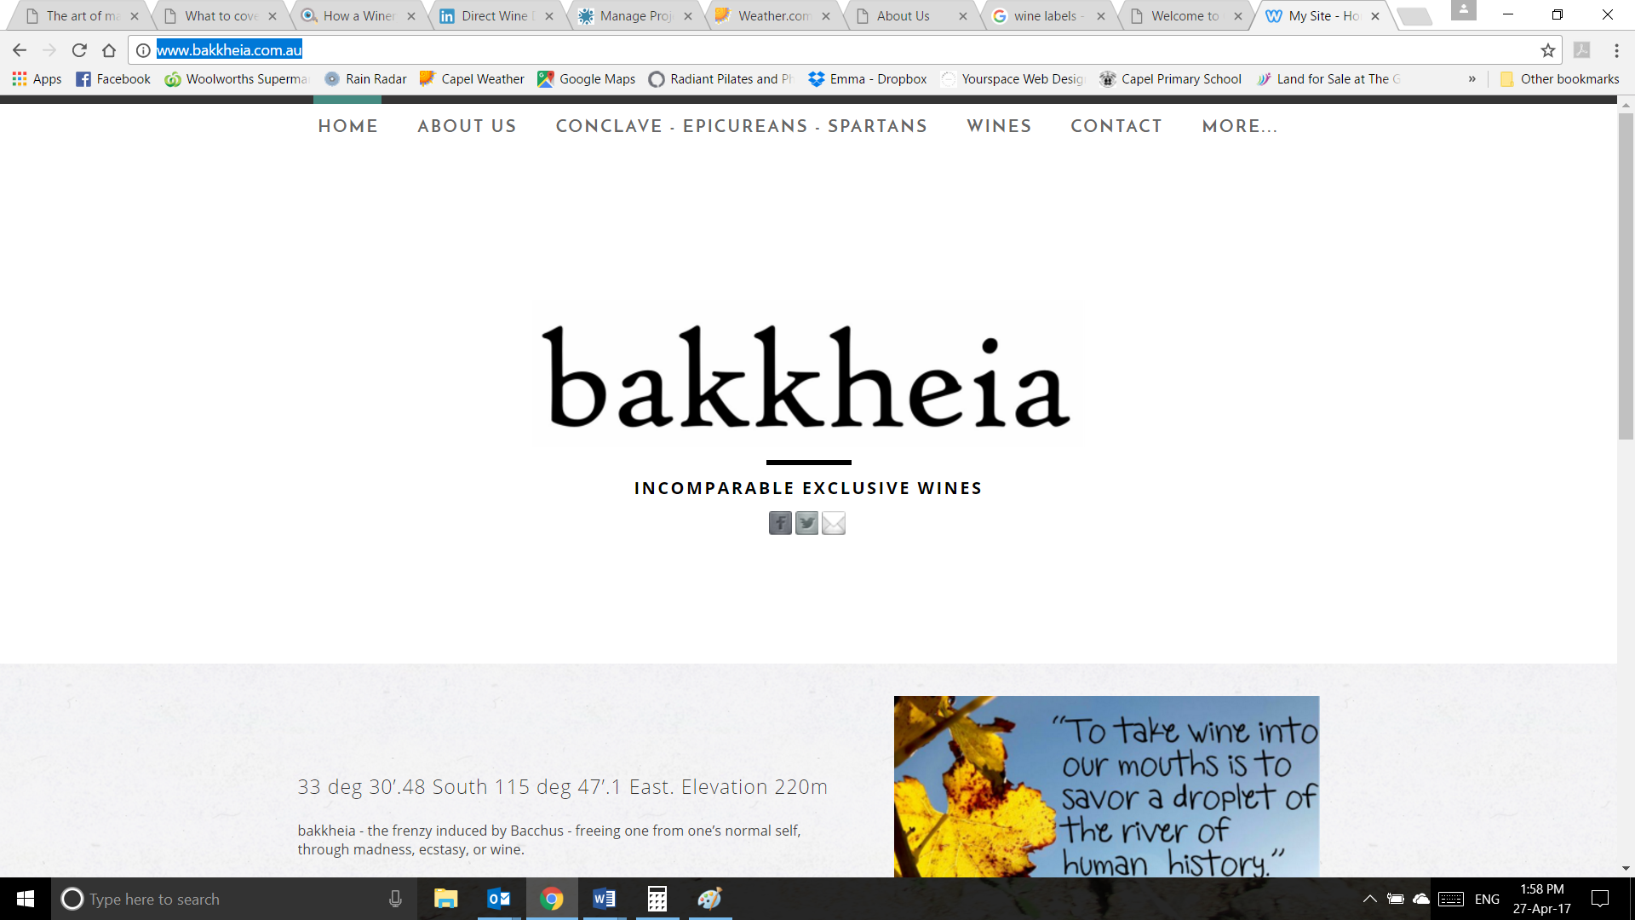
This winery operates in the same wine region as Kellivale Estate, but a version of this sort of “contemporary” look and feel is where my head is at.

