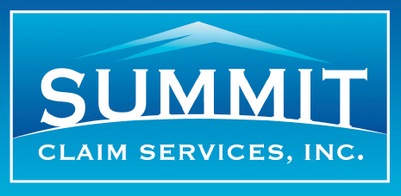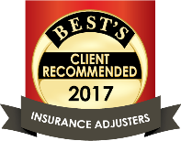

Why Summit Claim Services, Inc.? Because EXCELLENCE is no accident.

SUMMIT recognizes that the Insurance industry is customer-centric.
Summit knows “the moment of truth” comes with a filed claim and that Industry advertising promotes responsiveness and quality of claims services because policyholders are quick to share experiences. Therefore, we understand the importance of a quick response and making sure your policyholder recovers quickly following a loss. It's as if you were handling the claim yourself. In this manner, your policyholder can share a positive experience.
SUMMIT enables carriers to achieve the goal of claims excellence.
Summit supports the entire claims process with a team of responsive professionals that interact in-person with claimants early in the process, in essence becoming the face of the insurance company, and are supported by claims software to quickly and accurately prepare an estimate to repair damages
SUMMIT enables carriers to deliver on their core promise of dependability.
Industry advertising has established a heightened sense of entitlement and policyholders expect prompt and attentive assistance. Catastrophes happen daily to your policyholders and we handle those daily catastrophes at the personal level. We are there to make sure policyholder needs are met when they suffer their own individual loss.
SUMMIT cares about its Client’s objectives:
Summit knows the challenges facing carrier claims executives. With ongoing resource constraints and customer satisfaction demands, Summit works to help solve these challenges; handling claims quickly, courteously and professionally.

But that's not just us saying that.

Summit's performance and commitment to service has been validated through a third party, A.M. Best, the insurance industry's oldest and most recognized provider of insurance industry ratings. Based on A.M. Best’s validation of Summit's outstanding credentials, Summit qualified for their "Best's Client Recommended Insurance Adjusters" recognition.

In Addition…
Summit Claim Services has proudly provided our services to a client that J.D. Powers has awarded “Highest in Customer Satisfaction Among National Homeowners Insurers” 15 years in a row.

Summit Claim Services will deliver that same service to the policyholders of your company too.

Try Summit, you will not be disappointed.

