IMPRÜV YOUR LIFE LOGO
Imprüv Your Life has two core elements to the business, the consumer brand and the business opportunity brand, the logo must lend itself to both.
Some of the key points are:
Retail market
- Revolutionary health supplements
- Cutting edge scientific and medical research
- Premium fuel source for the human body
- Better focus, fat loss, sleep, energy, health
- Used by athletes, celebrities, astronauts, business executives, students, everyday people of all ages.
- Massive benefits for those with excess weight, cancer, Alzheimer’s, diabetes, Parkinson’s, autism, ADHD, arthritis and many more.
- Optimal performance
- Minimal lifestyle adjustment and cost

Business Opportunity
- Global market- not officially launched in the UK or Europe
- Only sold by word of mouth through registered distributors
- Full or part-time saleable business
- Unlimited earning potential with residual income
- Profitable lifestyle business
- Opportunity for anyone regardless of background
The health supplements are produced by Prüvit- Imprüv Your Life are an independent promoter. Elements of the Prüvit branding can be incorporated, they are a young and progressive company that have captured a phenomenal market within a very short period. There logo is simple, effective and clean.

https://pruvitnow.com/

Imprüv Your Life will also promote other products, training and opportunities that will add value in achieving consumer and business owner goals. These may include:
- Business development
- Sales and Marketing training
- Personal and Professional coaching
- Related lifestyle products

The logo will need to be:
- Progressive
- Strong
- Modern Urban- but appeal to all ages and walks of life
- No fluff

Images
The film and series limitless really portrays some of the benefits people experience with the health supplements. The concept of the brain or DNA helix in an enhanced, modern state could be a potential theme.

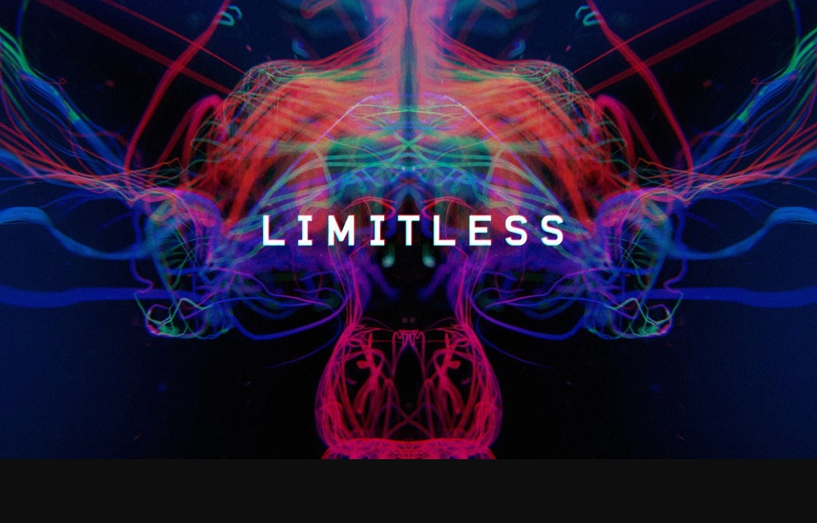
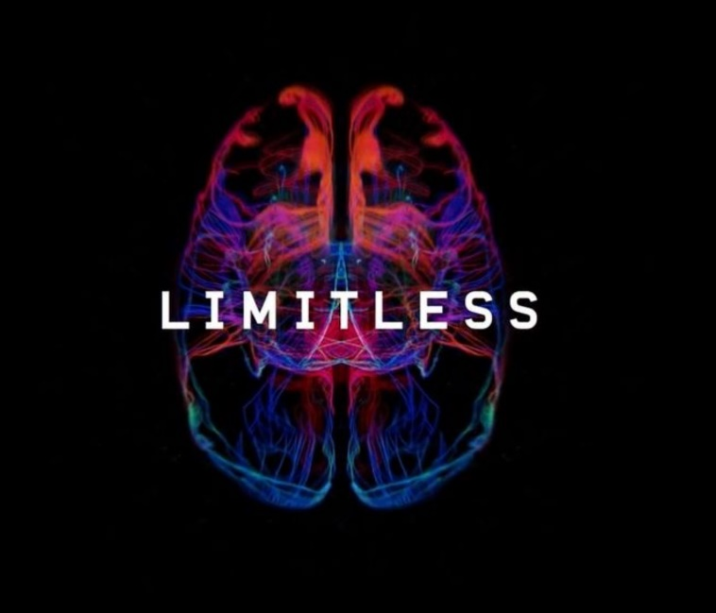

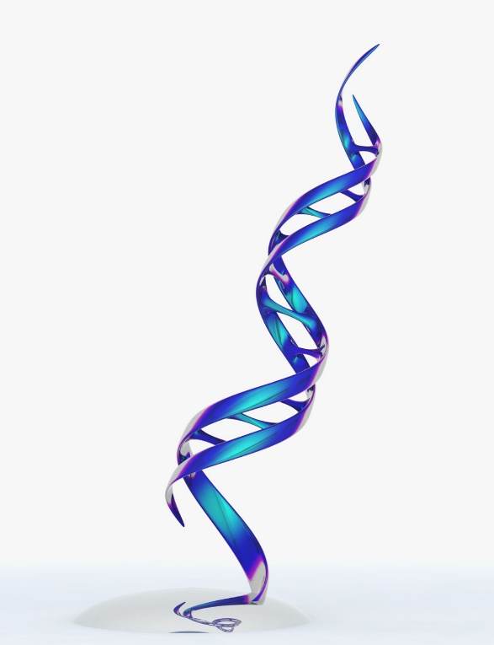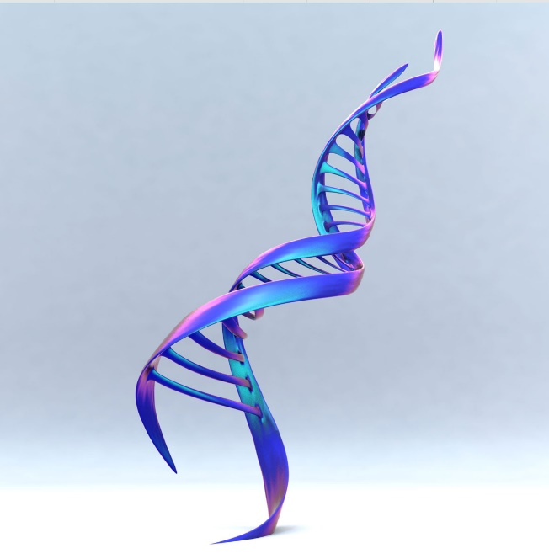



Perhaps incorporating ‘Imprüv Your Life’ into the DNA helix strands, with an option to have other versions of the logo with different wording

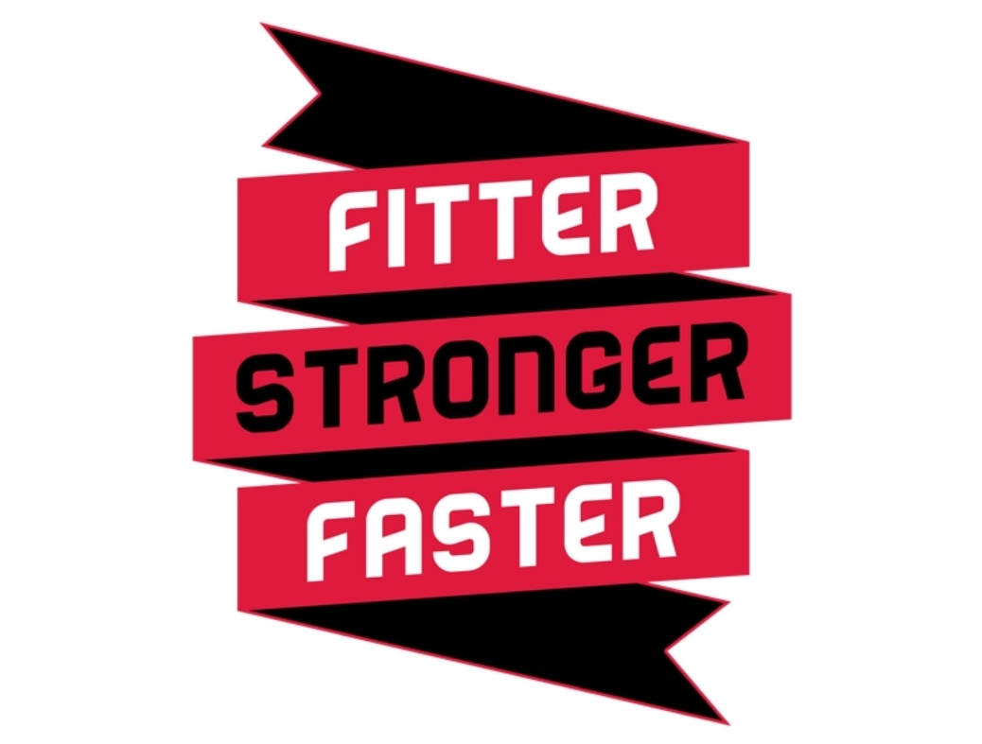

Other images for Imprüving



Colours:
- Blue- preferred
- White- preferred
- Black
- Purple – may be incorporated, i.e. for DNA helix

Other Pruvit Branding that the Imprüv Your Life branding and logo should complement
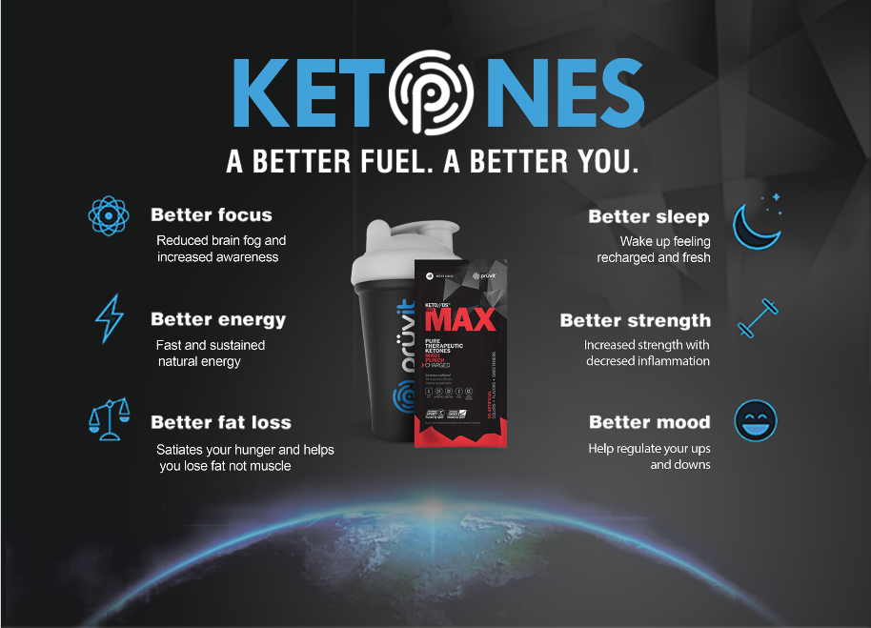

Other considerations
- Logo must be suitable for merchandise printing, i.e. shaker bottles, clothes
- Print dynamic

