Design Brief:
THIS PROJECT IS TO DESIGN A LOGO AND PACKAGING FOR AUTHENTIC CINNAMON.

Brand Name:
Authentic Cinnamon

Logo:
Using current logo idea, upgrade to Authentic Cinnamon branded version.
Logo design required to be incorporated into new packaging design.
Current logo is attached to this brief. Please use the new brand name – Authentic Cinnamon.
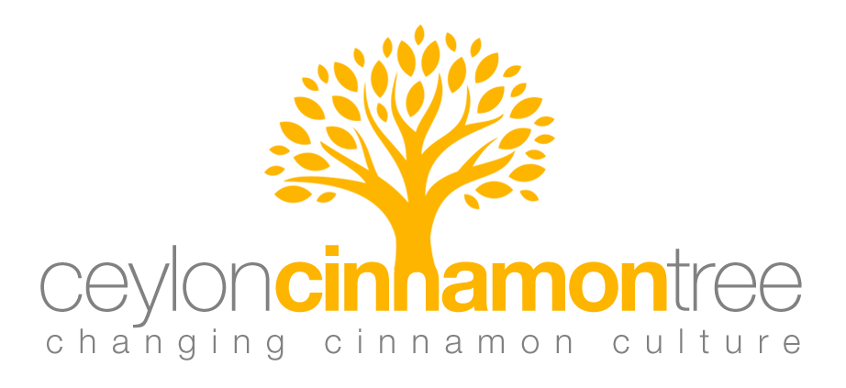
Product Packaging:
The product must be a pouch design, capable of being used for both 150g and 250g pouches. (Also replicate design for Plastic Tube if possible)
Product: 100% Organic Ceylon Cinnamon Powder

Here are the design guidelines:
Key Message 1: - Safe and Non Toxic:

- ‘Safer’ ‘Non-Toxic’ Wording
- Clear design & Big/Bold text
- Use-By Date prominent

*Not all cinnamon is created equal. Learn more @ www.authenticcinnamon.com

Key Message 2: - Better Taste:

- Flavour Profile
- Descriptions of Taste

Description Example: ‘Naturally Sweet Authentic Cinnamon Flavour’

For the flavour profile
I have sketched something here that I would like...see below for an example of what I am looking for:

I would like it to be a comparison between
‘Authentic Ceylon Cinnamon’ and ‘Regular Cassia Cinnamon’

I would like to compare 4 elements of the flavour:

NATURAL SWEETNESS:
Authentic ‘Ceylon’ Cinnamon 9/10
Regular ‘Cassia’ Cinnamon 3/10

SPICE:
Authentic ‘Ceylon’ Cinnamon 6/10
Regular ‘Cassia’ Cinnamon 9/10

AROMA:
Authentic ‘Ceylon’ Cinnamon 9.5/10
Regular ‘Cassia’ Cinnamon 4/10

BITTERNESS:
Authentic ‘Ceylon’ Cinnamon 2/10
Regular ‘Cassia’ Cinnamon 8/10

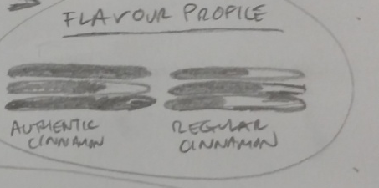

Key Message 3: - Health Benefits:

- Clear design
- ‘Health benefits’ wording
- Anti-Oxidant, Anti-Viral and Anti Bacterial

Learn more about health benefits of Authentic Cinnamon @ www.authenticcinnamon.com
(or something like this ... I need to draw attention to the range of health benefits...)

Key Message 4: - Better Smell:

- ‘Talk’ of aroma/Description of smell

“More Aromatic” – Or something like that...

Key Message 5: - Organic, Sustainable and Authentic:

- Certifications (USDA/EU Organic)
- Organic/GMO free ‘Wording’
- Country of origin (Sri Lanka)
- Big/Bold Text – “Authentic”
- Picture of cinnamon

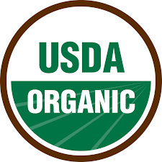
Include the above certifications
Pictures of Cinnamon – I have attached this file below if you wish to use it.
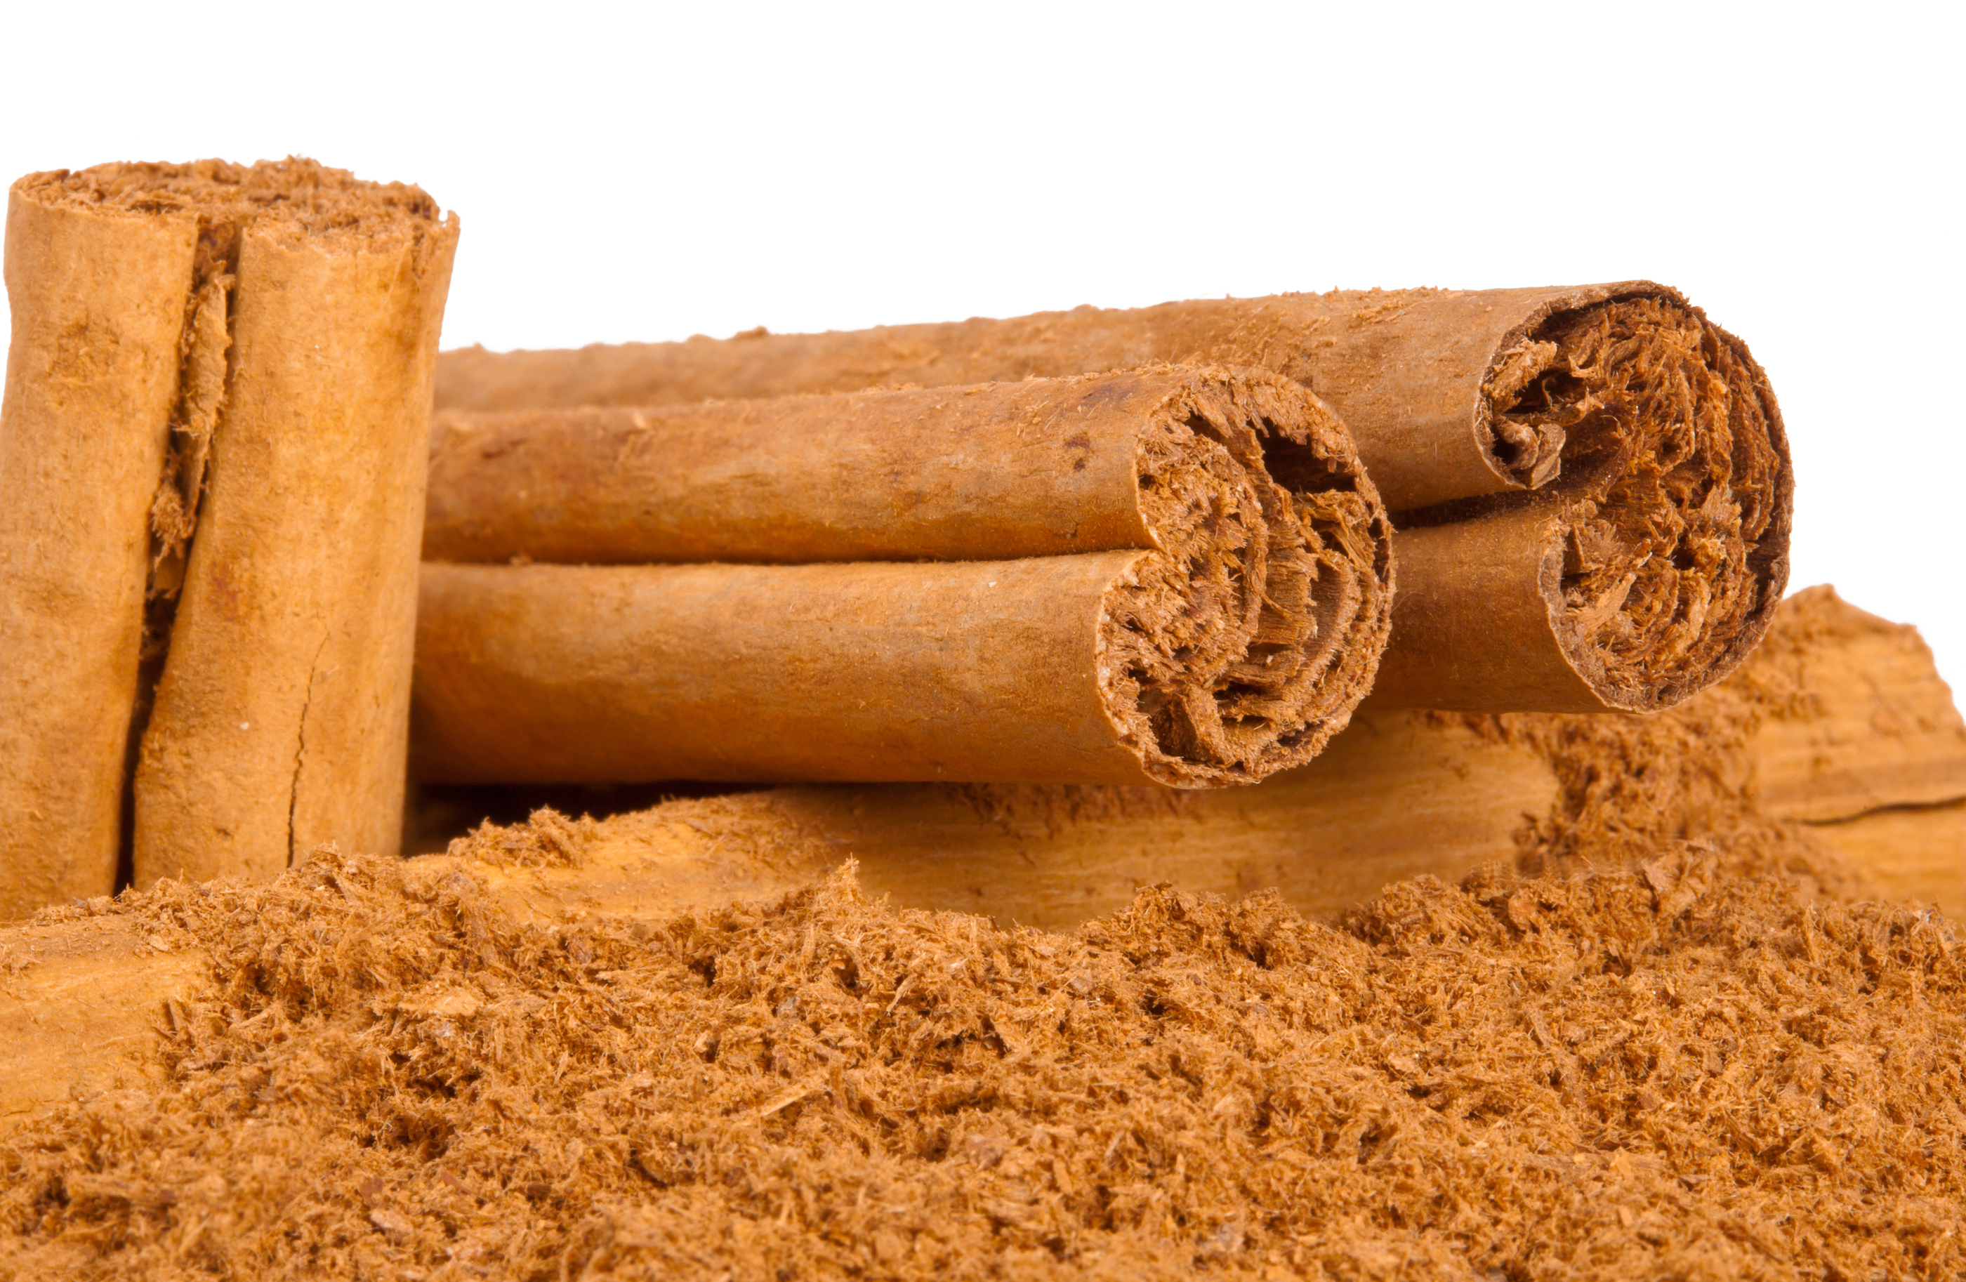

CAD
Please see the 3D CAD designs here for both 150/250g Pouch and 28g Tube Designs: 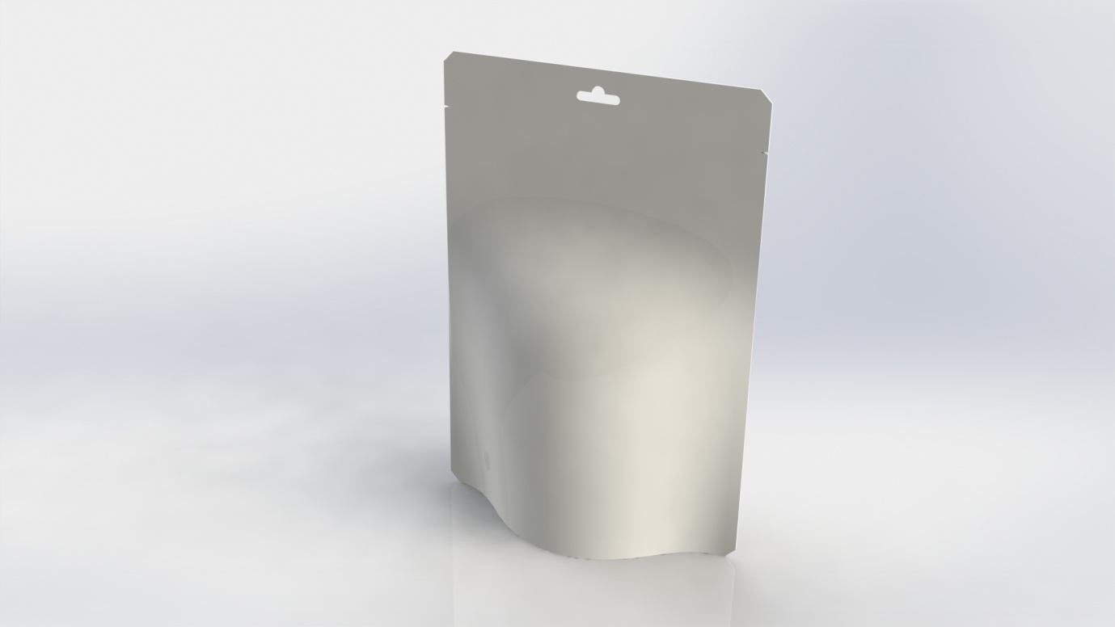
150/250g Angled.

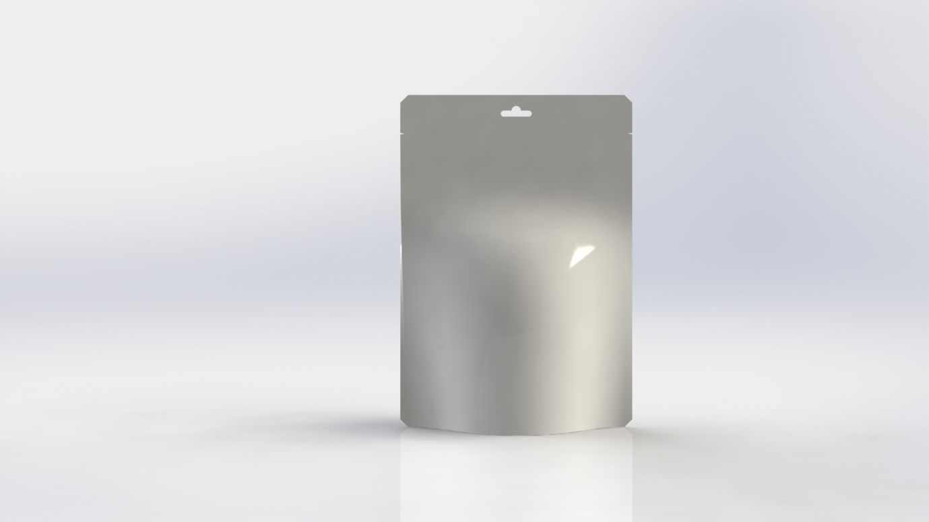
150/250g Front.

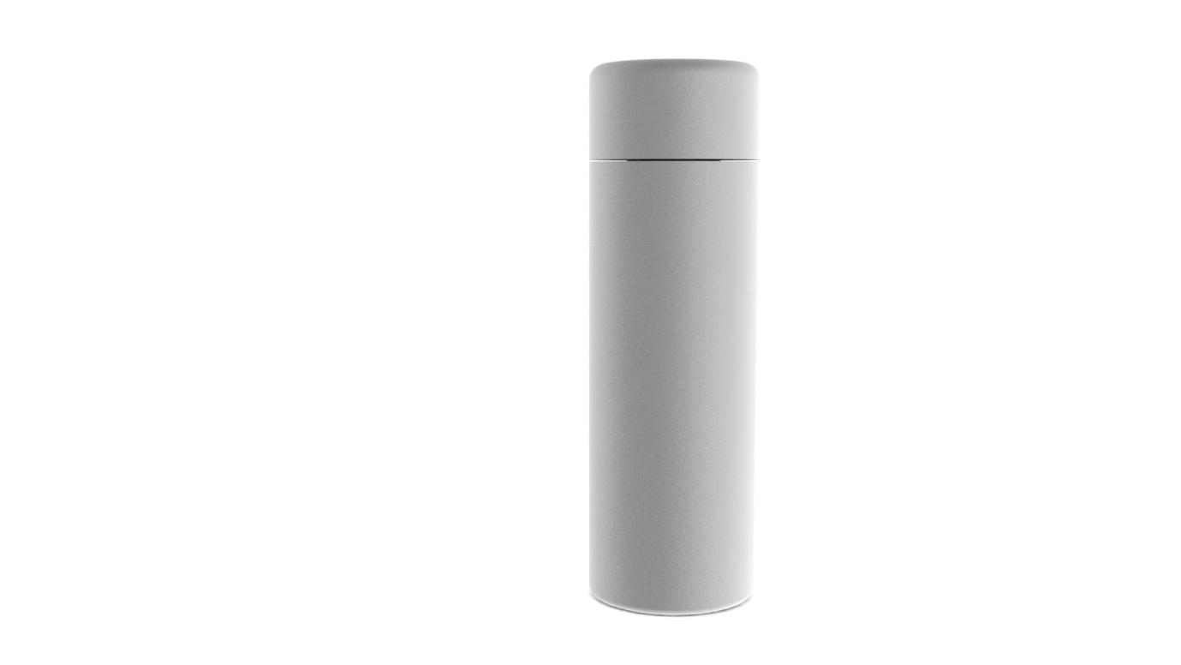
28g Plastic See Through Tube - Front.

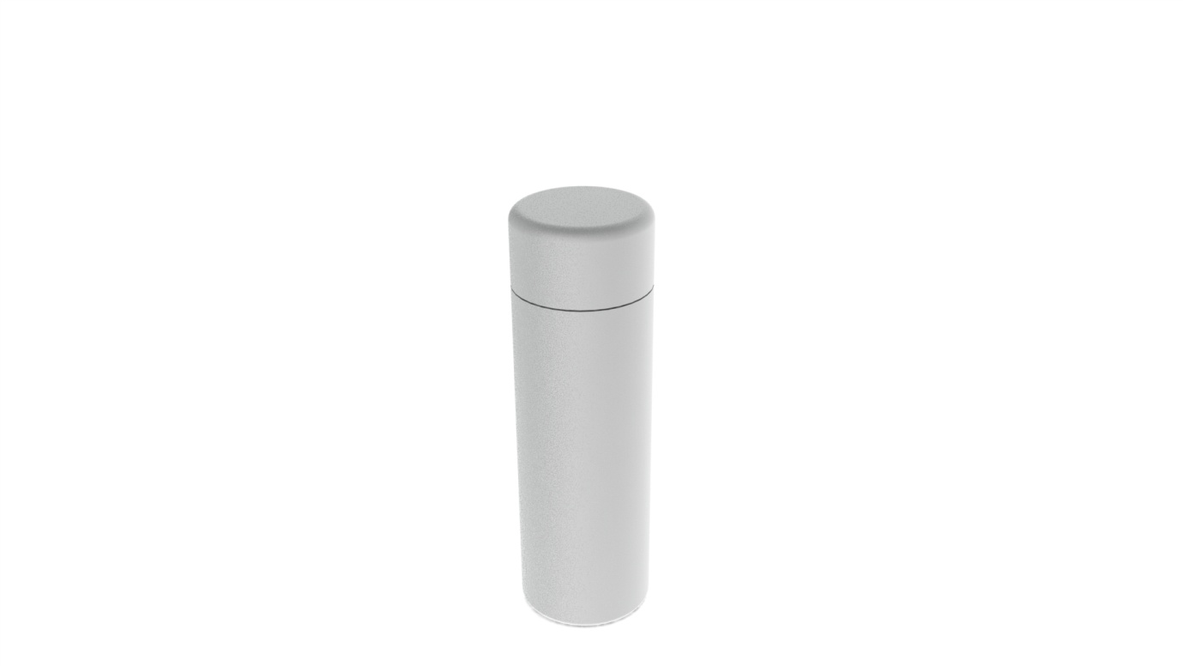
28g Plastic See Through Tube - Angled.

Inclusions:
Bar Code
Ingredients – 100% Pure Ceylon Cinnamon (Cinnamomum verum)
Product of Sri Lanka
Imported and Distributed by Authentic Cinnamon Pty Ltd.
Include the little social media images
@authenticcinnamon
www.authenticcinnamon.com

Preferences:
Use of warm colours. Keep the same colour for the logo. Clean design, with See-Through element (like pictured below) Resealable design

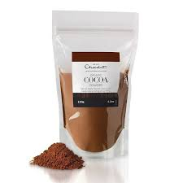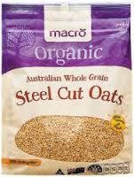

Sizes
Here are some sketches showing the sizes in mm.
250g – 150mm x 215mm
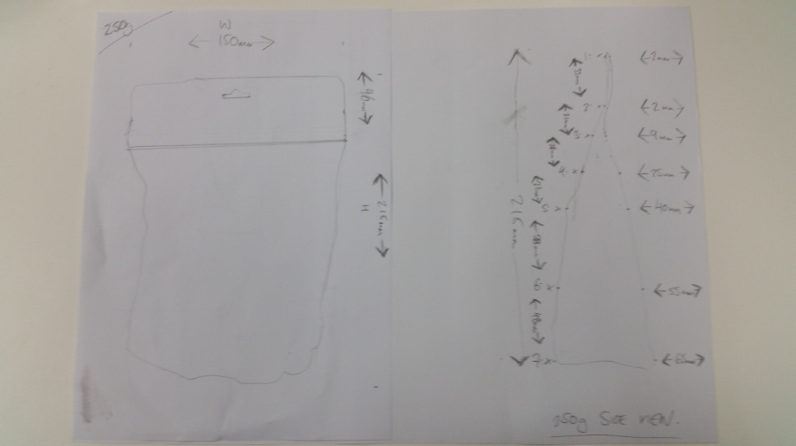
150g 120mm x 180mm
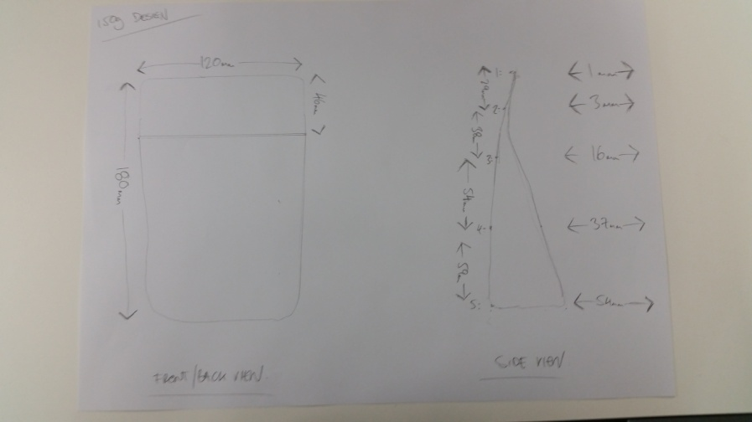
28g Tube 45mm x 145mm
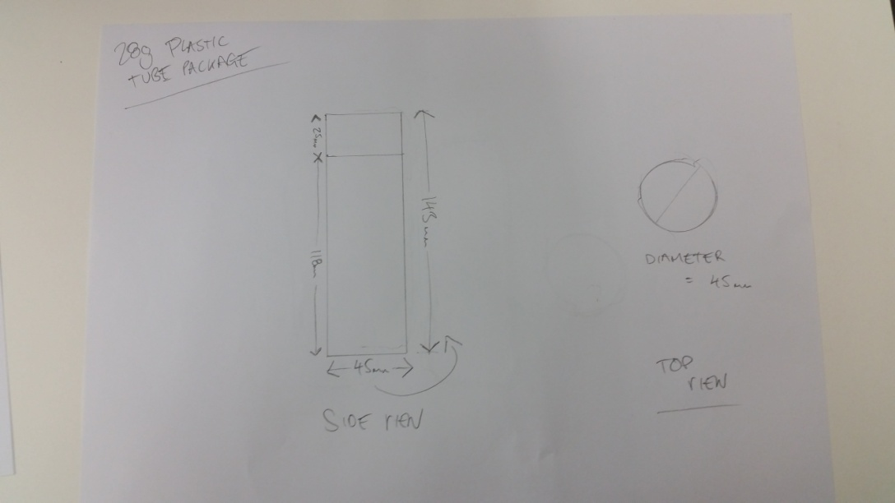
FINAL DESIGN:
Design for Pouch front and back which can be used for 150/250g packaging.
If possible, replicate or show visual of design over Plastic Tube model. (If it can be included in this project)

