6.0 Styles

6.1 Products

Navigation
Main Navigation
Arial Gray #666666 11pt

Main Navigation Active
Arial Blue #007AB8 11pt

Channel Specific Navigation
Arial Gray #666666 18pt

Channel Specific Navigation Active
Arial Blue #007AB8 18pt

3rd Level Navigation
Arial Gray #666666 14pt

3rd Level Navigation Active
Arial Orange #FF3300 14pt

Breadcrumb
Arial Blue #007AB8 13pt
Body
Header 1 Page title
Arial Blue #007AB8 18pt Bold

Header 2
Arial Blue #007AB8 14pt Bold

Header 3
Arial Gray #333333 12pt Bold

Body copy
Arial Gray #333333 12pt

Link
Arial Gray #333333

Link hover
Arial Blue #007AB8

Table
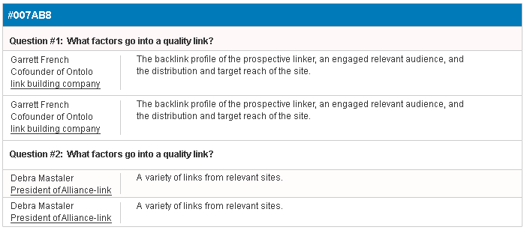

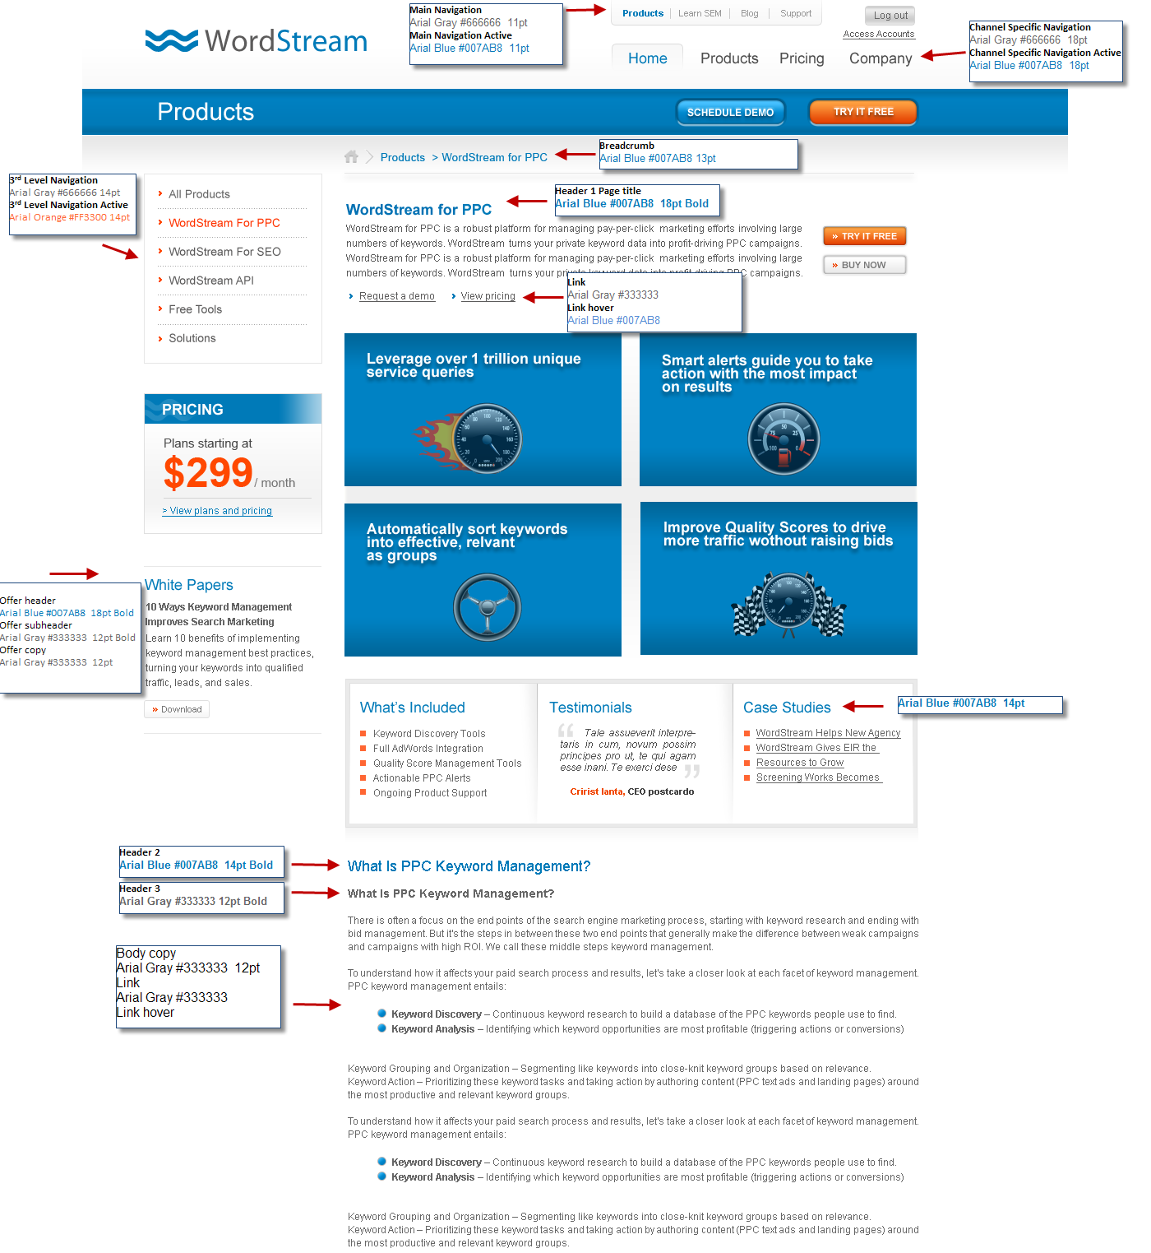

6.2 Learn

Navigation
Main Navigation
Arial Gray #666666 11pt

Main Navigation Active
Arial Blue #007AB8 11pt

Channel Specific Navigation
Arial Gray #666666 18pt

Channel Specific Navigation Active
Arial Light Blue #66ccff 18pt

3rd Level Navigation
Arial Gray #666666 14pt

3rd Level Navigation Active
Arial Orange #FF3300 14pt

Breadcrumb
Arial Blue #007AB8 13pt

Body
Header 1 Page title
Arial Light Blue #66ccff 18pt Bold

Header 2
Arial Light Blue #66ccff 14pt Bold

Header 3
Arial Gray #333333 12pt Bold

Body copy
Arial Gray #333333 12pt

Link
Arial Gray #333333

Link hover
Arial Light Blue #66ccff

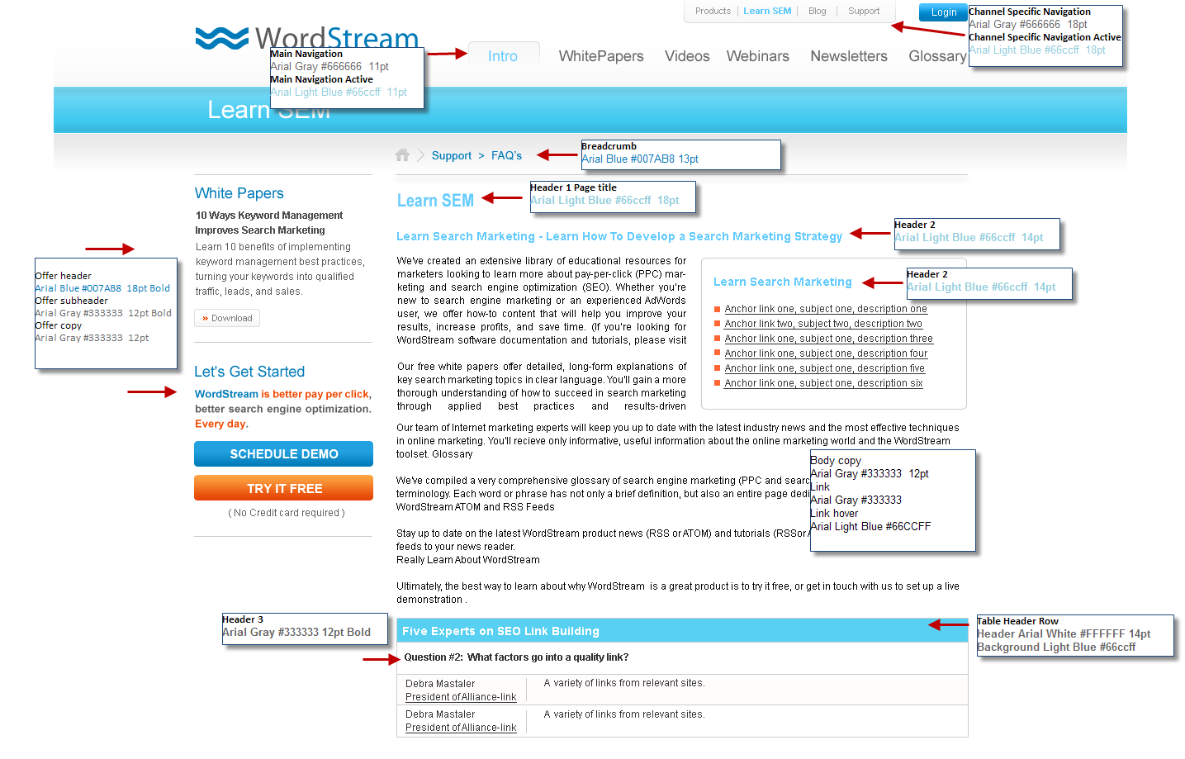
Table
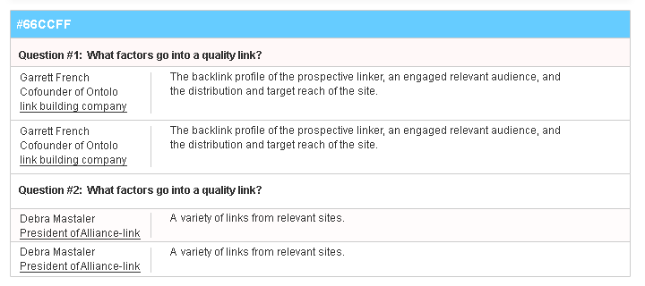

6.3 Support

Navigation
Main Navigation
Arial Gray #666666 11pt

Main Navigation Active
Arial Orange #FF3300 11pt

Channel Specific Navigation
Arial Gray #666666 18pt

Channel Specific Navigation Active
Arial Orange #FF3300 18pt

3rd Level Navigation
Arial Gray #666666 14pt

3rd Level Navigation Active
Arial Orange #FF3300 14pt

Breadcrumb
Arial Blue #007AB8 13pt
Body
Header 1 Page title
Arial Orange #FF3300 18pt Bold

Header 2
Arial Orange #FF3300 14pt Bold

Header 3
Arial Gray #333333 12pt Bold

Body copy
Arial Gray #333333 12pt

Link
Arial Gray #333333

Link hover
Arial Orange #FF3300

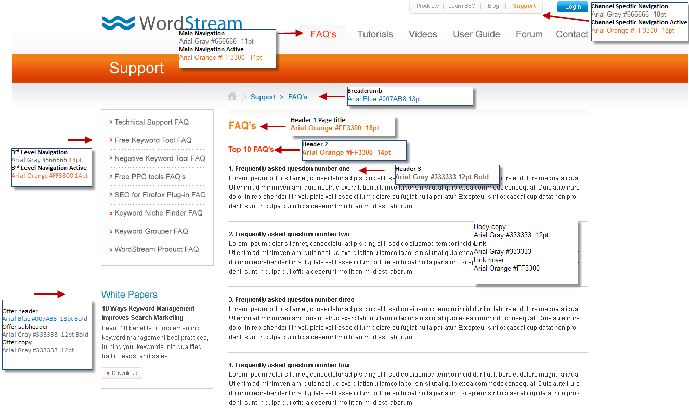

Table
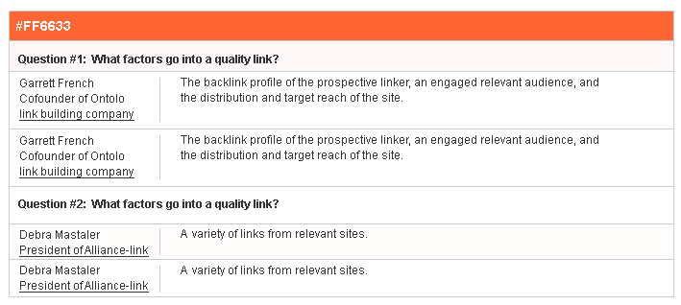

6.4 Blog Styles

Navigation
Main Navigation
Arial Gray #666666 11pt

Main Navigation Active
Arial Blue #007AB8 11pt

Blog Block Header
Arial Gray #333333 15pt

Blog Block Links
Arial Gray #333333 13pt

Blog Block Links Active
Arial Orange #FF3300 14pt

Breadcrumb
Arial Blue #007AB8 13pt
Body
Header 1 Page title
Arial Blue #007AB8 18pt Bold

Header 2
Arial Blue #007AB8 14pt Bold

Header 3
Arial Gray #333333 12pt Bold

Body copy
Arial Gray #333333 12pt

Link
Arial Gray #333333

Link hover
Arial Blue #007AB8

