Project Logo “BRICKS”
Description of the Coffe-shop Restaurants
Bricks – Coffee n’ Kitchen is a new coffee shop restaurants located at the main business district of Tunis, Les Berges du Lac 1. A vintage-modern ambiance offset by tasteful and comfortable renovations designed to put everybody at ease through the coziness and warmth brought by the concept itself.
Logo Description
We need a logo for a new coffee-restaurant that will be bases in Les Berges Du Lac, main business district of Tunis. We would like to stay away from the typical cup of coffe or food pictures that are part of most restaurants logos. We would prefer using something more creative, highlight the cozy-modern side of the place (see attached a 3D design of what the place will look like). Our restaurants will focus on both offering coffees to workers in hurry the mornings, give them the comfort to have lunch and why not to pass by after work for friendly meetings. The target is principally workers and students.
Proposition The main name “Bricks” should be highlighted and have the “coffee n’ Kitchen” less viewed.
Look and feel
Each slider illustrates characteristics of the consumer’s brand and the style the logo design should communicate.
Elegant |  |  |  |  |  |  | Bold
Playful |  |  |  |  |  |  | Serious
TRaditional |  |  |  |  |  |  | Modern
Personable |  |  |  |  |  |  | Professionnal
Feminine |  |  |  |  |  |  | Masculine
Colorful |  |  |  |  |  |  | Conservative
Economical |  |  |  |  |  |  | Upmarket

Good Logos Examples
(my opinion next to each logo, try to not read it before u make ur own judgment)
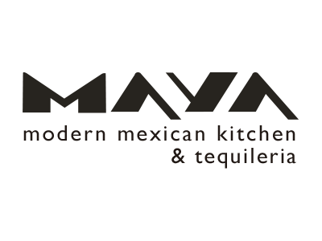(Modern but I don’t see the coffe-shop concept into it)
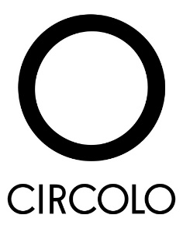 (too bland)
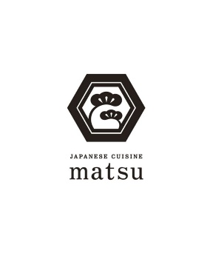(Rather modern, I like the font)
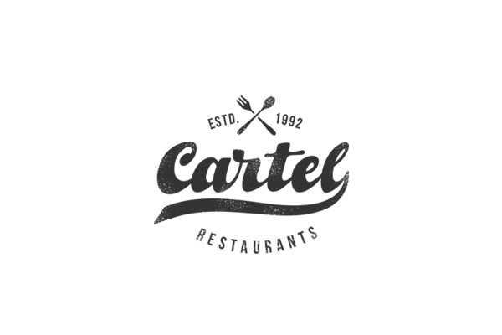 (this one is good, maybe with a little brick icon for a vintage touche, without the line, I like italics)
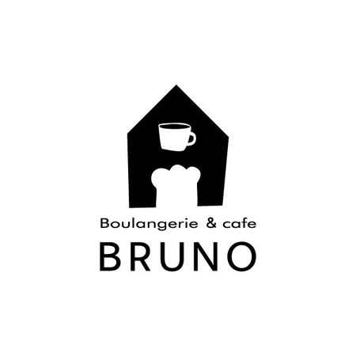 (not representative for the name “Bricks” but some modifications could be brought)
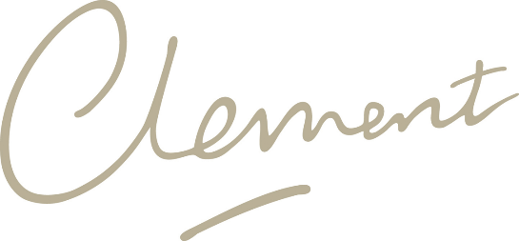 (I like italics, I see “Bricks” in italics)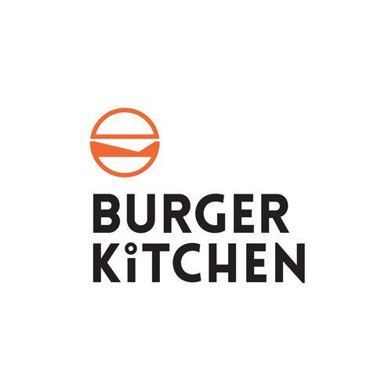(The font is good, the way it’s written also, this combination of black and orange can be used)

