Fixed with Food

Tag Line

Food is medicine

Logo Ideas

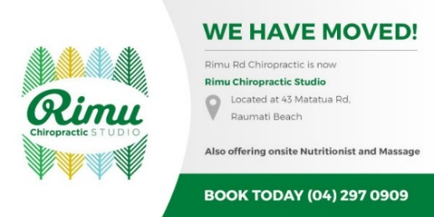

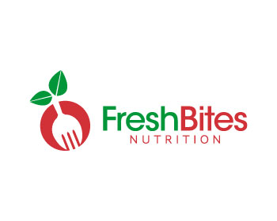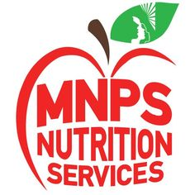



Brand

Fixed with Food….

…..For you
…...@Home
……@Your Family
… ..@Sports
……@Workplace

About Fixed with Food

Fixed with Food is a nutrition business focussed on optimising your health through a natural and holistic approach to nutrition. This involves looking at your lifestyle as a whole, not just your nutrition, for more effective, long-lasting results.

Key to our ethos is putting the person at the centre of everything we do – this means treating the person and not just the problem, being non-judgemental and being flexible in our approach. On the ground this translates to understanding your environment as well as your nutrition in initial assessments with clients and developing a Personal Health Treatment Plan which is tailored specifically to the individual. It also means being flexible about how we interact with clients to best meet their individual needs and, also, preferences – for example, in person, skype, phone and/or email consults and ongoing support.

We pride ourselves on going the extra mile and leaving no stone unturned when it comes to your health. This includes conducting research around your particular health issues, if necessary.

Why Fixed with Food is right for you:

- Qualified Nutritionist with extensive knowledge and expertise
- We will optimise your health and make you feel and look great
- Look at your lifestyle as a whole – not just treat the nutritional aspect
- Treat the person, not just the problem
- Provide Personal Treatment Plan and service that is developed with you and tailored to you
- Attention to detail – including thorough investigation and research around the problem
- Provide you with the best, up-to-date information
- Ongoing support to help keep you on track
- Real-life practical approach to nutrition and making changes that last
- Recipe ideas

Areas where we can help:

- Mental health and wellbeing, stress, anxiety and depression
- Digestive health
- Skin health – acne, eczema
- Cancer support
- Thyroid
- Teenage health
- Child health
- Family health
- Conception health, pre and post-natal
- Sports performance
- Tiredness and fatigue
- Allergies and food intolerances
- Diabetes management
- Workplace performance / employee wellbeing

Services:

- Nutrition consultations/ advice (optimal health and chronic conditions), includes tailored personal plan (can include tailored recipes)
- Supermarket tours
- Cooking demonstrations – individual, family or small group
- Workplace wellness – wellness talks and workshops (focus on employee performance and the link to health and wellbeing)
- Seminar/conference speaking for events
- Menu makeovers – home and café/business
- Kids lunchbox – ideas, plus tailored recipes, e.g. covering food allergies and intolerances, reducing sugar

About Tim Barclay, Founder and Director

I have always been passionate about food and understanding the impact, good and bad, that food can have on your body. I am also interested in biology and chemistry and the interaction of biological and chemical processes in the body. As a qualified clinical nutritionist (diploma xx and certificate from the Australian College of Nutritional Medicine), it is my personal mission to spread the message about good nutrition and help as many people as possible. Too many people are suffering in silence with sub-optimal health. I believe it is a human right for people to understand nutrition and, since we are all different, what works for us individually so we can each live life to the fullest.

My philosophy is treat the person, rather than just the problem, which means that take a person-centric view in everything I do. In my consults, this means understanding your environment as well as your nutrition, and developing a personal health plan which is tailored specifically to you. It also means being flexible about how I interact with clients to best meet their individual needs and, also, preferences – for example, in person, skype, phone and/or email consults and ongoing support.

When I am not giving nutritional advice and support, or ‘geeking’ about nutrition, in my spare time I love to cook and try out new recipes. I am a Dad with two children under the age of 5, and it gives me a buzz to know that by getting their nutrition right I am helping to give them one of the best possible starts in life. My other (non-food related) hobbies, include cycling and running. As an Outdoor Pursuits Instructor in a former life, I love being outside where possible!

