Dear Designers,
we need a logo for a project that will support EU citizens to improve their energy efficiency, please find the outline of the project attached.
We expect a logo that has the project name it “SUSTAINERGY” and demonstrates we want to create a community of consumers. As an example please see the logo of the project PEAKapp below, which is a project brings renewable electricity via a smart phone app to households – and we think the logo tells the story quite good.
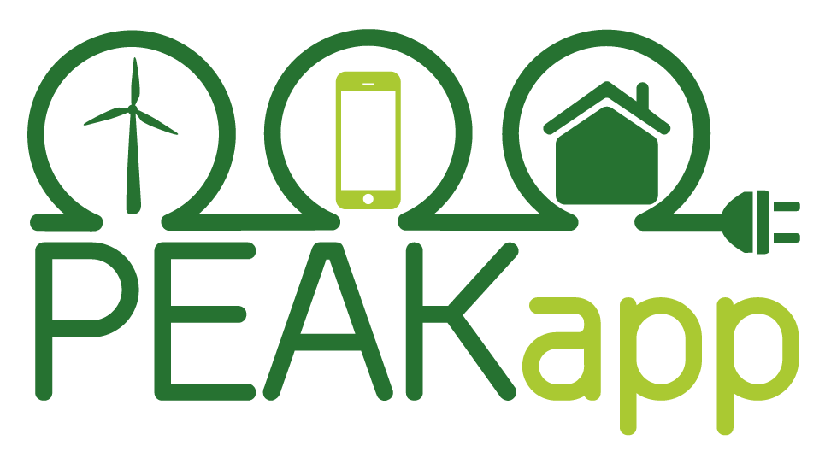
We need a high resolution graphic in png format that is transparent. While the logo shall be colored, it needs to make sense also in black/white.

Outline of the SUSTAINERGY project:
Based on a high level expertise in both social sciences and energy, the SUSTAINERGY project aims to improve the engagement of consumers towards sustainable energy. It will make all relevant stakeholders work together, including 5 partners that will focus on research and 7 consumer organisations that will reach about 275 000 consumers, trigger a change of behaviour for more than 10 000 of them, and lead to 67 GWh of energy savings each year.
Based on current knowledge concerning consumer decision making processes, a new methodology to involve consumers in behavioural change will be developed. Best practices for sustainable energy (from simple and costless actions to more complex ICT-based solutions, through production of renewable energy) will be identified. In parallel in-depth studies will result in the more precise market segmentation related to energy consumers ever being made. This will enable to propose tailored actions to specific target groups of private consumers and lead to a high appropriation.
A double scale dissemination campaign will enable the diffusion of these actions, based on an online platform and ground activities realised by “Consumer Advisors” in the 8 EU Member States directly involved in the project. Besides, financial and regulatory barriers will be analysed and recommendations for structural changes will be proposed to regional/national policy makers. Specific actions will improve the knowledge of consumers on their energy bills, reduce their consumptions, facilitate deployment of ICT-based solutions and even stimulate private investments in sustainable energy. From a long term perspective, the SUSTAINERGY network and solutions will be extended to new countries in order to better address consumers, efficiently fight against fuel poverty and lead to more sustainable energy behaviours all over Europe.

