Date:
Author:
Project: | Matrecis
Subject: | Web Redesign

Tabs At Top

Home page then the following tabs
- Model Example
- Pricing
- Resources – video, FAQ’s
- Consultancies
- About Us
- Contact

Home Page

Top of page

Welcome to Matrecis the global platform for enterprise efficiency.

Watch the video [summary video]

Rotating gallery 5 clickable images plus text (text to be indexable by google).

- Show the value delivered by IT to the business using Technology Business Management
- Create and share models that allow like for like comparisons across a business or across business units.
- Prove the true cost and value of any process, service or organisational unit.
- Easily benchmark cost and performance regardless of source or complexity of underlying data
- Remove the barriers to efficiency by deploying standard taxonomies to measure cost and value

- Show the value delivered by IT to the business using Technology Business Management

Link down to Technology Business Management

Technology Business Management (TBM) is a fast growing industry standard taxonomy designed to help manage IT as a business. It delivers true IT cost transparency that shows where in a business IT costs and resources are being consumed.

Given the now vital nature of technology and IT to all businesses, Matrecis comes complete with a fully operational TBM model. This means you can get all the benefits of TBM immediately, out of the box.

Show the value of IT by running IT as a business and delivering:

- Cost Transparency
- Consumption by business unit
- Show back, charge back to the business
- Benchmarking

- Create and share models that allow like for like comparisons across a business or across business units.

Link down to Create and Share Models

A model is a standard taxonomy that you create to describe a process, a service or in the case of TBM an entire IT organisation.

A model allows a standard, comparable view of input costs, services that result from those costs and units of production that come from the services. For example, the cost of supplying a CRM system to users consists of:

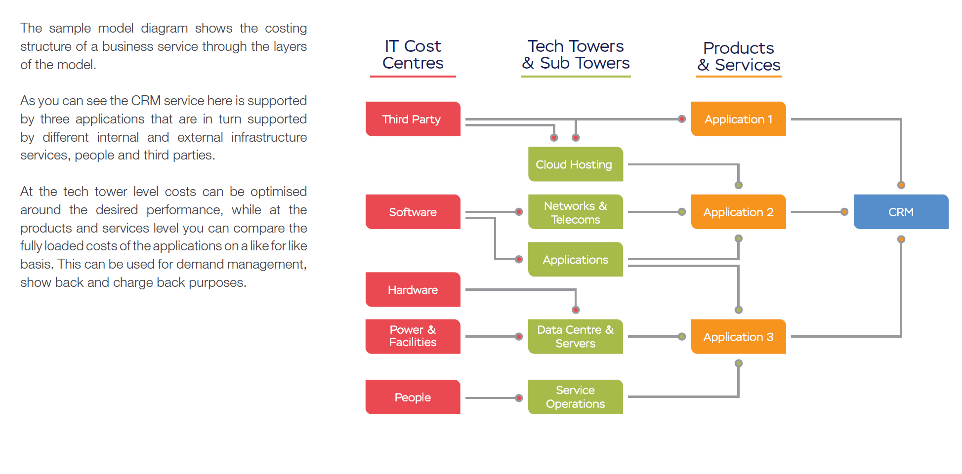

This model can be shared and populated across your organisation regardless of the form and content of the underlying data that may exist in different repositories. The models you create are not limited to IT they can model anything.

The benefit is a single, comparable point of truth that reveals the relative efficiency of providing the same service in different parts of an organisation or group of organisations.

- Prove the true cost and value of any process, service or organisational unit. Link down to

Prove The True Cost and Value of Any Process, Service or Organisational Unit

NOTE that we have new and better looking graphs now – some of these have also been attached

Show fully loaded drillable costs together with relevant outputs.

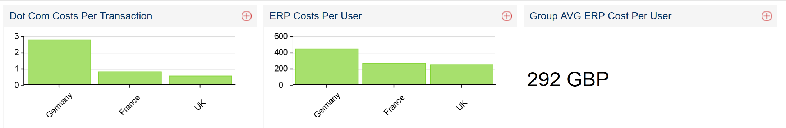

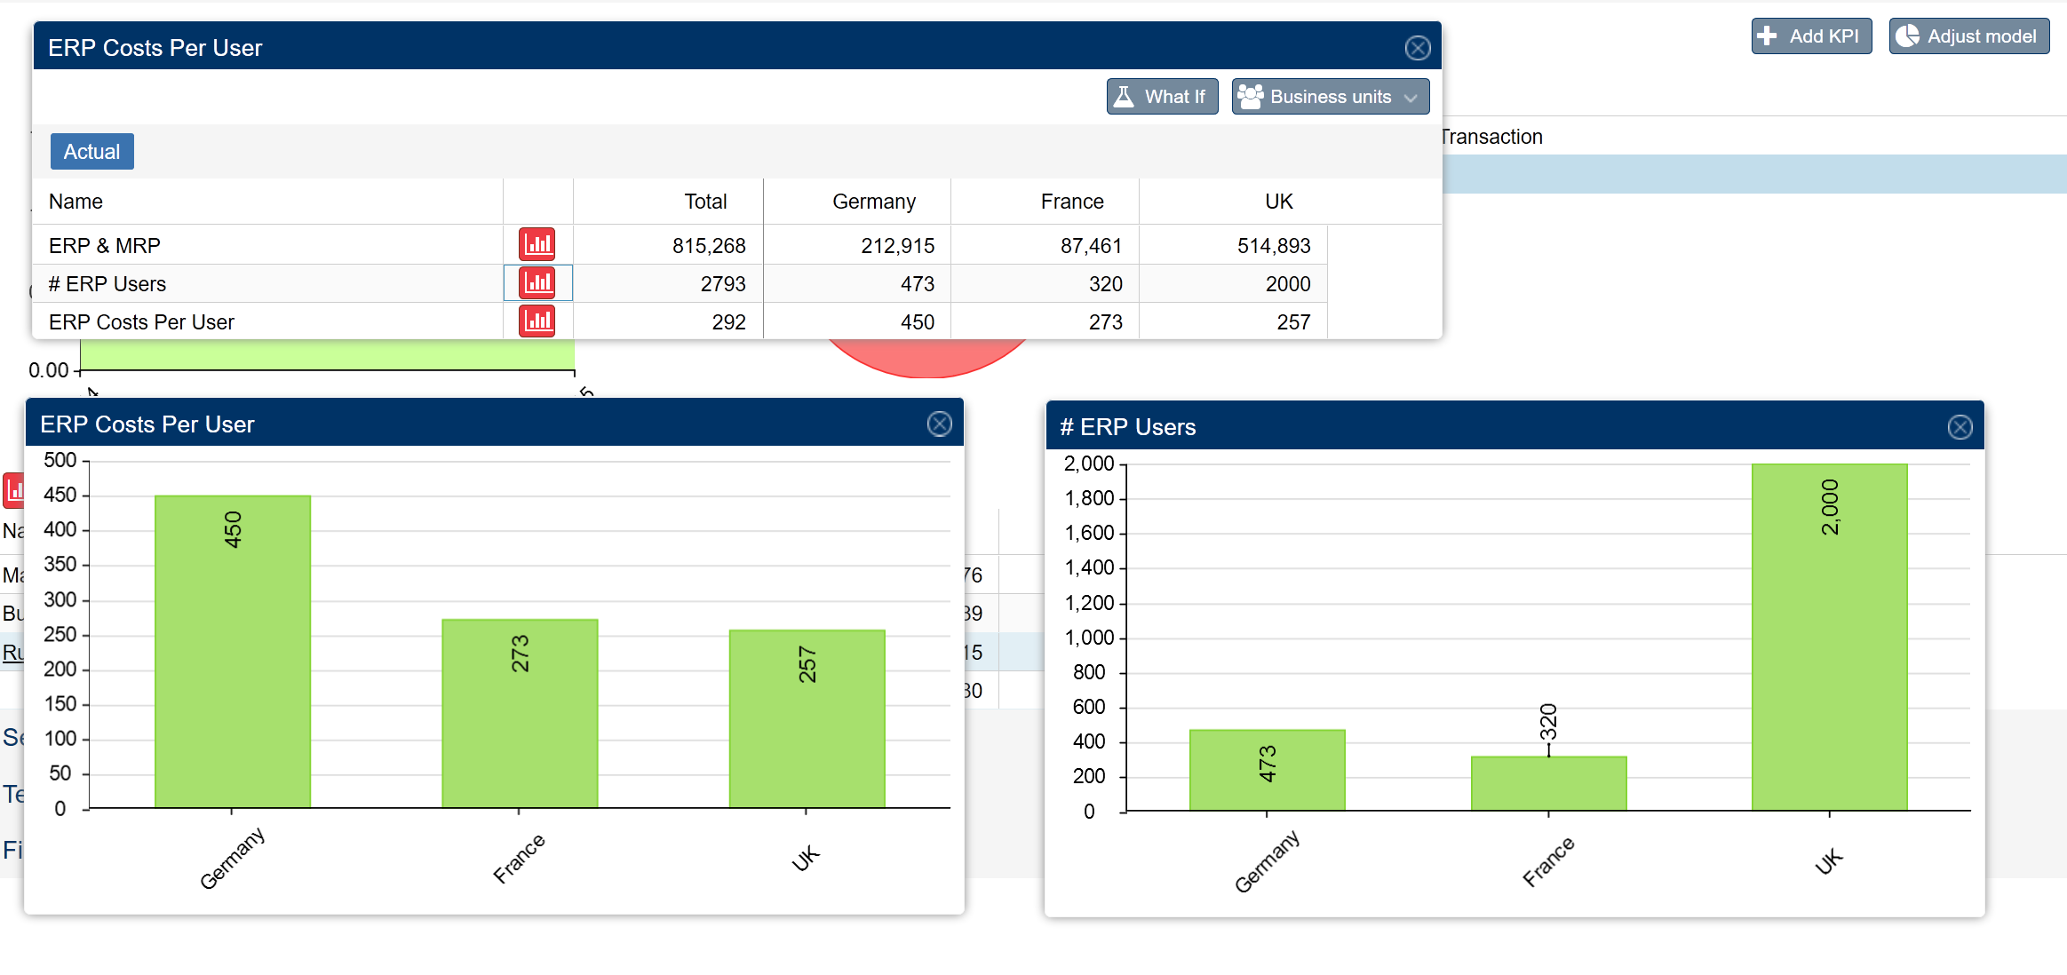

- Easily benchmark cost and performance regardless of source or complexity of underlying data. Link down to:

Easily Benchmark Cost and Performance

Placeholder. Image(s) that illustrate this together with strapline.

- Remove the barriers to efficiency by deploying standard taxonomies to measure cost and value. Link down to

Remove the Barriers to Efficiency

Placeholder. Image(s) that illustrate this together with strapline.

Model Example link to tab

Then all this text and imagery including the download capability: http://matrecis.com/model-example/

Pricing Link to Tab

Place three options in nice looking boxes similar to sales force or https://snapengage.com/live-chat-pricing/

Matrecis is available only through carefully selected consultancy partners. See consultancies (link to tab) for a list of these.

Consultancies wishing to apply for distribution rights please click here (link to consultancies tab) to get in touch.

Resources

- FAQ’s similar to those produced for TechM

- Videos

- Download model.

Consultancies

We operate a consultancy program for firms that can demonstrate the right level of people and skills necessary to assist (typically) larger organisations with cost transparency, BPO, process costing and now Technology Business Management.

Contact us for further details link to contact us.

For those qualifying firms we have attractive offers on using the software. Existing consulting organisations are:

Tech Mahindra
Morgan Hill Consultants Ltd

About Us Tab

Contact

Contact capture screen, same as or similar to existing sign up for model http://matrecis.com/download-full-model/

Images required for:

Taxonomy
Model
Home Screen
Cost Transparency illustration
Show back charge back
Benchmarking?

