AWEquestrian

What is AWEquestrian

- There are 3 levels to AWEquestrian:

  - Buying, producing and selling quality young horses
    - I mostly buy unbacked/largely unhandled horses, back them, prepare them for shows or do their first show, then sell to professionals and amateurs to compete and enjoy.
  - Riding my own horses in competitions
  - Breeding rare coloured top sports horses

  - These will eventually be broken down to three separate businesses, but for now AWEquestrian covers all 3.

    - AWEquestrian will be the buying, selling and competing.

    - Bilingual Equine will be the training business, offering training and training demos for riders and horses, my half specialising in the ridden training of young sports horses, my friend’s half speciliasing in behavioural problems and in particular, the partnership between horse and human on the ground.

    - Acorn Stud will be the breeding side.

Competitive and Business Aims

*The Dream*
- My competitive aims are to win at top international level across the 3 major disciplines of Dressage, Show Jumping and Eventing. My dream is to win prestigious events, such as Badminton and Burghley CCI****’s, the Hickstead Derby, Olympic Gold Medals and World Championships.

- I have so much passion for training and producing horses that it is as much about the progress and the ‘small wins’ on the way as it is the end result. I love every aspect of horsemanship and competing, and love learning as much as I can. I would love to become a world renowned trainer and producer of young horses (more so than a trainer of people/riders).

- The ultimate goal is to run a stud, breeding rare coloured performance horses that I ride at the highest level. Some horses are retained and some will be sold to fund the business.

Values

- To be someone who honestly sells elite horses, suitable for amateur and professional markets.
- To be a highly conscientious agent who meets the individual needs of every client. I want my clients to feel like they are a priority and I am providing the best service that I can to every client.

- To be a world class producer and trainer of horses.
- To compete and win at the highest international level in all the major disciplines of dressage, show jumping and eventing.
- I eventually want to also have bred all those horses myself.
- I train horses in quite a different way to a lot of people, and would also aim one day to breed rare coloured horses, so want a logo that implies a different/unusual twist, but that as a result creates all-round success.
- My team are really important to me and I want to continue to develop a happy and solid team structure, where everyone works together towards a common goal and supports each other.

Mission Statement

- BUYING AND SELLING

- To source sound, quality, beautiful, talented horses with incredible temperaments.

- To produce them to be the most confident, trainable, happy and well schooled horses on the market, both on the ground and under saddle.

- It is really really important to me that all the horses are trained clearly, fairly, with no force and aggression, with the aim of creating a happy, confident partnership between horse and rider, that the horses have a good understanding of everything required of them and are physically and mentally prepared for everything that will be expected of them in the future, so that they can go on and be successful with their new riders and have long term careers.

- To sell them in complete honesty, with the aim of finding the perfect home for each horse.

- To have happy customers, who return and buy more horses, and also recommend me to others.

- To gain a reputation for providing a service that really tries to match the horses to the client – I always ask my clients exactly what they are looking for and won’t just show them anything, I only show them the ones that suit them according to their description, whilst making them aware of others available in case they may be interested, but not pushing those ones.

- COMPETITION

- To source elite sports horses, capable of competing on the world stage.
- To train and produce them to love competing, be confident and happy in everything they do.
- To win on them at international level myself.

- BREEDING

- To breed world class horses in dressage, show jumping and eventing.
- To breed performance horses that are the rarest colours in the world.
- To compete some myself at top level.
- To sell the others, who will be quality horses, bred and trained to be suitable for both the amateur and the professional market.

Logo ideas

- For ‘Amber Woodhouse Equestrian’, I would like to capture the concept of good horsemanship, happy horses and high level competition success. In the near future I will be looking to do logos for the other two businesses (particularly Bilingual Equine).

- I am looking to have a logo that will last in relevance even as my business develops. I want it to be a recognisable logo that will become well known.

- Ideally I would like a simple design, but am happy to see all ideas. I love the designs below because they are simple but explain the aim.
- But also love the concept of a ‘story’. For ‘Bilingual Equine’ I would love a simple horse and human showing togetherness, and for ‘Acorn Stud’, I would love a design of a gold mare and foal under an oak tree. Slogan for Acorn and Bilingual will be ‘from small beginnings’. I haven’t yet got one for AWEquestrian, but it nearly could be that…

- (Will go into more detail on those logos when we get to that point), but the AWEquestrian needs to cover all those concepts, and more, ideally in a simple way, but I would also be very open to the idea of having a foal > young horse with a person > competition horse doing a jump > champion. (“From foal to full grown” concept).
- Also love when a horse jumps over the name. But a lot of logos are like this so it would have to have an individual twist.

- Colour coding: My cross country colours are green, purple and white. I wanted my SJ colours to be navy, beige (camel) and silver. But I think with the rare colours idea and the individual twist I want on the business, I would love to see designs that are iridescent in colour. I don’t want to mix the navy theme with the green and purple theme, otherwise am fairly flexible. I can picture the iridescent logo standing out and really catching the eye on a white numnah, or on a lorry, but not sure if it will work on clothing so happy to see lots of different ideas.

Examples of logos I currently like:

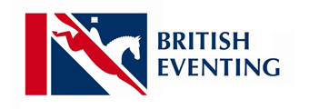
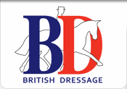

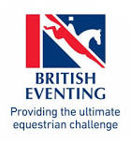
I LOVE these because they have the British Team colours but the horse describes the exact disciplines the sports entail.

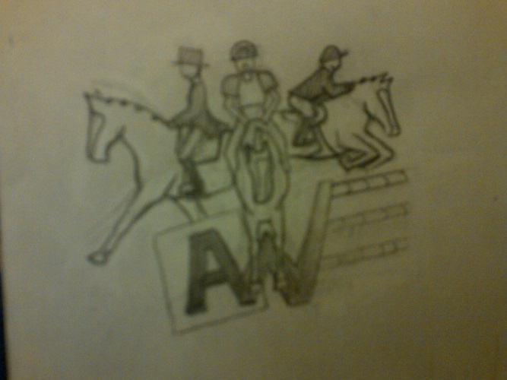

Maybe too complicated but provides dressage, show jumping and cross country references within the name. Would write the name/website underneath.

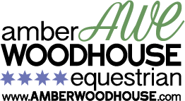


My current logos. 4* is the highest level of eventing, but I now want to expand to all the disciplines/all round horsemanship so 4 stars wouldn’t be relevant now (as opposed to 5 if stars were used at all). I have this design with the black writing in white as well.
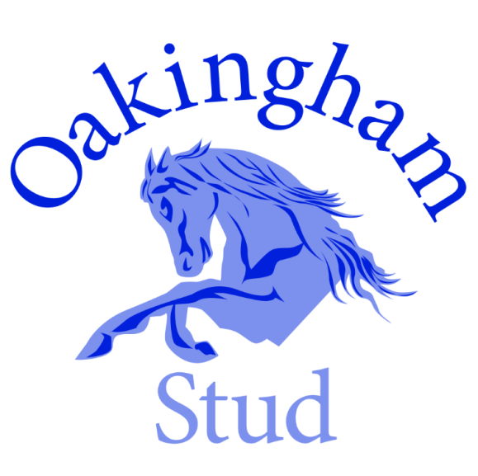

I love the simplicity of this and how it can be applied to all areas of the relevant business (breeding and competing high level horses).

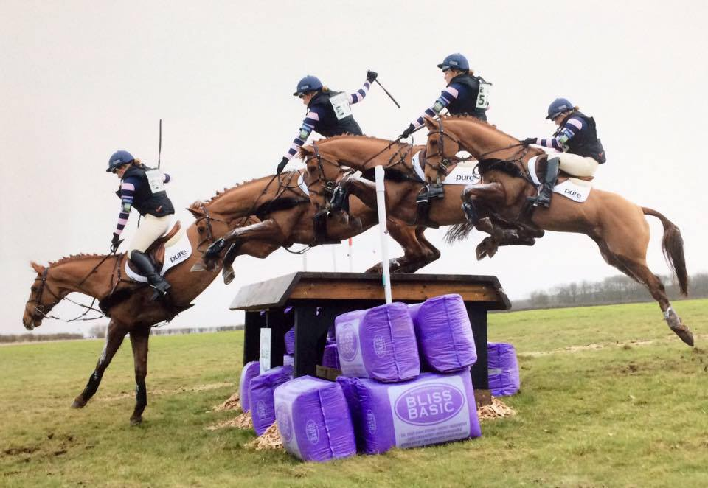
As an idea for the ‘story’ of foal to full grown, I think it would be interesting to have a logo similar to the way this photo is edited.
Foal > person patting horse > DR > SJ > XC > Medal/Star/Cup etc but that might be too complicated.

As a personal preference, I would like the horse/story to be facing/going left to right.

