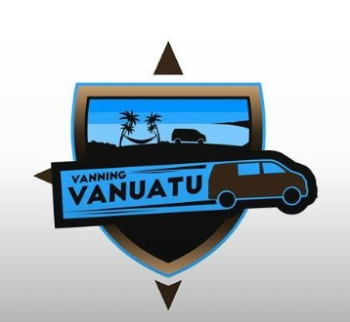

These designs have many elements I’m looking for and are some of my faves! For the 1st one- Instead of a shield design- I thought maybe it could be vacation images- like photos- inside of a camera lens. Instead of a van, maybe an airplane somewhere, and a train separating destination imagery. My logo could be on the strap of the camera. Just a thought- I’m also interested to see what your take on it is! I love the colors in the other 2 and how much the images portray!
My website: www.makeamemorytravel.net
MY FB: www.facebook.com/makeamemorytravel/ Also on Google +

