[Bikes Welcome – flier for business owners]

[FRONT of flier]

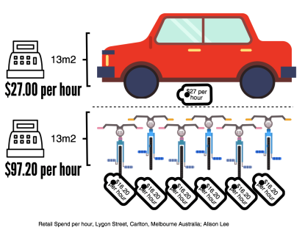
Spend per park

Why make biking customers – and their $$$ – welcome at your business?

[BACK of flier]

Why welcome bikes?

- Biking customers spend $$$ where parking’s easy.
- They spend $$$ locally as they must carry what they buy.
- Biking customers move slower, so see what your business offers.
- They tell friends where’s good to park and shop, where they feel welcome.
- You’re helping people be environmentally, budget and heart friendly – and they’llyou for it.

A Melbourne study showed swapping a car park for six bike parks could increase the space’s retail spend from $27 to $97.20 an hour.

Just think – every bike parked by someone else’s business could have been your customer.

See bikeswelcome.org.nz to see how you can become a bikes welcome business.

