



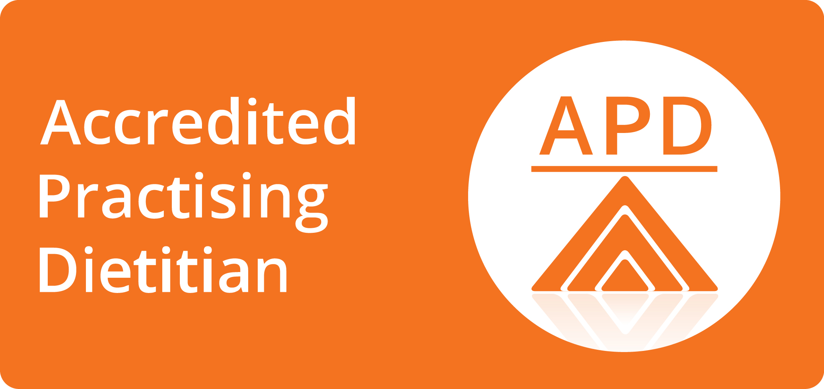





An Accredited Practising Dietitian can assist you with:
- Diabetes – Impaired Glucose Tolerance, Type 1 & 2 Diabetes, Gestational Diabetes
- Digestive Health – Irritable Bowel Syndrome, Coeliac Disease, Diverticular Disease
- Gastric banding and other surgical methods of weight loss
- Cardiovascular - High cholesterol, High Blood Pressure, Risk Reduction
- Weight Management – loss/gain and support
- General Healthy Eating & Nutrition
Stephen Hodgkinson
0419 838 674
stephen.h.nutrition@gmail.com

www.launcestondietitian.com.au
Fax: 6301 9228
Accredited Practising Dietitian & Chef
Helping you to meet your individual nutrition goals with an emphasis on practical skills, everyday foods, and providing you with up to date advice.

We work together to develop personalised eating plans that take into consideration your food preferences, health, work, family and lifestyle needs.

Accredited Practising Dietitians (APDs) are university trained experts in food and nutrition, they are able to translate the latest scientific evidence into sensible and practical advice. Dietitians differ from nutritionists as they have specific training in clinical environments such as hospitals. This training allows a dietitian to interpret blood tests, understand any food and medication interactions, and communicate with other health professionals involved in your care.
Seeing a dietitian for the first time involves working with you to develop strategies and goals to improve your health. Follow up visits are recommended to monitor your progress and may include more measurements and new strategies to help YOU realise your goals. Every person is unique and I can provide motivation, support and advice to suit your individual circumstances and lifestyle.
Locations
Summerdale Medical Centre Prospect - Fridays
Mowbray Medical - Wednesdays
West Tamar Health Riverside – Thursdays
Scottsdale Doctors Surgery – Approximately every 4 weeks

Fees

Chronic Disease Management Plans
If your Doctor has referred you with a Chronic Disease Management Plan to assist in the ongoing management of your health condition you are eligible for a rebate of $52.95 from Medicare.

All Fees are payable on the day
Private Patients
Initial Consultation (60mins) $120
Follow up Consultation (30mins) $65

Private Health Funds
Rebates are available through most private health funds but rates vary depending on your level of cover. Check with your fund directly to find out more.
Payment is required on the day of your consultation. Either by cash, credit card or EFTPOS

