Oak Fine Wine Label Design brief

What does the organization do?
Oak Fine Wines Australia P/L is a well funded start up. We export Australian value wines to China. Our vision is Make quality Australian wines accessible and affordable to 2nd-4th tier Chinese cities’ market.
Company website www.oakfinewine.com
Who is our target market?
Oak Fine Wines are targeting middle class wine drinkers in 2nd-4th tier Chinese cities.
Who are the main competitors in the market?
Chinese Local wines, international wines such as French wines, Chilean wines… and other Australian wines in our market segment.
How are we different from our competitors?
Currently we are focusing on Western Australia boutique wineries products. Wine quality is our priority then is price. After first screen, we will put our selected wines to our focus group and let the end consumers to make the final decision by blind tasting and score card. Therefore we will procure wines with the best value which fit into our target market in the same time.
Why we seek design service?
We are developing our own brands by labelling wineries naked bottles. We want to establish below ranges:
Bronze:- contain 2 reds
Silver:-contain 3 reds, 1 whites
Gold:- contain 3 reds, 1 whites
Platinum:-contain 2 reds
So we will launch 12 labels in 4 ranges in the next 2 years.

What is the scope of the project?
At this stage, we will decide 2 brand names for our Bronze and Silver ranges. And we have 2 product lines are releasing in this Jun in China – one Bronze red and one Silver red
Bronze red 1:
Name: Manna (the wines we find is manna, it’s even a once off edition as we may not be able to find wines with same quality and same friendly price in the future)
Vintage 2007
Grape Varieties: Merlot & Cabernet Sauvignon
Cap color: Black
Retail Price: 20 AUD – 30 AUD
Bottle height 30.1cm，diameter：7cm，neck height：11.5 cm

Silver red 1:
Name: Moolawa, Ni or Kep yoonga (Western Australia aboriginal language)
Vintage 2008
Grape Varieties: Cabernet Sauvignon
Cap color: White
Retail Price: 35 AUD – 45 AUD
Bottle height 30.5cm，diameter：7cm，neck height：12 cm

What we want designer to present?
One Label template for each range (Bronze Silver Gold Platinum) – Brand Name, vintage, vineyard can be filled in. So 4 templates in total
1 label design for our Bronze red 1 (Manna)
1 label design for our Silver red 1 (Brand name to be confirmed)

So 1 Bronze label (Mana); 1 Silver Label ; 1 Gold template draft; 1 platinum template draft
Label requirements
- Importantly on all 4 label template ranges we would like some sort of common link
- We’d like something that at first glance is Australian (element, style or color…) but subconsciously connects to the Chinese. Demeanor bearing in mind the demographics targeted across the ranges. We would expect the designs and naming to becoming more formalized as they rise to platinum.
- Traditional Chinese like red, black, gold(yellow)
- Recommended label size: 85mm W 86mm L (open to discuss)
- Different style from an existing Australian brand ‘Yellow tail’ be conscious of animal elements
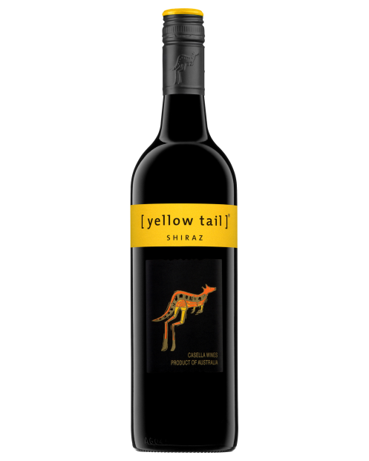
- The labels below were selected from our Chinese focus group which are between 25-30 years old, just want to give you some inspiration or sample
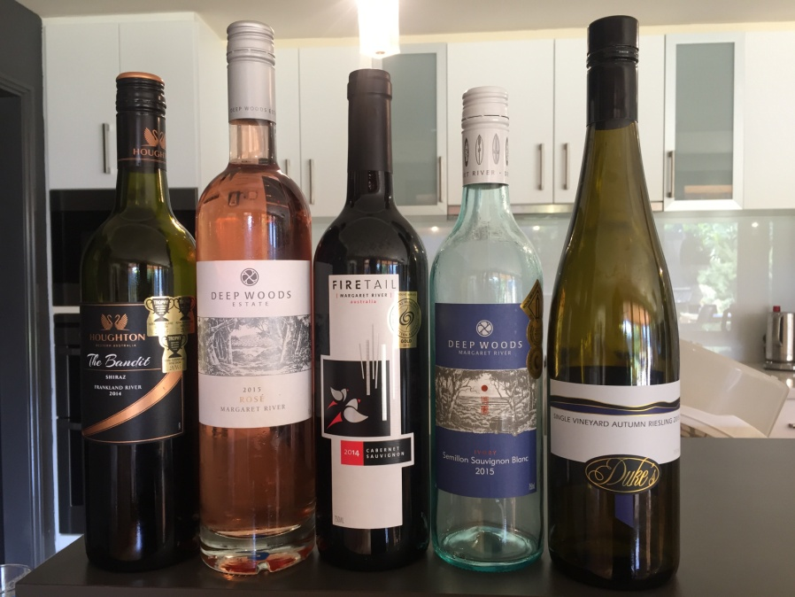

Project budget and continuing jobs:
- First stage: 2 templates and 2 label design – 800 AUD in Apr 17
- Another 10 labels – 200-300 per label from Jul 17 to Apr 19
- Potential banner, brochure and marketing material design
- Potential logo design
- Potential company branding service

