Skipper Smart

 | - PROFESSIONAL PRACTICAL BOAT TRAINING ON ONE OUR NEW STABICRAFT 1850 WITH ALL THE LATEST GARMIN EQUIPMENT AND ENJOY A LEARNING FUN DAY ON THE WATER.  - HAVE YOU SUFFICIENT SKILLS TO NEGOITATE OUR BUSY WATERWAYS, WHO HAS RIGHT OF WAY.  - WHICH WHARF IS SAFE TO COME ALONG SIDE, ARE YOU CONFIDENT TO DO SO, CAN YOU BACK A TRAILER AT THE RAMP SAFELY.  - DO I FEEL CONFIDENT TO TAKE MY FRIENDS & FAMILY OUT?  A NEW BOAT FROM THE DEALER? NEED TO PICK IT UP???

  - Skipper Smart – Safer practical boating
- WE ALL KNOW THAT THE TIME ALLOWED FOR PRACTICAL TRAINING FOR A BOAT/PWC LIC IS NOT SUFFICIENT TO ENABLE A SAFE & FUN DAY OUT ON THE WATER, AND PICKING UP A NEW BOAT SHOULD BE ENJOYED!
- BASIC OUTBOARD/INBOARD ENGINE CHECKS THAT ARE CRITICAL FOR SAFETY & YOUR WALLET! DO I NEED A MARINE RADIO??, CAN MY BOAT GO IN OPEN WATERS?
- A DAY OUT ON THE WATER SHOULD BE FUN & NOT STRESSFUL! LET US SHOW YOU HOW TO ENJOY YOUR NEW BOAT ON ICONIC SYDNEY HARBOUR, PORT HACKING /CRONULLA / BOTANY BAY /GEORGES RIVER, OR EVEN BATEMANS BAY.

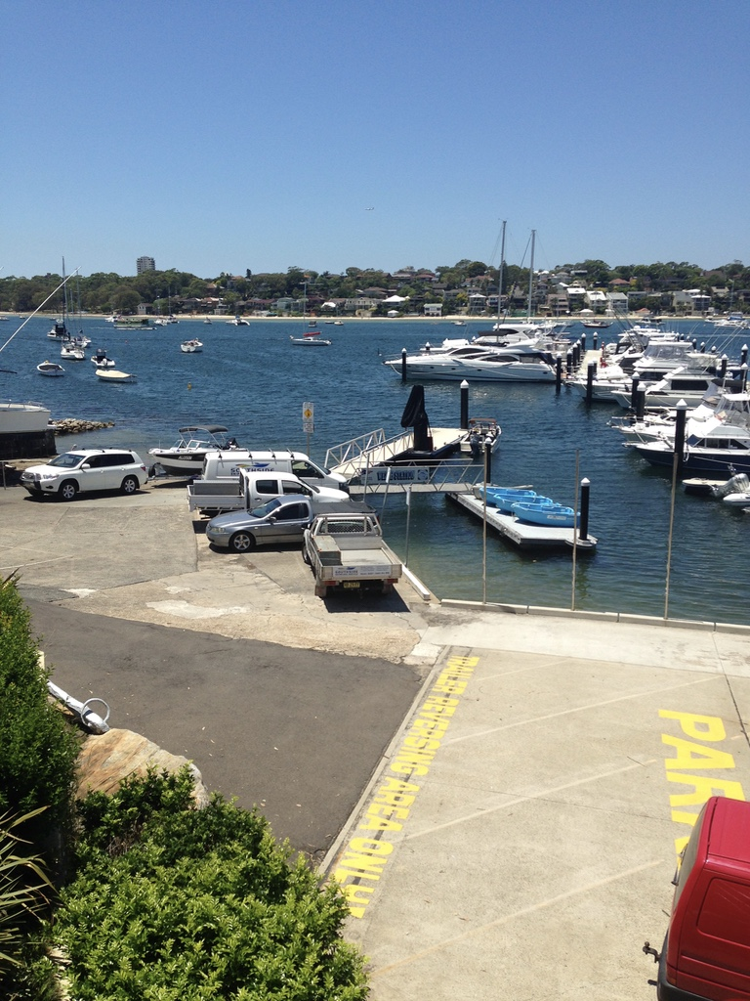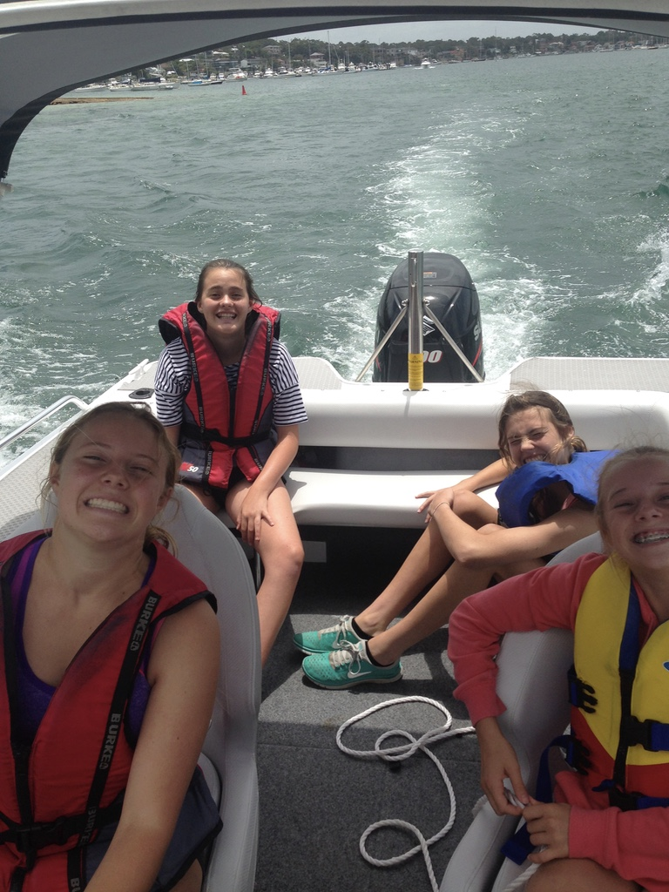

BOAT RAMPS, HOW TO BACK A TRAILER IN, GETTING THE BOAT READY TO LAUNCH,
- ARE YOU COMPETENT WITH DRIVING ON & OFF THE WHARF OR JETTY? GOT ALL YOUR CHECKLISTS COMPLETED BEFORE YOU GET THERE, COMPLETED YOUR SAFETY CHECKS,
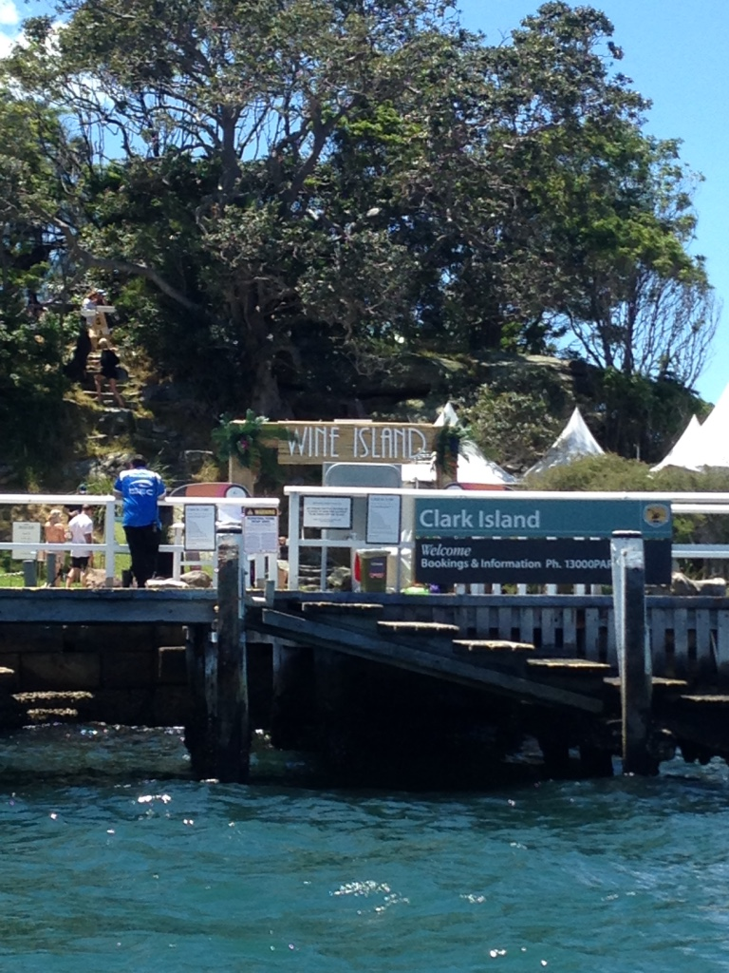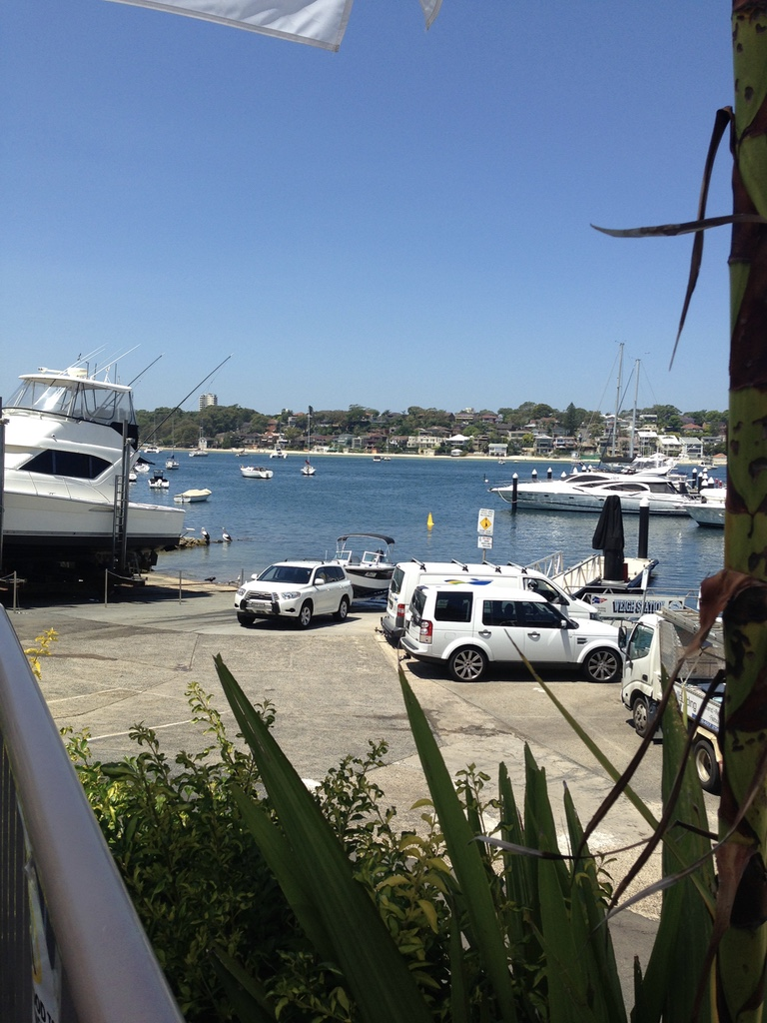

WHARF SKILLS, WHICH WHARF CAN I USE, WHERE CAN I ANCHOR, IS MY EQUIPMENT SUITABLE,
- WE HAVE ALL SEEN THE LEAP OF FAITH FROM THE BOAT TO THE WHARF WITH SOMEONE TRYING TO GRAB THE LINE IN THE WIND, ONLY TO MISS AND LOSE THE VESELL, NOT ONLY IS IT DANGEROUS, BUT COMPLETELY UNECESSARY, LET US SHOW YOU HOW TO GET THE BOAT SAFELY ALONGSIDE AND SECURED WITH EVERYONE SEATED.

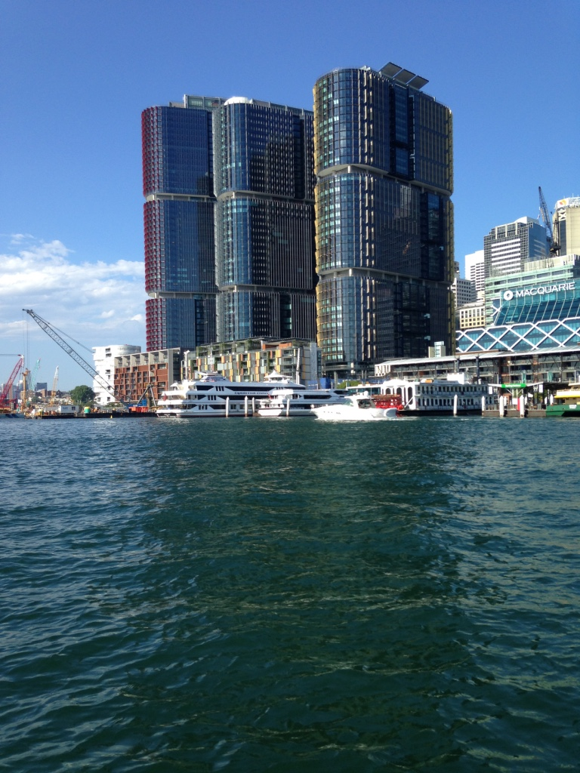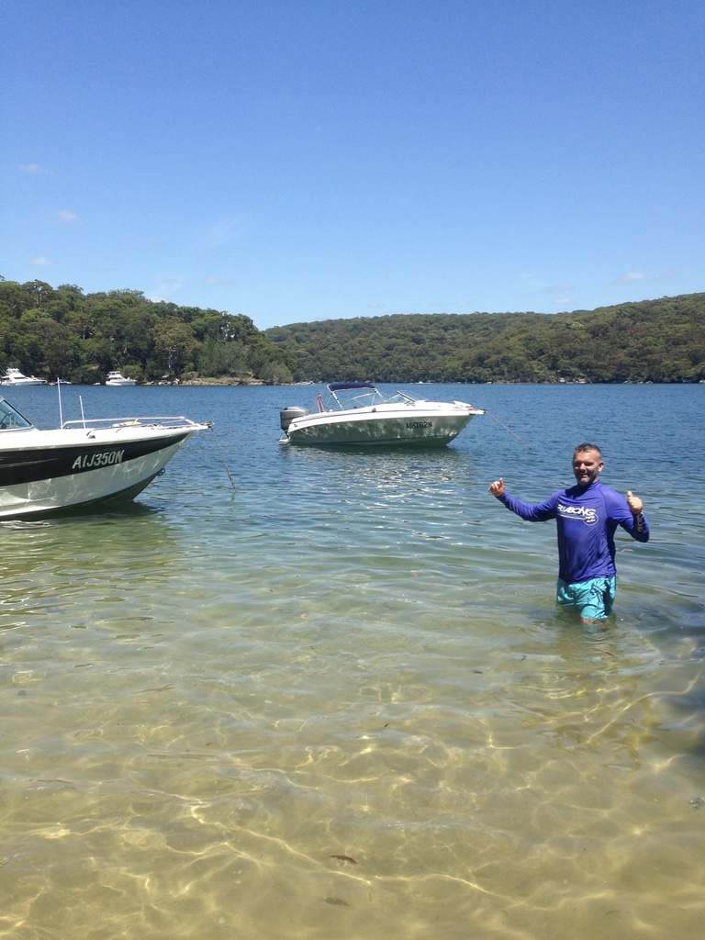

RULES OF THE WATER, HOW DO I USE A COMPASS?
- WHICH IS UPSTREAM / DOWNSTREAM, WHICH WAY DO I TURN, HAVE YOU BEEN CONFUSED WITH WHO GIVES WAY AND WHY, HOW FAST CAN I GO, WHICH WAY WILL I TURN, HOW DO I GET TO DARLING HARBOUR & FISH MARKETS, WHAT ABOUT MANLY, OR JIBBON BEACH CRONULLA?
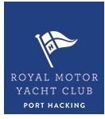

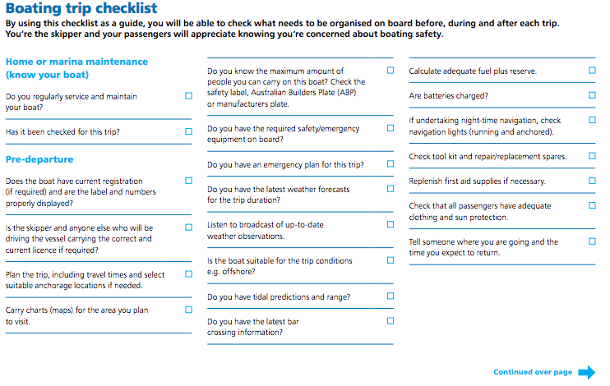

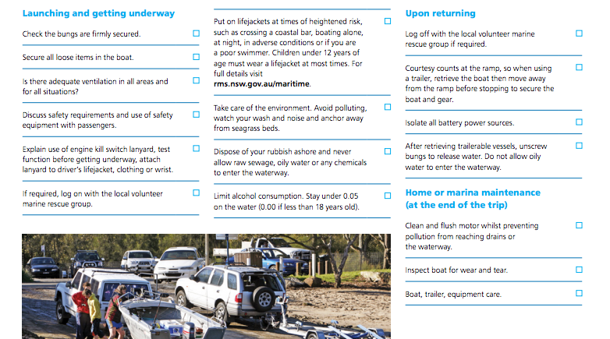

- A DAY OUT IS A LITTLE AS $90!! PLUS,
- *MIN 2 PERSONS,2 hrs., PACKAGES TO SUIT ALL BUDGETS! MARINE SAFE SKIPPERS ARE AMSA APPROVED PROFESSIONALS
- WE USE AND RECOMMEND VESSELS.
Remember , you’re the Skipper, your’e responsible!!!, which means it is up to you to ensure you have sufficient skills to safely navigate our waterways and look after your family and other waterway users at the same time
Clearly, having a new boat licence does not mean you will up to speed on practical boat handling skills and confidence, unlike a car, the are no ABS or traction control features, nor brakes on a vessel, so having a sound understanding of the dynamics and handling characteristics will put you in good standing to look after your family and others
Are you picking up a boat from the dealer for the first time??, let us take care of getting you in the water and properly set up from the beginning, from which ropes, fenders, mooring lines and safety gear is appropriate for your boat and family

RMS Checklist courtesy of Roads & Maritime NSW

