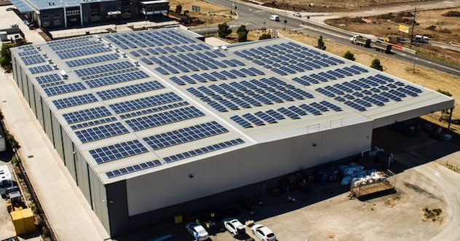



Design & Support Services

Schedule Of Rates
Grid and Off Grid 5kW – 10MW

P: 03 8524 5890 M: 0478 545 245
E: sales@blackbirdgroup.com.au
W: www.blackbirdgroup.com.au
Services – Professional Panel Layout
- We can layout the panels for a small fee
- Clear & Concise
- Ranging from 5kW – 300kW

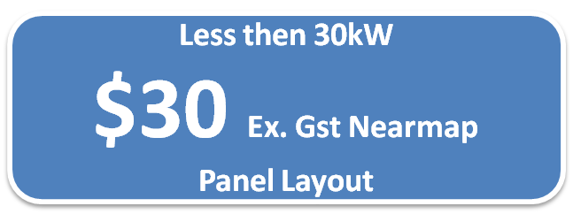


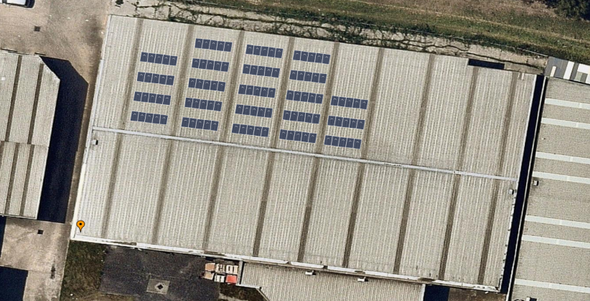


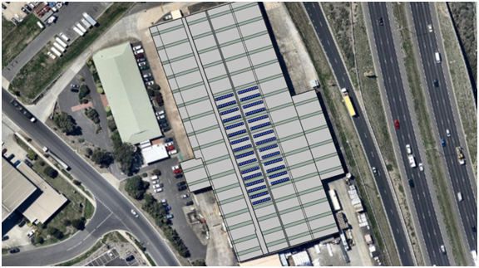

Grid Connection Services 30kW – 150kW

Powercor, United Energy
Service |  | Rates
Network Application & Case Management | AC schematic | $670
Network Application & Case Management | Site plan | $670
Network Application & Case Management | Voltage rise study | $670
Network Application & Case Management | Completed paperwork | $670
Network Application & Case Management | Case Management to approval | $670

Ausnet, Ausgrid
Service |  | Rates
Network Application & Case Management | AC schematic | $980
Network Application & Case Management | Site plan | $980
Network Application & Case Management | Voltage rise study | $980
Network Application & Case Management | Completed paperwork | $980
Network Application & Case Management | Case Management to approval | $980
Onsite Commissioning | Injection testing & report | $1350

Jemena
Service |  | Rates
Network Application & Case Management | AC schematic | $1820
Network Application & Case Management | PVsyst & load profile study | $1820
Network Application & Case Management | Site plan | $1820
Network Application & Case Management | Voltage rise study | $1820
Network Application & Case Management | Protection grading study | $1820
Network Application & Case Management | Technical report | $1820
Network Application & Case Management | Completed paperwork | $1820
Network Application & Case Management | Case Management to approval | $1820
Onsite Commissioning | Injection testing & report | $1350

SA Power
Service |  | Rates
Network Application & Case Management | AC schematic | $790
Network Application & Case Management | Site plan | $790
Network Application & Case Management | Voltage rise study | $790
Network Application & Case Management | Completed paperwork | $790
Network Application & Case Management | Case Management to approval | $790
Onsite Commissioning | Commissioning Plan for onsite witness testing | $550
Power quality measurement & injection testing (if required) |  | Case by case

Energex, Ergon
Service |  | Rates
AC design & Voltage rise study |  | $190
Network Application & Case Management | AC schematic | $2150
Network Application & Case Management | Site plan | $2150
Network Application & Case Management | Voltage rise study | $2150
Network Application & Case Management | Protection grading study | $2150
Network Application & Case Management | Technical report | $2150
Network Application & Case Management | Completed paperwork | $2150
Network Application & Case Management | Case Management to approval | $2150
Network Application & Case Management | RPEQ certification of design | $2150

NT Power & Water
Service |  | Rates
Network Application & Case Management | Preliminary Enquiry | $1400
Network Application & Case Management | Site plan | $1400
Network Application & Case Management | Voltage rise study | $1400
Network Application & Case Management | PVsyst simulation & load profile study | $1400
Network Application & Case Management | Completed paperwork | $1400
Network Application & Case Management | Case Management to approval | $1400

Western Power
Service |  | Rates
Network Application & Case Management | Preliminary Enquiry | $4200
Network Application & Case Management | Site plan | $4200
Network Application & Case Management | Voltage rise study | $4200
Network Application & Case Management | Equipment schedule | $4200
Network Application & Case Management | Protection grading study | $4200
Network Application & Case Management | PVsyst simulation & load profile study | $4200
Network Application & Case Management | Completed paperwork | $4200
Network Application & Case Management | Case Management to approval | $4200
Network Application & Case Management | NPER certification | $4200
Onsite Commissioning | Injection testing & report  Power quality monitoring | $3600

PVSyst / Interval Data

PvSyst Report - $130 Ex Gst
PVSyst is the industry leading PV performance simulation software globally. This program provides an highly accurate annual PV production report to assist financial forecasting, system optimization, performance warranties, etc. Our PV engineers can provide an accurate, tailored PVSyst report for your solar project as required.
If 3D shading loss is required in the report, please contact us for a tailored quotation.
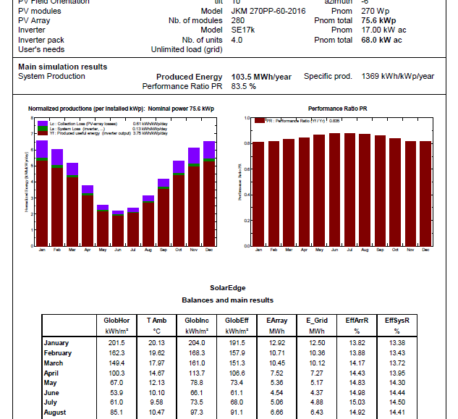

Interval Data Analysis - $230 Ex Gst
Interval data analysis is becoming an increasingly important tool for commercial and utility scale solar design, helping to determine optimum PV system size, storage sizing, financial forecasts and grid integration. We are able to combine PVSyst production data with your clients load interval data. This is usually provided in 60 minute intervals for a calendar year along with graphical representations.
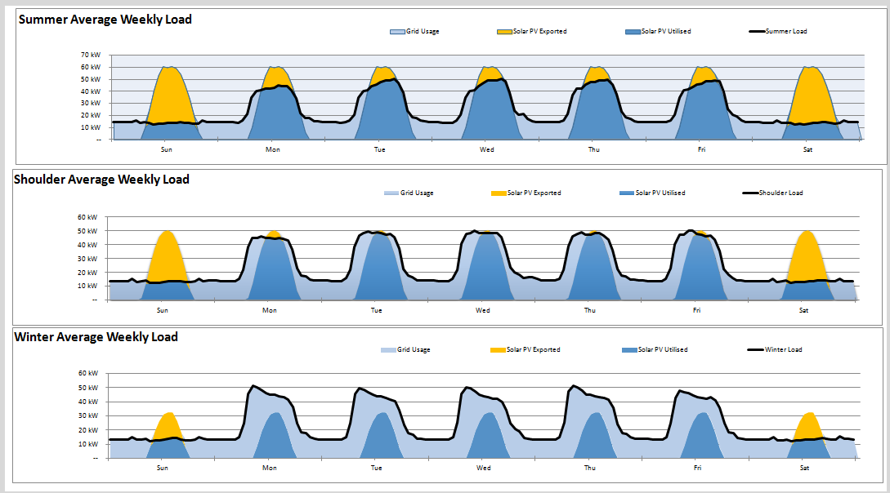
Shading Modeling

Shading Report - $380 - $1500 Ex Gst (Case by Case)
Of course, nearby shading obstacles can ruin any performance estimate unless they are accounted for. We can integrate a 3D shading analysis with your PVSyst report or drawing, helping to provide you with the most accurate performance modeling currently available. This service also assists in system design optimisation, e.g. selecting DC optimized vs standard PV modules.

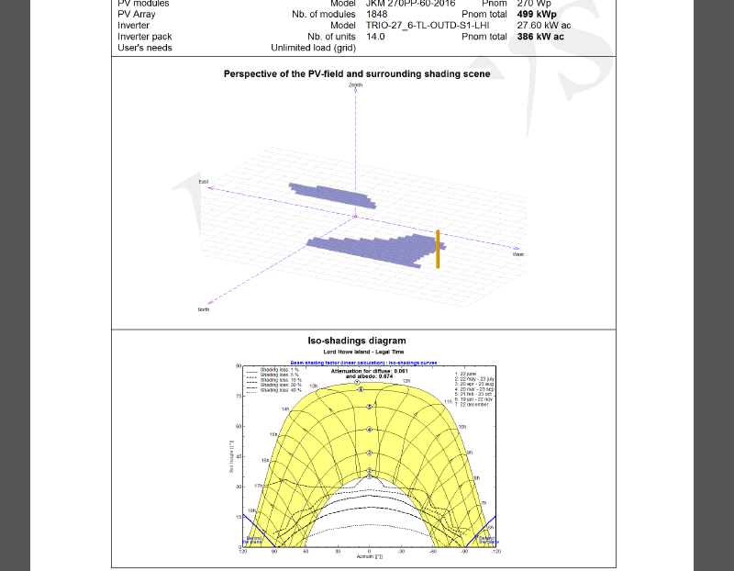

Design Process
Data Analysis

Design Stage

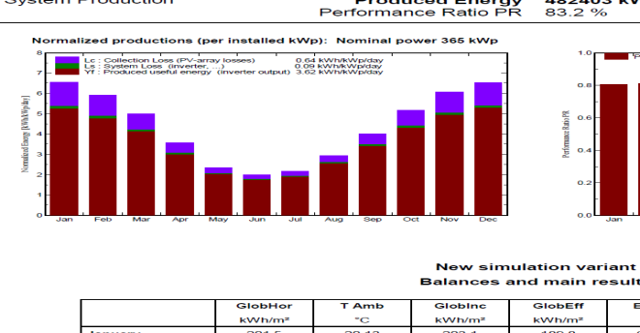

Grid Services Above 150kW
Our in house team has experience in design and delivery of multiple large scale PV projects including rooftop, ground mounted, LV, HV systems. Systems above 150kW often require more complex integration such as PFC, load shedding, communications integration etc. We are experienced and equipped to meet these needs.
Please contact us to discuss your project requirements

Protection Relay Board
If your system requires a custom design Grid Protection Relay Board, we can help.
Please contact us to discuss your project requirements.

Off Grid / Batteries
As well as working with industry leading brands and partners, our accredited engineers can assist you in your project specific storage design requirements.
Please contact us to discuss your project requirements.

About Us
Our team of renewable energy experts specialise in project development, feasibility studies, system design and delivery. We have successfully delivered over 40MW of commercial and utility renewable energy systems; our team has proven capability in this space.
With our in-house team of engineers, designers, and business analysts, the New Phase Energy team has the expertise and dedication to provide your business with a superior design solution.
We utilize our real-life experience, industry leading software and trusted industry partners to provide an optimum and cost effective energy solution for our customers.
Some of the key services we offer in this area are:
- Grid tied and off-grid renewable energy design.
- Battery Storage design and integration.
- Energy data analysis and modelling
- DNSP and other relevant approvals
- Electrical Installation Design

