Belltown Power Texas works with
Property owners and local communities
on renewable energy projects that support
clean energy generation

Why Solar?

Environmentally Sound - Secure and stable source of power with low environmental and global warming impact. Solar contributes to making the world a better place to leave for our children.
Significant Efficiency Gains - Continued improvements in efficiency and cost declines continue to make solar a competitive source of power.
Great Match with Demand - Solar matches peak-time output with peak-time demand especially in Texas.
Leading Source of New Capacity - Solar installations increased by 100% in 2016 and ranked as the #1 source of new generation capacity at 39% of the total installed.
Positioned for Continued Growth - Total installed base of 42 GW with an expected 100GW of new installations by 2021.
Other Advantages - Solar land leases offer a very predictable revenue stream (more predicable than oil & gas or wind leases). Solar panels do not disrupt site lines, and they produce no noise.

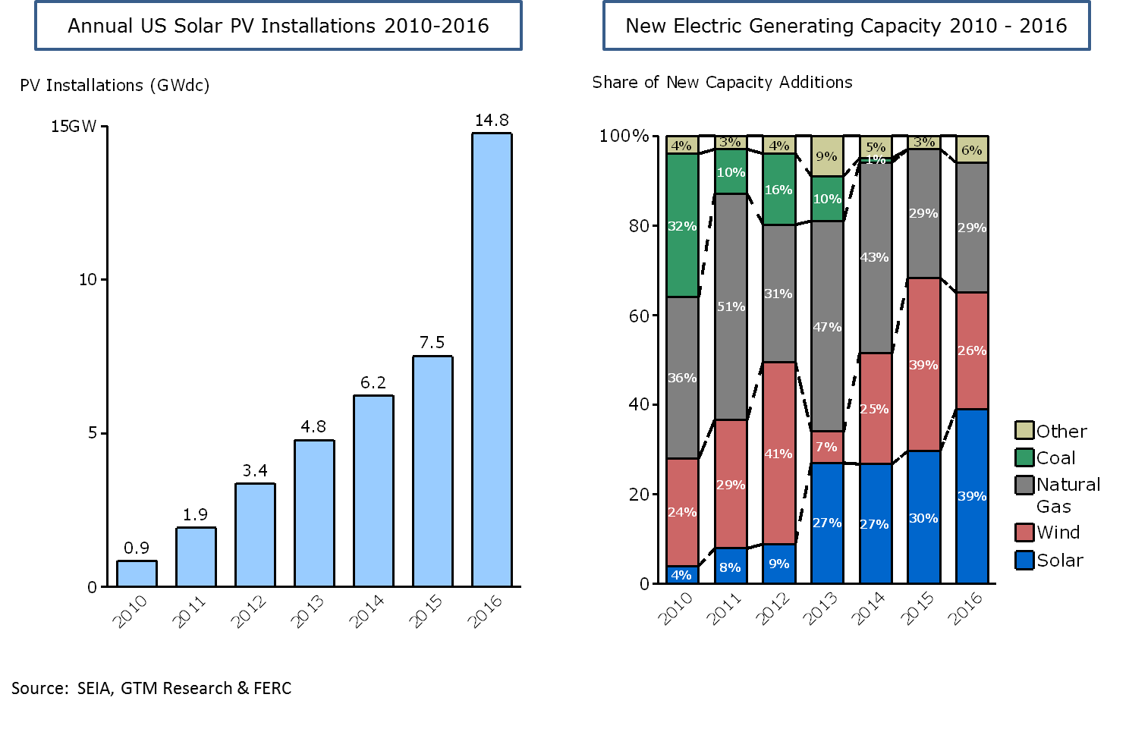

Benefits to Landowners

At Belltown Power Texas, our business is to develop and maintain utility scale solar projects that produce clean and predictable energy. These projects transform economically under-utilized land into a clean energy source that will meet Texas’ long-term energy needs. In return, your land asset will generate revenue to you through lease payments while converting your unutilized land into an asset capable of increasing property value with no capital outlay. We provide landowners with:
- A long-term, dependable revenue stream from lease payments. In many cases we have seen solar leases provide retirement income that allows for peace of mind and security. In some cases, we have even purchased property at a fair market value.

- The ability to preserve land ownership for future generations as solar farms creates no permanent impact on your land, and solar panels are easily decommissioned after their useful life

- The opportunity to generate higher returns per acre than alternative agriculture and hunting uses

Belltown Power Texas is committed to responsible and sustainable energy development. We work hard with our partners and communities to understand concerns and find solutions that address needs.

Is My Land Eligible?

Good solar site locations are evaluated on many criteria. First, a property must be in close proximity to the electric transmission grid. This would include electric substations or electric transmission lines. A site would also need to be relatively flat, mostly located out of a flood plain and predominantly cleared of heavily treed areas. Another factor we consider is access to the property via a well-constructed road. Belltown Power Texas is looking for landowners with 100+ acres of land that demonstrates the criteria above.

Solar Development Process

Solar leases aren’t overly complicated. Essentially Belltown Power Texas would become a tenant on your property. The benefit for us is we can develop and construct a solar farm that produces clean, renewable energy that we sell to an end user. The benefit to you is the rent you collect for the use of your land. Belltown Power Texas covers all expenses associated with the installation, inspections, permitting, connection fees, metering costs and maintenance. In return, the landowner enters in to a 30-year lease agreement with us. The lease may have an option to renew for specific periods. The systems are not dangerous to your land and will not impact the overall esthetics of your property.

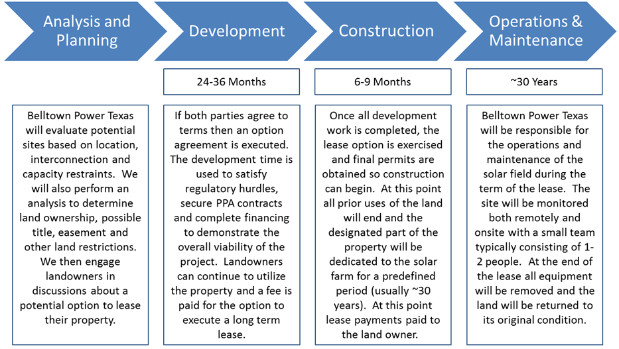

Who We Are…….
Belltown Power Texas was established in November 2016 by Texas natives Jeff Clay and Lloyd Pope in partnership with Belltown Power Limited, to develop renewable energy assets in Texas. Belltown Power Limited, was founded in 2013, has over 25 professionals and has invested over $500M to develop 22 sites with over 220MW of solar, wind and hydro assets. Belltown Power Texas is targeting the development of 6-8 sites and 500MW of utility scale solar in the next 3-4 years. Belltown Power Texas is headquartered in Dallas, Texas with Jeff serving as the President and Lloyd serving as the COO. The company is actively developing several sites in Texas.
If you are ready to learn more about Belltown Power Texas and explore the opportunity for your land to provide a dependable revenue stream, then contact us today for a member of our team to evaluate your property.

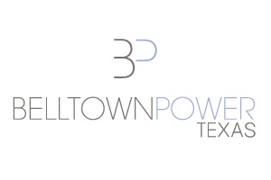
Belltown Power Texas, LLC
17217 Waterview Parkway, #102
Dallas, TX 75252
(972) 656-9150

Jeff Clay, President, jclay@belltownpower.com
Lloyd Pope, Chief Operating Officer, lpope@belltownpower.com
website: www.belltownpowertexas.com

Landowner FAQ

How long does the option period last and what am I required to do?
In most cases the option period is 2-3 years. This time is needed to allow Belltown Power to complete all required permitting, environmental and other transmission related studies. The property owner has control of the property during this timeframe and can continue to utilize the property as they see fit. Belltown Power will need occasional access to the property to conduct some studies that are need to fully develop the property.

What if I already have lease agreements for agriculture or hunting use?
Given the length of the option period and the time we need to fully get the site ready for construction we have been able to provide sufficient notice to landowners and current lessees allowing them the needed time to complete.

How am I paid for the lease?
The payments will all be addressed in the original option documents. We are open to different structures, but typically an initial payment is paid to the land owner upon execution of the option agreement. The agreement will outline any option extensions and what payments the landowner will receive. Additionally, the agreement will address all future rent payments to be made during the construction and operation periods.

Will the facility be fenced and what access will the landowner have?
The land utilized for the solar farm will be fenced off for security, liability and safety reasons. Once construction has started the landowner will not have access to the property unless coordinated with Belltown Power.

Are there negative impacts to the land?
Solar farms are very low impact projects to the environment and land. Typically, access roads will be built on the property, but no hazardous materials are used in the construction of the solar project. Solar farms also produce no noise or air pollution. Once construction is completed there is also limited traffic and employment needed on the site to maintain the operations. Solar farms are also easy to decommission at the end of the lease and your property will be returned to its existing state.

What happens to my property taxes?
Belltown Power will typically assume all responsibility for any changes in taxation.

