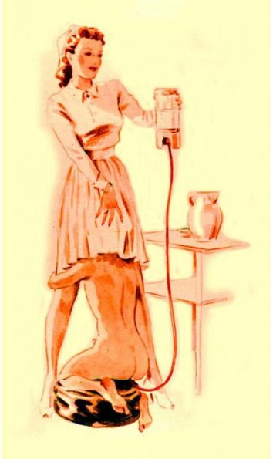
Richard Hegemann

Irresistible Orgasms™; java enema and others reveal their erotic benefits!

Seemore Butts
Enema Enthusiast
Introduction
This book features two stories; one introduces and explains the use of enemas to achieve sexual benefits; the second was an internal struggle to hide Seemore Butts’ klismaphilia. Irresistible Orgasms™ describes myriad aspects of “liquid refreshment for the anus”™. Enema enjoyment happily emerges from shadows of misunderstanding to its’ rightful bedroom welcome. If you are willing to experiment, enemas can become an occasional or regular feature in your Irresistible Orgasms™ (IOhz™).

Seemore’s goal is to talk about the subject of enemas with those already having intimate experiences, to consider the possibility of enema experimentation. Many have heard it promoted as a new erogenous zone for intimacy & satisfaction; the medical title for this behavior is “klismaphilia”.

Until recently, Seemore could NEVER have imagined writing these words for you. Sexual enema enjoyment was his secret hidden from EVERYONE, much as some hid their non-heterosexual preference. He has now decided to emerge from his shadows of fear to discuss a life featuring klismaphiliac activities. Decades of use have provided the experience, knowledge and confidence to talk with others and provide relationship suggestions. He is optimistic that you will discover enjoyment possibilities and topics for discussion, without his demons. Sexual activity using enemas has an equal role, with that of other adult toys, for satisfying adult entertainment.
Note: Though written from a male perspective, the orgasmic enjoyment from enemas works equally well with all genders and sexual preferences; the effects can be universally appreciated.

FYI: 10% of book sale net profits will be divided equally between two great non-profit organizations:
Heifer International https://www.heifer.org/
The Independence Fund http://independencefund.org/

Table of Contents

- The Author
- Reputation and Mechanics
- Ism’s and Enemas
- History through Art
- Accomplishing the Goal, Choices
- Ask Seemore Questions
- Research
- Linked Stories
- Erotic Supplies
- Stay in Touch
- Index

