Your builder and their supplier have partner together to offer you this special 10% discount on a wide variety of window blinds and shades along with other products to finish making your house your home. We offer faux wood blinds, roller shades, verticals, faux wood shutters, sliding panels and honey comb shades in a variety of colors and finishes.
Go to www.movingin101.com to shop for your home and during checkout enter your promo code DHI10 for your discount.

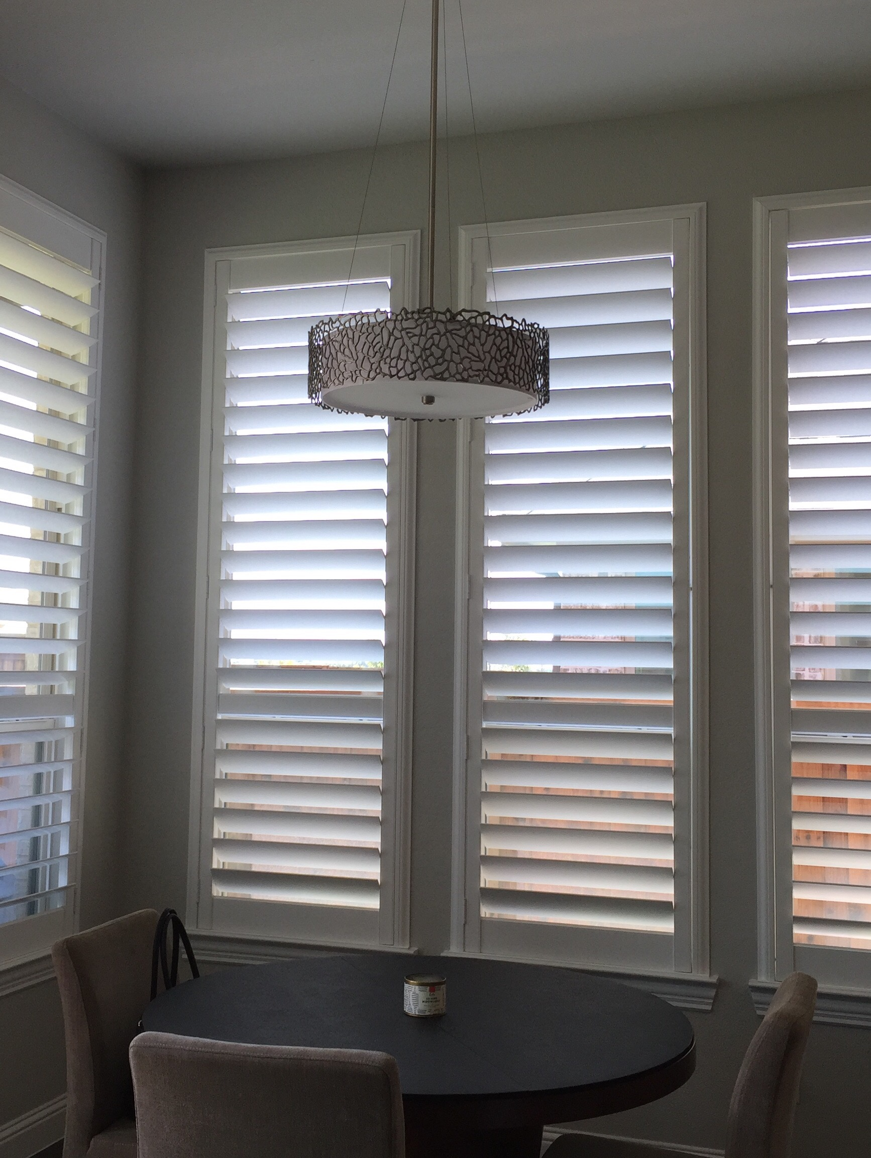visit us at: www.movingin101.com. Live chat available to answer any questions you might have

Phone: 801-210-1942

