
DID YOU KNOW?
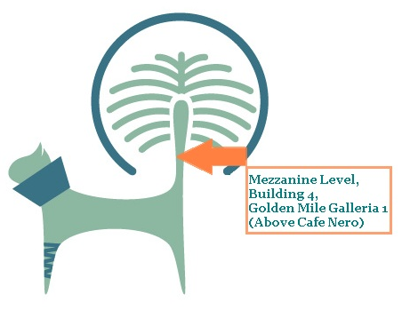
The Palm Jumeirah now has its own Veterinary Clinic
OPEN 7 DAYS A WEEK
SITUATED IN GOLDEN MILE GALLERIA

 @2F4PVetsThePalm
 @2feet4pawsvet
 @2f4pvetclinic
How To Contact Us?
Call: 800-2F4P-VET
Call: 04 442 8330
www.2feet4paws.ae
info@2feet4paws.ae

