1



Company Wide Branding Guidelines Version 2.0.2, January 2017

Brief

Table of Contents Introduction

Messaging 3
Color Pallete 4
Imagery 5
Iconography 6
Typography 7-8
Infographics 9
Contact Marketing if... 10
Hello. Thank you for taking the time to getting up to speed with what we want the DrFirst brand to feel. Branding helps diﬀerentiate companies from each other and helps people remember a company’s story. Think of it as: if you were to introduce DrFirst a person, how would you describe them?
As best as possible, we want to keep all of DrFirst’s products and materials to have a similiar feeling to it. That way, it feels like a cohesive experience from the user’s perspective. Also, so that viewers can tell all this material is coming from the same company.

Disclaimer

The guidelines in this document are to be taken as a starting point. If there is a reason to diverge from these guidelines, please do so. If you are unsure, please contact marketing.

2

Messaging

Adjectives
Innovation Pioneers

Professional Passionate Challengers Innovation Pioneers Physician Champions Bold but not loud
Designed with simplicity in mind Reliable
...even in Crisis
Reliable

Story

DrFirst was founded in 2000 as pioneers in software solutions and services that provide real-time access to patient medication data, improve care team collaboration, and help doctors engage better with patients in order to drive better health outcomes.

DrFirst was the ﬁrst company in the nation to have a certiﬁed EPCS solution, and laid the groundwork for electronic prescribing of controlled substances, several years before the DEA rule.


Dare for a brighter tomorrow
Champions
3

Color Pallete
Use Hex codes for digital materials; use Pantone names for printed materials.
Core Brand colors consists of mainly 3 colors, with a 4th to be used when an extra blue is needed. For more information on colors, go to: http://rgb.to/ and enter in a “#” followed by the Hex code.

Core Brand Colors

D . B l u e

M . O r a n g e

L . B l u e

M . B l u e

Hex #002855
RGB: 0, 40, 85
Pantone 2767 C
Hex #ef5523 RGB: 239, 85, 35
Pantone 7579 C
Hex #0082ca RGB: 0, 130, 202
Pantone 660 C
Hex #005cb9 RGB: 0, 92, 185
Pantone 2131 C

Supporting Colors

P u r p l e

D . G r e e n

L . G r e e n

L . O r a n g e

Y e l l o w

R e d

Hex #6e298d RGB: 110, 41, 141
Pantone 526 C
Hex #0c6c36 RGB: 12, 108, 54
Pantone 349 C
Hex #8dc63f RGB: 141, 198, 63
Pantone 368 C
Hex #f99d31 RGB: 249, 157, 49
Pantone 2011 C
Hex #fdbb30 RGB: 253, 187, 48
Pantone 7408 C
Hex #a6192e RGB: 166, 25, 46
Pantone 7427 C

Hex #2b54af
RGB: 43, 84, 175
Pantone 2367 C
Hex #00a39b
RGB: 0, 163, 155
Pantone 2401 C
Hex #949ca1 Hex #a0865f
RGB: 148, 156, 161 RGB: 160, 134, 95
Pantone Cool Grey 7 C Pantone 2325 C
4

C e r u l e a n

Te a l

S i l v e r

G o l d

Imagery

Flat and Bold

When creating vector images and infographics for a presentation, make sure there is strong contrast between elements and background. This emphasizes the ‘boldness’ of our brand’s messaging.
Avoid gradients and drop shadows.

“Diamond” Shape Pattern

If you take a square that is 75 px per side, the roundness of the edges is 12 px, and the stroke width is 2 pt.
12 px
75 px
56%
Drug overdose deaths
in New York have risen 56% since 1999

10% Silver Background with Dark Graphics

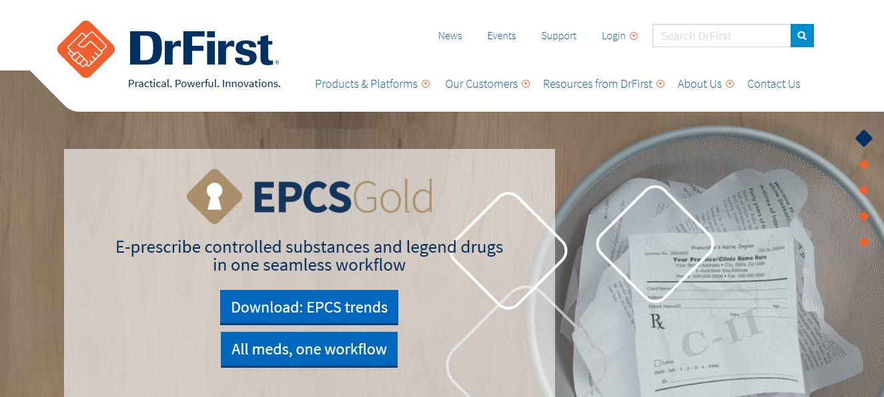
Thought Provoking Stock Images

Photos and pictures chosen for presentation should inspire some thought or question.
Avoid happy doctor pictures.

Transparency

Transparency should be used for the rectangle overlays over a stock image to help with text legibility. It should not be used over solid background colors.

Iconography

Font Awesome

All icons from DrFirst come from Font Awesome.
To get a full list of all the icons, go to http://fontawesome.io/cheatsheet/

♥

To use these icons in your designs:
- Be sure to have the font “FontAwesome” installed
  - MIS should have already installed this on your work computer
  - If not, you can install the font from: http://fontawesome.io/get-started/
- Copy and paste the icons (not the unicode) directly from this page into your designs
- Now highlight the icon you pasted, and change the font to be “FontAwesome”
- You can now manipulate that icon just like a normal font

Typography
Font Family: Source Sans
More Information: https://fonts.google.com/specimen/Source+Sans+Pro

Levels

Heading 1
Key Word(s) - Weight: Black, Size: 30 pt, Color: D. Blue Supporting Word(s) - Weight: Light, Size: 30 pt, Color: D. Blue
Example

Rcopia 4

Product Features

Heading 2
Weight: Light, 18 pt, Color: Black (#000)

Heading 3
Weight: Black, 14 pt, Color: Black (#000)

Heading 2 - Link
Weight: Light, 18 pt, Color: D. Orange

Robust Medication Management
Runt quia conectatem Nu essimo nos arbi pulabute, sendem ipte inatilicam ina, consule geripior aus. Ardr ertae ert.

Screenshots

Great Customer Support
Runt quia conectatem Nu essimo nos arbi pulabute, sendem ipte inatilicam ina, consule geripior aus.

Body Text
Weight: Regular, 12 pt, Color: 70% Black (#464646)
Read Reviews

Body Text - Link
Weight: Regular, 12 pt, Color: M. Blue

Contact Sales
Runt quia conectatem Nu essimo nos arbi pulabute, sendem ipte inatilicam ina, consule geripior ausIs delitia te.

Typography Cont’d

Paragraph Styling Bulleted Lists

Paragraphs should be left aligned, not justiﬁed No indent for the ﬁrst line of each new paragraph
Make sure lines do not hyphenate (as in, words should not split with some characters on the top line, and the rest on the second line)

Tone: Active Voice

Layout
  - Bullets should be solid circles
  - In Bulleted lists where phrases are short, put no period at the end
    - When indenting, this is how the bullets should line up
    - Do not indent more than this level (as in, only 2 levels of bullets allowed)
  - If there are multiple sentences in a bulleted list or if the sentence is long, do include punctuation marks at the end.
  - If short and single statement per bullet, do not include a punctuation mark at the end.

Keep captions and pictures together and on the same page

No orphan lines (such as the last sentence of a paragraph appearing at the top of the next page)

Infographics

Pre-Branding

" Uses visuals related to content,
)( No consistent font,
The PROBLEM: Addiction to prescription drugs and deaths from overdoses

6.2 million

)( No text heirachy,
)( Lack of spacing,
)( Background competing with content,
)( Transparency used over solid objects,
)( Diamond roundness
56%

Drug overdose deaths in New York have risen 56% since 1999

Nationwide, drug overdose was the leading cause of death from injury in 2012
53%

Most drug overdose deaths (53%) are caused by prescription drugs

Each month, 6.2 million American adults use prescription drugs non-medically

noticibly oﬀ,
)( Non-standard icons
Deaths from opioid pain reliever overdoses are four times
the rate of heroin and cocaine deaths combined and, as
a percentage of total prescription drug overdoses, are up: for women since 1999 for men since 1999
Each day, 46 Americans
die from an overdose of prescription painkillers

Branding Guidelines Followed

- Kept content the same as before
- Clear hierarchy,
The PROBLEM: Addiction to prescription drugs and deaths from overdoses

6.2 Million

- Bold look,
- Emphasis on key words,
- Simpliﬁed redundancies,
- Tell a story,
- Stronger DrFirst branding
56%

Drug overdose deaths in New York have risen 56% since 1999

Nationwide, drug overdose was the leading cause of death from injury in 2012
53%

Most drug overdose deaths (53%) are caused by prescription drugs

Each month, 6.2 million American adults use prescription drugs non-medically

Since 1999,
♀ ♂
Deaths from opioid pain reliever overdoses are four times the rate of heroin and cocaine deaths combined and, as
a percentage of total prescription drug overdoses, are up: for women for men
Now,
46 Americans
die from an overdose of prescription painkillers
per day


9

with Marketing if...
Work

- You are having an issue (such as size or scaling) a logo
- You are going to present something publically (also, ask Clinical if they need to review)
- To determine if what you are marketing is a feature or a product

End of Document

