Side ONE- OUTSIDE PANELS

RIGHT PANEL: Front Panel when folded (include Oswego Logo and DrFirst Logo):

Use the diamond shape and have an image representing medical community with dotted line leading to the network graphic on internal page

Invest in Our Region’s Legacy of an Interconnected Medical Community!

Join the Oswego Care Collaboration Initiative (OCCI)

“Be the change you want to see in the world.”

LEFT PANEL: Inside Single Panel when folded.

Header: Today in Healthcare…
- 80% of medical errors are due to communication issues*
  - Communication errors are the leading cause of death and severe injury*
- 70% of providers say secure, text-based messaging improves patient care*
  - Staff Efficiency and Productivity Increases
  - Clinical data is more accurate, robust, and accessible
  - Care transitions improve and readmissions plummet
  - Patients are Happier with their care
_{You Can Make an Impact!}
*Joint Commission

MIDDLE PANEL: Center Back Panel when folded

Header: Get Connected!
Learn more about how DrFirst, OCCI, and many other regional medical communities are building a new nationwide legacy of care collaboration at:
https://www.getconnected.drfirst.com/

“DrFirst gave us the tools to create a truly responsive and adaptive care collaboration network for our area hospitals, clinics, and pharmacies. We’re eager to see the benefits of a centralized communications and data sharing and our community’s overall health improve!” - Barry Ryle, CIO, Oswego

“There’s tremendous possibility here to dramatically impact population health. We’re proud to have worked alongside Oswego to create this powerful collaborative network, using our tools and their incredible initiative.” – G. Cameron Deemer, President, DrFirst

Oswego Logo
Your Community Liaison is ______________
Contact Information:

DrFirst Logo
Your Regional Tech Advisor is: Stu Ballatt
Email: sballatt@drfirst.com
Phone: 301-231-9510 x 2649

SIDE 2 (INSIDE PANELS)
Top of First Two panels on the open tri-fold spread GRAPHIC
Header: The OCCI Community Network

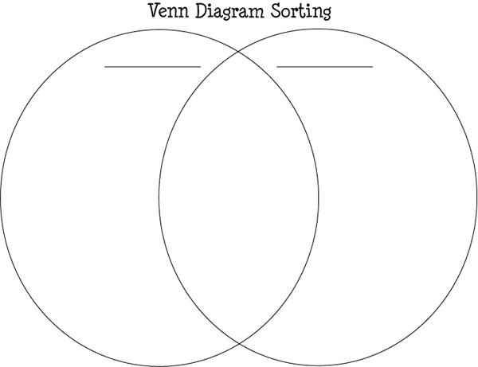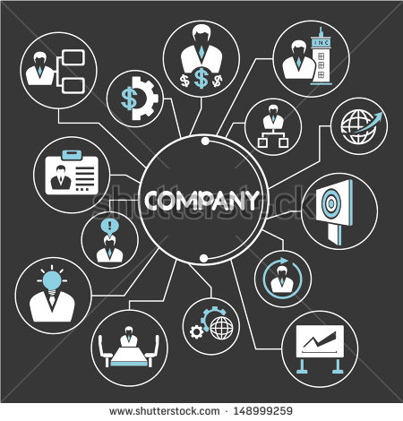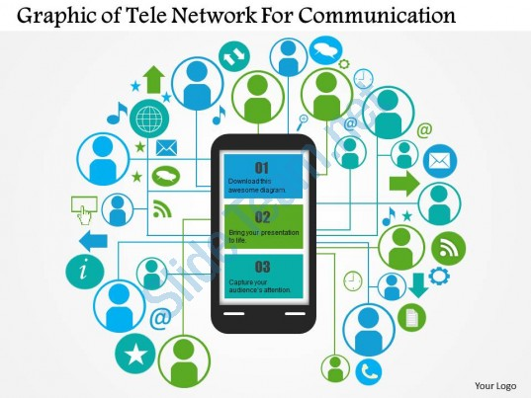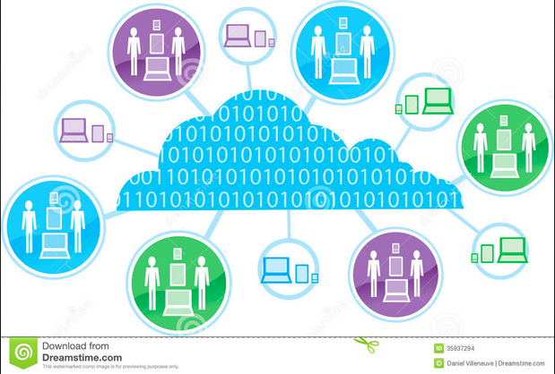

Create graphic that shows patient in the center with 2 bubbles (Backline: use icons X-rays, lab reports, video screenshot, chat text bubbles), and (Pills, Rx script, Medication History)

Surrounding this, there should be connection to images depicting with labels (see sample graphics for inspiration):
- Hospital
  - Hospitalist
  - Attending
- Providers
  - Specialists
  - PCP: Primary Care Providers
  - Nurses
- Rehab Facilities
- Pharmacy
- Dotted line connection from front page labeled “YOU”

INSIDE LEFT Panel
Below the graphic
Header: Bigger. Better. Stronger Together.

Everyone plays an integral role towards creating a well-informed and collaborative medical community. The greater the adoption of the DrFirst Backline secure communications, care collaboration and iPrescribe medication management tools across all Oswego County healthcare facilities, including our hospital and area practices and providers, clinics and pharmacies, the better and more useful the network becomes. We’re counting on your active adoption of these tools to continue our pursuit of increased community collaboration and enhanced patient care, patient safety, and patient outcomes.

INSIDE MIDDLE Panel
Below the graphic
Header: Anywhere. Anytime. Access to Critical Patient Data and People.

Backline and iPrescribe is available to clinicians and staff of Oswego Health and other healthcare facilities who serve our community’s patient population. These tools support our goal to provide our patients with top-notch care and giving care teams the real-time information you need, when you need it. Even in times of emergency or power loss, these two apps can be used over your cellular network and wifi so you have flexibility and uninterrupted access to connected members of our OCCI community!

INSIDE RIGHT Panel (FULL PANEL)
HEADER: Award Winning, Proven, and Reliable Tools at Your Fingertips
Being part of the OCCI Network gives you access to two mobile apps from DrFirst: (Should include screenshot of app on a phone.)

- iPrescribe®: Mobile e-prescribing app
- Write new/renewal e-prescriptions for legend drugs and controlled substances
- Check patient prescription benefits/costs
- Instantly view patient medication history
- Clinical alerts and decision support for adverse drug events and allergies

- Backline®: HIPAA-compliant communication and collaboration tool
- Secure text messaging:
  - Provider-to-provider: Referrals and consults
  - Provider-to-staff: Patient centered private or group discussions
  - Provider-to-pharmacy: Prescription clarifications and follow-ups
  - Provider- to-Patient: Engage directly with patients and their families securely
- Media and file sharing of clinical content
  - X-rays
  - Test and Lab results
  - Charts
  - Videos and more

