Please note, the below pictures are all submissions for another business from some very talented Design Crowd companies. They are here to help describe what we like, not meant to be copied. i.e the business is NOT ‘Norfolk Island Realty’.

In the below picture we loved the gorgeous contrast colours

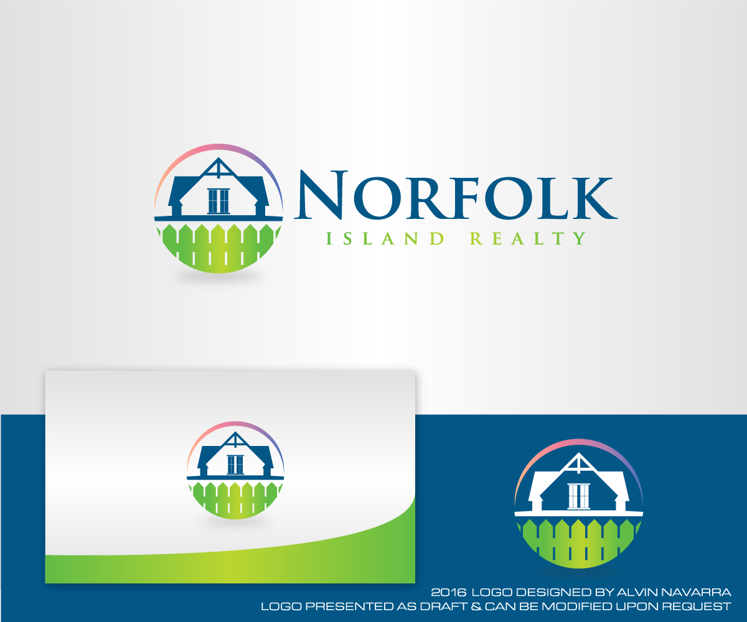

We like the simplicity and sophistication of the submissions below

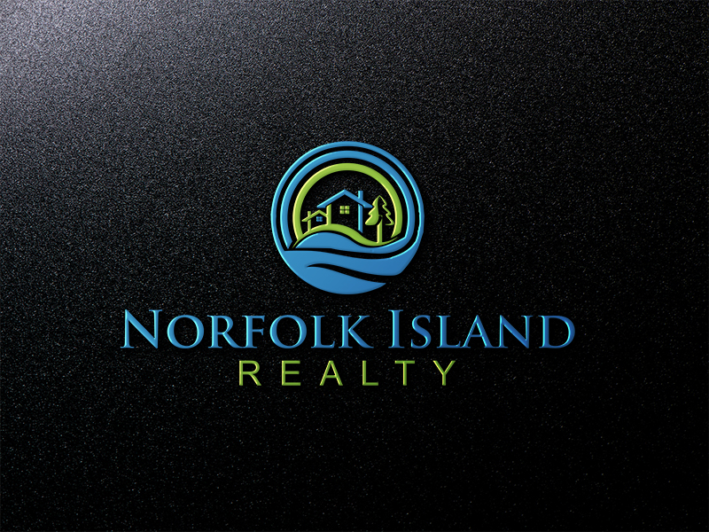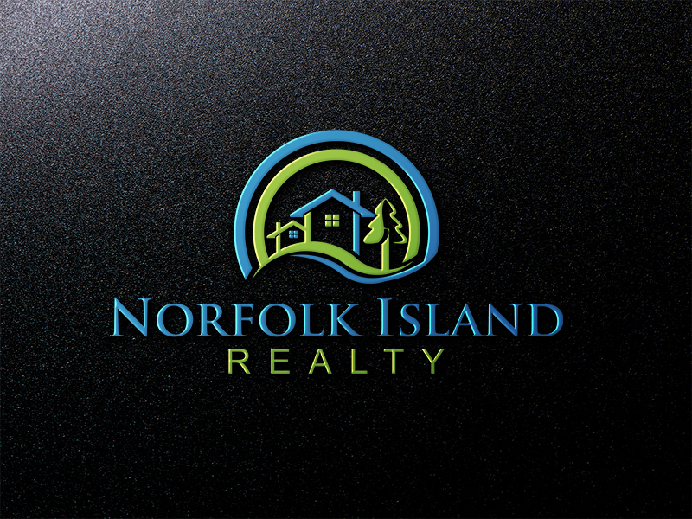

IDEALLY, the text “Shiralee” could be incorporated into the picture (eg. Above right, the text would form the bottom part of the circle) so the logo can be used and recognized with or without the words “Executive Cottages”

The stars could be incorporated within the circle (as literally stars in the sky) OR a line in between the wording as below, as Shiralee Cottages are officially rated 4-stars.

SHIRALEE
* * * *

EXECUTIVE COTTAGES

Thank you kindly, any questions welcome.

