BACK PAIN? SHOULDER PAIN? KNEE PAIN?

FREE SEMINAR
ON HOW TO STOP PAIN

RESERVATIONS REQUIRED. CALL 303-503-9344 TODAY
LIMITED SPACE SO DON’T WAIT TO SIGN UP

THURSDAY, APRIL 13th 7:30PM-9PM

- How to Get Out of Pain
- What to do When an Exercise Hurts
- How Exercise Helps Pain
- Q & A to Fine Extraordinary Health

KINETAFIT PERSONAL TRAINING STUDIO
50 N. Main St. Brighton, CO 80601

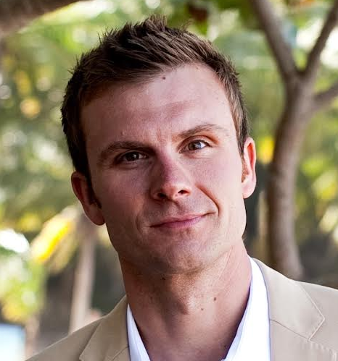 | 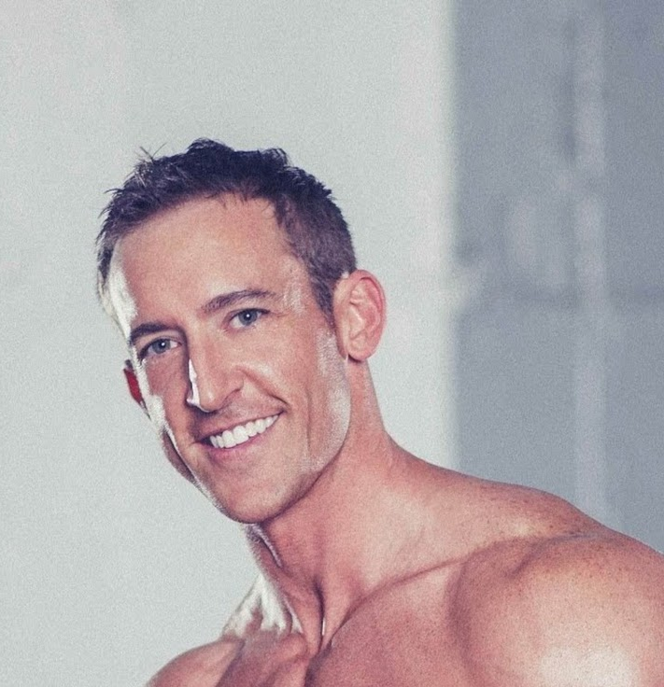
Adam Engel, PT, DPT, OCS | Ruston Webb, MS, CSCS, FMS

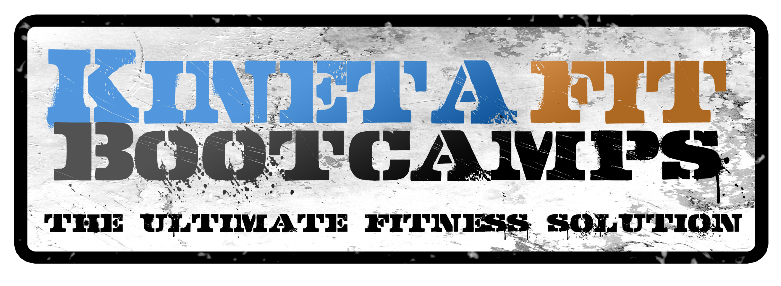
www.Kinetafit.com

