The Meat Box

Content:
- Shawarma description + pictures
- Seray description + pictures
- Requirement

The Meat Box Restaurant will offer 2 type of meals Shawarama and Seray.
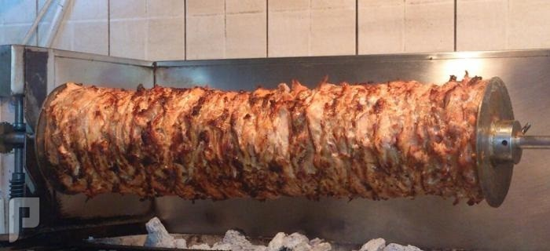
- Shawarma is a Levantine meat preparation, where lamb, chicken, turkey, beef, veal, buffalo meat, or mixed meats are placed on a spit, and may be grilled for as long as a day. Shavings are cut off the block of meat for serving, and the remainder of the block of meat is kept heated on the rotating spit. Shawarma can be served on a plate (generally with accompaniments), or as a sandwich or wrap. (The Meat Box restaurant will grill the shawarma by burning coal ) see below pictures.
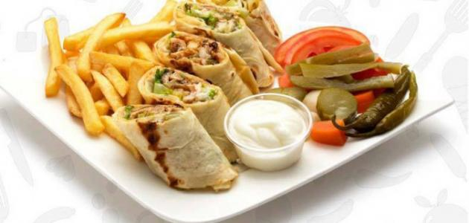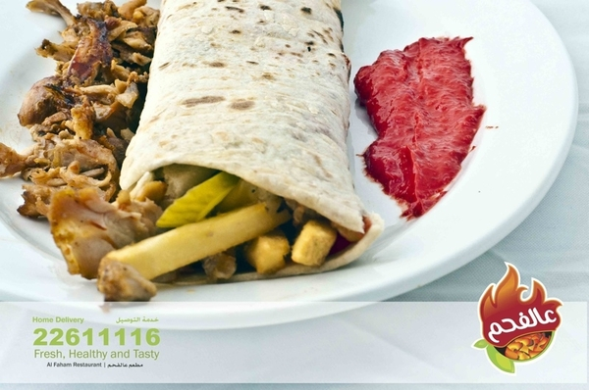
- Seray is a spicy shish kebab (skewered meat) which is a popular food item in West Africa. It is traditionally prepared by the Hausa people of northern Cameroon, Nigeria, Niger, and some parts of Sudan (where it is called agashe). Seray is generally made with skewered beef, ram, or chicken. Innards such as kidney, liver and tripe are also used. The thinly sliced meat is marinated in various spices which include peanut cake, salt, vegetable oil and other flavorings, and then barbecued. Seray is served with further helpings of dried pepper mixed with spices and sliced onions. Halal meat preparation methods are normally used, especially in the northern parts of Nigeria, where the suspicion of nonconformity to Muslim dietary prohibitions in Seray preparation has been known to cause riots. A dried version of Seray is called Kilishi.
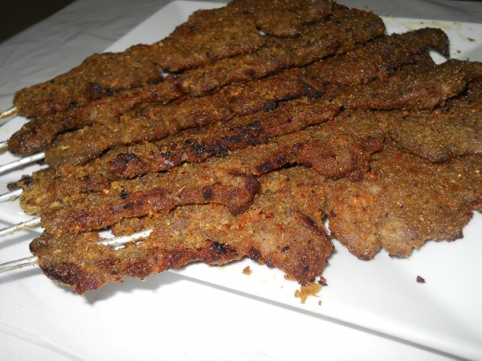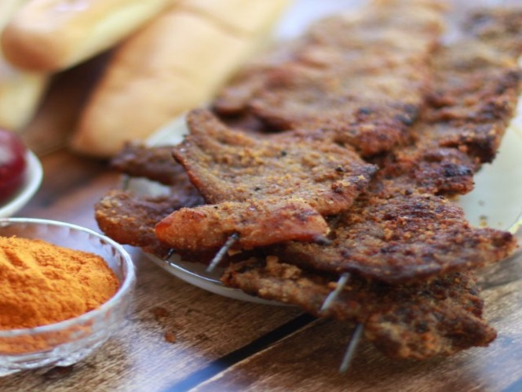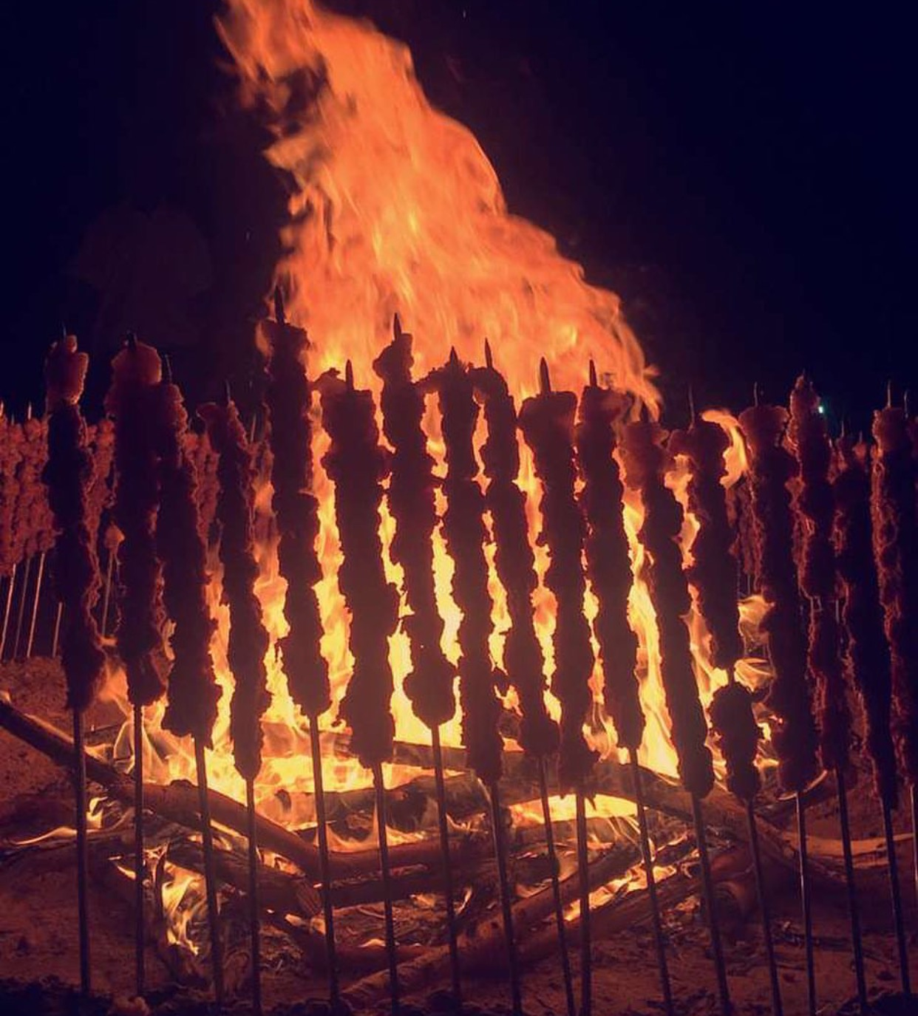
Requirement:
Is to create a distinctive logo for The Meat Box restaurant where the logo reflect the BOX shape and both meals (SHAWARAM & SERAY) in a way that the logo gives an equal value to both meals in customer eyes.

Be creative ….

