This is the current backside you have created:
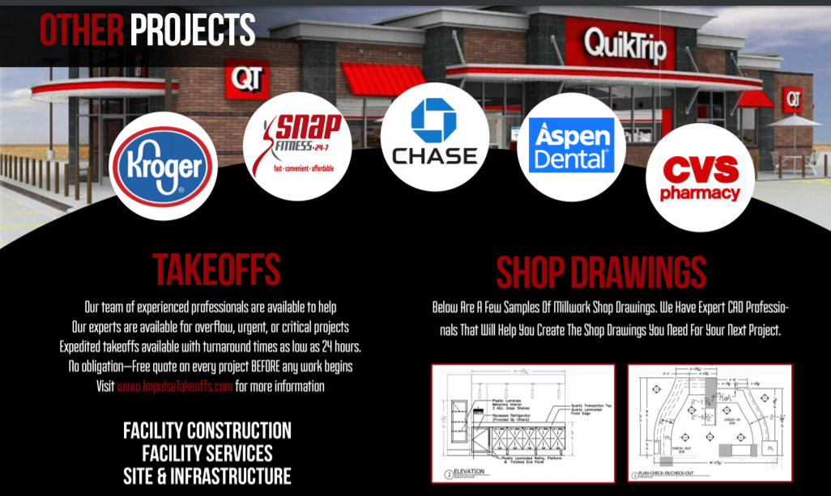

Change 1: remove “Takeoff Section” and replace with this:
Flooring Professionals

- Impulse Flooring LLC has been handling commercial flooring projects, small and large, since 2009.
- We have dozens of repeat customers showing our commitment to the success of every project
- We are CTI certified by the Ceramic Tile Education Foundation (CTEF)
- We are fully insured

Change 2: remove “Shop Drawings” section and replace with this:
QuikTrip
We have completed over 50 projects covering Georgia, North Carolina, and South Carolina including store 2.5 remodels, new 3.0 store designs, and even large Travel Center locations
