Front:
Impulse Flooring LLC has been specializing in the restaurant and food service industry since 2009. With the successful completion of over 75 projects in the industry, our experience and attention to detail will help you complete your project on time and on budget! Our service area is primarily within a 250-mile radius of Atlanta, GA though we occasionally work outside that area for our most trusted partners.
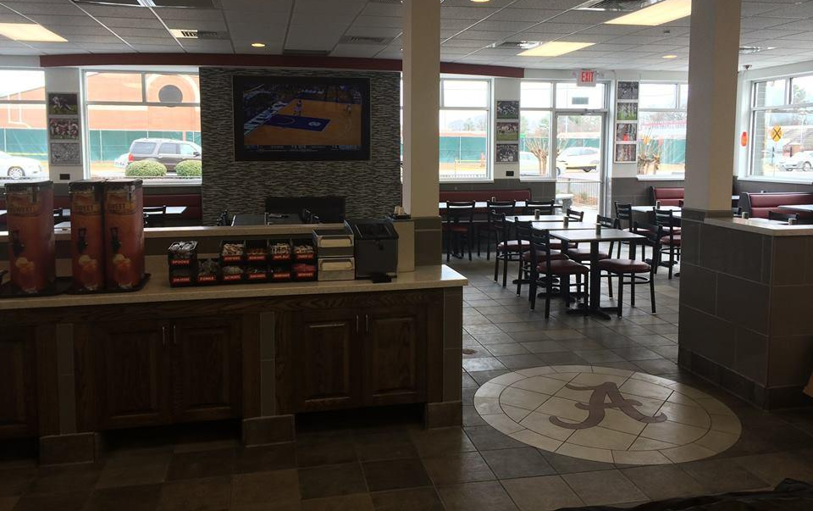
Jack’s Restaurant – Tuscaloosa, AL (completed 2016)

