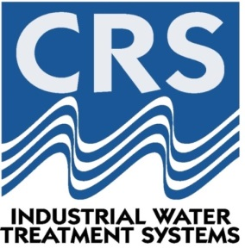
ABN: 998 894 822 094

INTEGRATED PRODUCT RECOVERY (IPR)
SUMMARY DOCUMENT
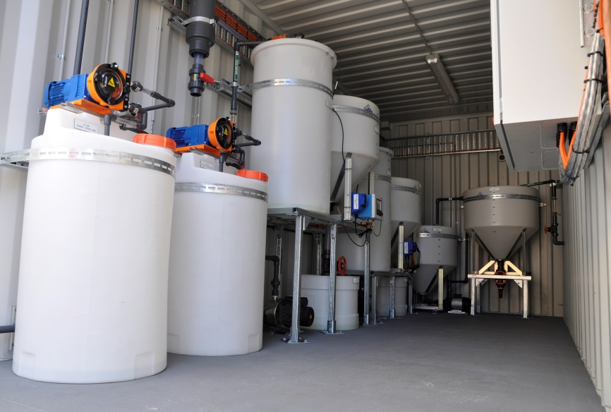
Containerised Trial Unit

Wednesday, 4th March, 2015
Revision B
Integrated Product Recovery (IPR) – The Treatment Technology
Integrated Product Recovery (IPR) is a sequential waste minimisation process, ultimately resulting in the recovery of saleable chemical products. Brine streams are treated via an integrated system that utilises chemical manipulation to minimise waste via selective salt recovery. The technology exercises the solubility laws that govern the formation of precipitates within solutions to remove certain constituents in a brine stream via precipitation.
The IPR technology is capable of treating alkaline brines with elevated carbonate and bicarbonate species, such as those generated by Coal Seam Gas (CSG) operations. Either a single reagent or a combination of reagents are added to the brine and allowed to react with the brine. The addition of the reagent(s) raises the concentration of specific ions to levels that force precipitation reactions to occur causing the removal of bicarbonate and carbonate species in the form of a precipitate product.
The IPR system put simply, “cleans up” brine streams and completely eliminates the need for waste disposal. The IPR process is a key step towards achieving a zero liquid discharge (ZLD) solution in the treatment of waste brine streams.

IPR Key Characteristics and Advantages
Key characteristics of CRS’ IPR technology include the following:
- Provides a sustainable waste solution
- Provides a cost benefit as constituents are removed as vendible products, which can offset disposal and operation costs.
- Results in the beneficial reuse of products
- The treatment process is highly flexible, with the ability to utilise multiple, different reagents to create a selection of products based on process and economic factors.
- Reduces the required thermal equipment size and improves thermal operations
- Removes constituents contributing to downstream scaling problems (bicarbonate/carbonate removal)
- Removes impurities within the brine stream via co-precipitation. Undesirable species such as silica, heavy metals, sulphate, phosphate, fluoride, bromide and iodide can cause downstream processing issues and interfere with the operation efficiency of equipment. These species can be removed by the IPR treatment process.
Integrated Product Recovery (IPR) Coupled with a Seawater Reverse Osmosis Unit
- The IPR treatment system can be easily integrated into the current CSG brine management method to achieve a more efficient and more cost effective brine management solution.
- The concentrate from the initial RO unit undergoes treatment via IPR prior to entering a brine concentrator (BC). See Figure 1.
- The IPR treatment process will remove scaling components and undesirable species.
- The IPR treatment process will produce useful, saleable products and a ‘clean’ brine stream.
- The ‘cleaning’ of the brine, through IPR, subsequently allows further volume reduction through conventional, lower energy reverse osmosis.
- The secondary lower energy RO unit operates at approximately 50% recovery. This halves the brine flow to the downstream brine concentrator (BC) unit.
- Downstream BC and crystalliser units are therefore significantly reduced in size (approximately 50% smaller in size).
- Smaller BC and crystalliser units considerably lower the capital (CAPEX) and operating (OPEX) costs associated with these units.
- A solid sodium chloride salt product is achieved from the crystalliser unit, with greater than 99% purity. No mixed salt waste is produced or sent to landfill.
- The cost savings from the reduced unit size alone makes IPR coupled with an additional (seawater) lower energy RO unit, an attractive treatment add-on.

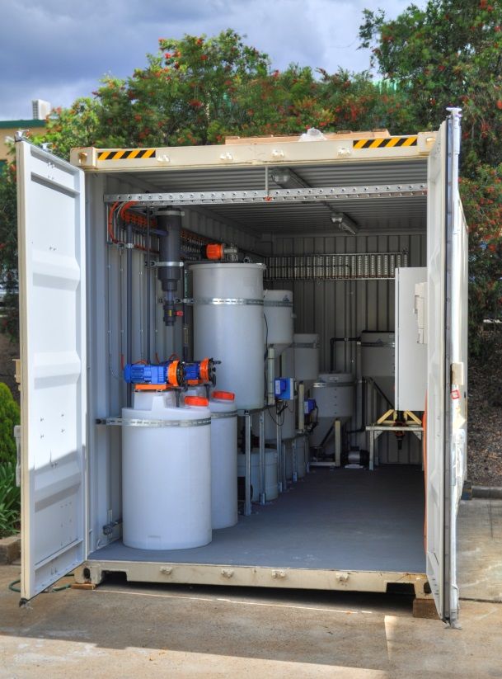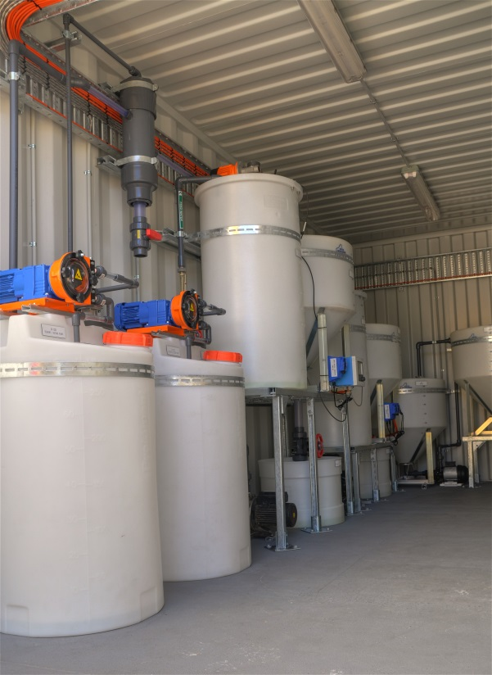

Figure 1: A representation of the general process steps involved in the current CSG brine management method (left) and the alternative brine management method with the additional IPR and low energy seawater reverse osmosis (SWRO) unit add-on (right). The IPR and SWRO add-on processes are highlighted in green. The alkaline waste brine stream, resulting from the first reverse osmosis unit, is contacted with reagent 1, a precipitation reaction takes place and a solid-liquid separation technique is utilised to recover product 1. The same general process is employed to treat the supernatant from the first reaction step. The IPR treated ‘clean’ brine is then fed to a low energy, seawater reverse osmosis unit. The brine resulting from this secondary RO unit then passes through significantly smaller (approximately 50% smaller in size) brine concentrator and crystalliser units.

