LIVING LOUD LOGO BRIEF

Our Mission
Living Loud is a recently launched not-for profit with following mission:
Living Loud was founded by people with diabetes to help people with diabetes live longer, healthier and happier lives. Our mission is to unite into one voice to improve education, inspiration and support for everyone with diabetes.

Our Vision
Our vision is to build a global charitable alliance of health professionals, digital technologists and the creative industries to transform lifestyle healthcare. Using artificial intelligence, inspiring content, gamification, rich design and the latest thinking in diabetes management and health psychology we will educate, inspire and support people with diabetes to lead longer, healthier and happier lives.
Our solution will be always available, ongoing and universally accessible to anyone connected to the internet. Our solution will be universally free at point of use. Our platform will be personalised to each user’s individual needs and adaptive to their individual preferences.
Living Loud is dedicated to changing the culture around type 2 diabetes from one of blame, shame, failure and inevitable decline and dependency on medication, to a message of hope, reversal and no lasting heath concerns.
Living Loud is equally dedicated to supporting those with type 1 diabetes to help them successfully manage their condition with the least sense of emotional burden.

Brand Values
Our brand values emanate from our mission
- Hope for a better life - not fear of failure and of the complications of diabetes

- Liberation from the burden of diabetes through reversal or better management, Living Loud is not a “cure”
- We are empowering people to save themselves, we are not saving the world
- We focus on what people can gain now - not what they might lose tomorrow
- Living Loud is a celebration of the joy of life. We help people live their lives at a louder volume

Colour
Our colours are
Colour
R228 : G003 : B117

This pink colour conveys vitality and energy and through association with the pink ribbon cancer campaigns it conveys hope.
R79 : G129 : B189

This blue is the colour adopted by the International Diabetes Federation for their universal ​ symbol for diabetes, the blue circle. It is also synonymous with the United Nations, UNHCR and World Health Organisation and so conveys global collaboration.

Fingers
Fingers and hands appear throughout our imagery. As people with diabetes our fingers very much connect us with our condition, we use them for blood tests. We prick them to make them bleed and they can sometimes feel a little beaten up.
Core to our brand promise is that we are meant for greater things than managing our diabetes. Through our fingers we physically connect with the rest of the world - we touch, we caress, we hold a glass, a pen, a racket, we offer them in friendship and we raise them in support. Liberating fingers from pain and inconvenience to live, love and enjoy is symbolic of our core promise to bring healthier and happier lives to people with diabetes.
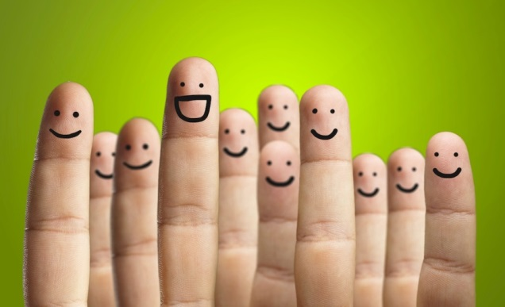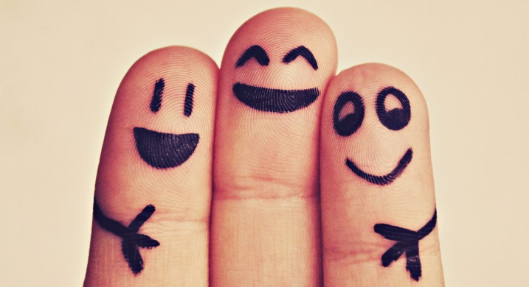

Utilisation
The expect usage of the logo
Website: http://www.livingloud.org.uk/
Facebook: https://www.facebook.com/LivingLoudUK/
Business Cards
We are likely to git it animated for pre & post roll video usage.

Key Success Factors
Must be suitable required utilisations above, will it fill the square space for logos on a Facebooks page whilst also not bring too much depth to website top navigation. Could we animate well for our video work at a later date?
Simple stylish, not gaudy, more likely to favour good font choice rather than clip art
Need to capture the brand values of hope and liberation and not veer into some medical.

