Gray’s Quarries Logo:

I would like to get a modern version of the below logo, my father set up this company in 1987 but passed away in 2014 and would like the R in Gray’s to possibly stand out as his name was Robert.

Would like to use the images below that were used from the start of the company but would like it modernised and would like to see what you would change or do differently?

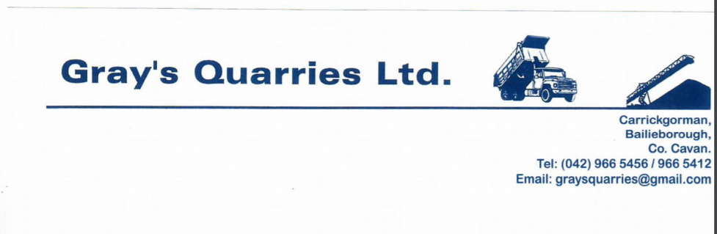

What is the name of the company?
Gray’s Quarries Ltd

Do you have a company tagline or slogan that could be used as part of the logo?

What products or services does your business provide?
Stone, Aggregrates, Sand & Gravel, Fill Products, Projects

How many years has your company been in business?
30 years

How does your audience learn about your product, organisation or service? Through word of mouth, local advertisement and sponsorship.

Is there a unique story behind your business?
My father set this up back 30 years ago on his own and It’s family run.

Are there any inspiring visuals associated with your business? As you can see from the above image this was used from the very beginning of the business but would like to possibly keep some of it as it’s part of the tradition and incorporate into a modern Gray’s Quarries Ltd logo.

What does your audience care about?
Customers care about the service provided, supply on demand at competitive prices.

Your design preference likes/dislikes or expectations?
Would like to keep part/some of the old image of the lorry etc to incorporate into the new logo with the R in Gray’s to possibly stand out for my Father’s name which was Robert.

