Typography

Hive Communications

Hive Communications

Hive Communications

Hive Communications

Hive Communications



Minimalust

Orkney

Logo inspirations
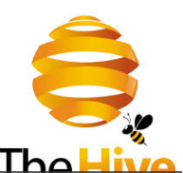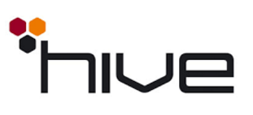



 (the lines on the logo is not too dissimilar to powerbuy’s 5 little men)

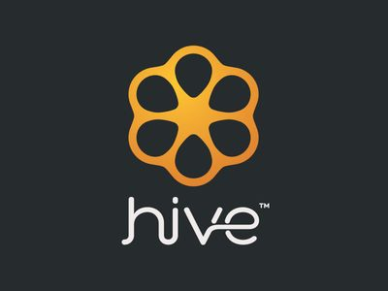
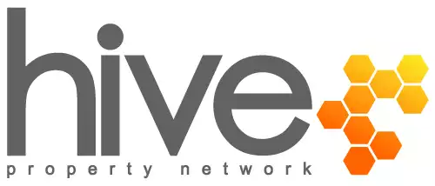
This is probably the close of where my idea was for font. Colour is not good. But the limited use of Hex is not bad. A bit too much, but not bad.

Colour scheme:
Primarily Blue with a hint of yellow/orange – reflects professional and yet creative/fun

Current product/business is PowerBuy
Hive Communications will be the PowerBuy parent company.
No plans to change PowerBuy branding just yet.

Current Powerbuy Logo as reference below:
