- Messaging to Accompany First Frame of Lonely Chair:
SHIF-T ‘ Where you can change a life, your community, our world without leaving your chair’

- Section: Trading Tools (Use a brief intro to each section, with a link to read more for the full version) Use playful images/icons as in example
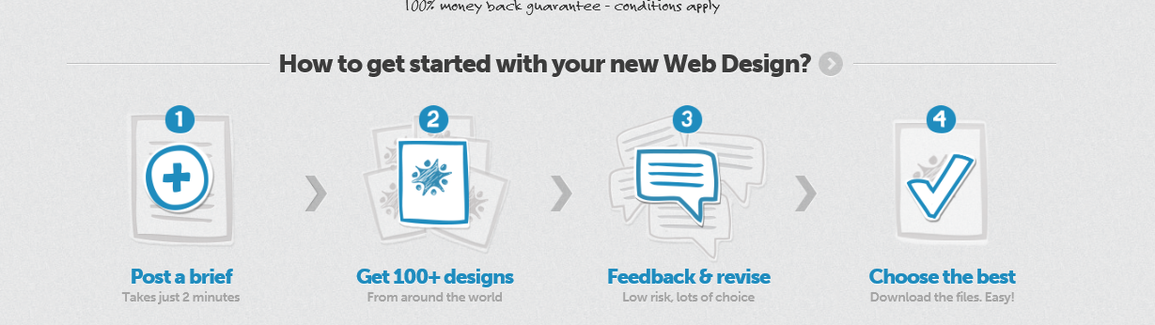
Market Place
Sell it. Buy it. Choose and support a cause that matters. You can do it all in the Market Place, where it’s always free to list and sell.
Our global marketplace gives sellers reach and buyers range, while improving their own backyards. Sellers: do everything from create a Store to run an Auction or Flash Sale. Buyers, bid with glee...or just Buy Now. Then watch the love flow direct from the checkout to a community project you or your seller cares about. So much more than an exchange of goods.

Business Centre
Build your business while empowering your community—and be a local superstar! The Business Centre inspires change through trade. By connecting business activities with grassroots communities, we create social enterprises who care.
Own a business? List it, sell products and services, post jobs, and find local talent—all for free. In the Business Centre, you can showcase your social footprint for community building projects. Be known as a business that makes a difference.

Event Point
Find power in numbers and alignment when you activate your local community. The Event Point brings your crew together to help grassroots projects make a bigger impact.
List your event, share it across your networks, and seamlessly manage payments, ticketing and attendee lists. Buy and sell tickets directly in the hub, with the option to send a portion of each sale straight to your worthy cause. With full transparency on every transaction, you can add creditability to passion—and spread the word quickly.

Crowd Source
SHIF-T brings you crowdfunding...but with a conscious, inspired twist. Raise funds for community projects—but keep every cent you raise. We call it “swarmfunding”. Allow your friends, family and followers to send a slice from their transactions to support your venture.
The Crowd Spot helps people find and fund local causes just like yours. Use Shif-t to drum up support by crowd-sourcing ideas, and even new skill sets that could benefit your next project. Share your story with updates and inspiration. Build a colony to champion your movement and bring life to your good work.

Social Space
How much time do you whittle away browsing through clickbait? Dare to trade some of it into making a difference?
Hubs, Hives, and Pods link you to grassroots projects and interest groups that matter to you—making it easy to collaborate, streamline information, and spread your community’s world-changing work.

- Statements (Section separators) - Samples attached
- Text to be displayed with video explainer section;
With SHIF-T, making a difference in the world is as easy as shopping online. A global Social Enterprising Network for driving local change, we connect merchants and socially conscious consumers to grassroots initiatives—both in their backyard, and around the world. Buy and sell what you need while supporting causes you care about. Create hives of social empowerment and change. SHIF-T gives everyone the power to change the world.

- Footer
- About Us, FAQ, Tutorials, Stay in the Know (email subscribe), Contact Us

