Interior Product Page – Example Content

<h1>WAF Rules That Harden Your Shell </h1>

Everything is moving to the cloud and most of it is accessed today through the web. That means a lot more web application servers have critical business data. How do you protect them? The first line of defense is a web application firewall (WAF) and the most popular today is the open source Mod_Security. But, that is just the starting point.

WAFs Don’t Work without Rules
WAFs don’t do a thing without rules. That is where Atomicorp comes in. We developed the first rules for Mod_Security running on Apache 1.x and published them in 2005. Today, Atomicorp maintains by far the largest number of active WAF rules and supports server types ranging from Tomcat and Nginx to IIS, Lightspeed and Apache.

Unmatched Protection, Unrivaled Convenience
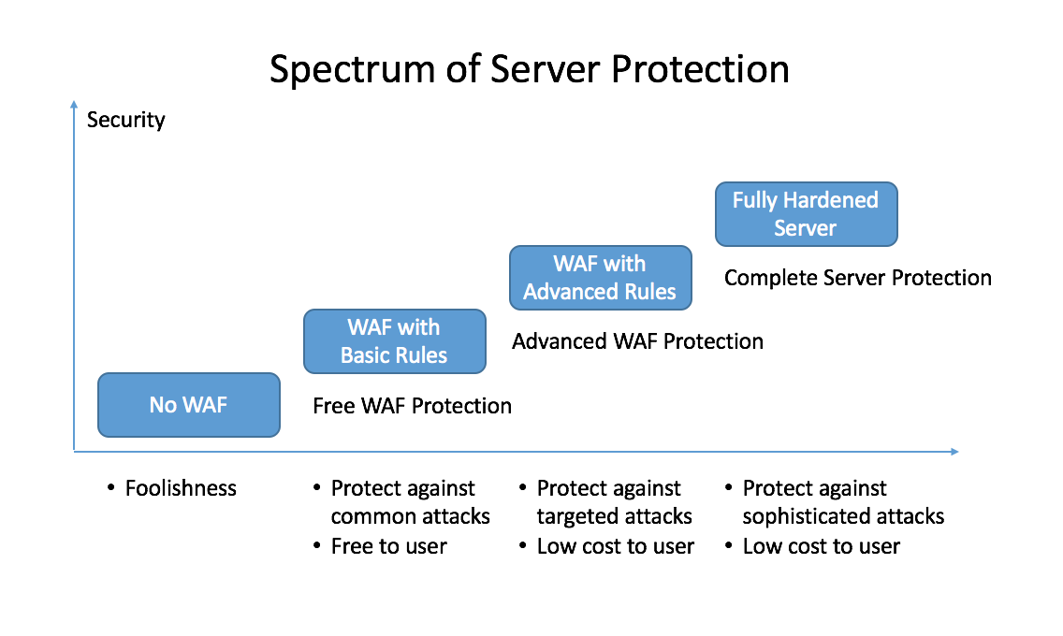Atomicorp provides the vast majority of its rules free of charge so even the most budget conscious user can implement basic protection. Users can protect themselves from more advanced, targeted attacks with Atomicorp’s paid WAF rules or go for full hardened server protection using Atomicorp Secure Linux.

<button: See Pricing> <button: Learn About Atomicorp Secure Linux>

Don’t Be the Next Victim – Get the Best WAF Rules on the Planet
Over 20,000 servers in thousands of organizations are protected Atomicorp WAF Rules. Atomicorp is trusted to protect so many companies because our WAF rules are the most comprehensive, have the highest quality and are backed by top flight customer service.

Don’t be the next victim of cyber crime. Harden your shell and get Atomicorp WAF Rules today.

<button: Get Started for Free>

<video>

