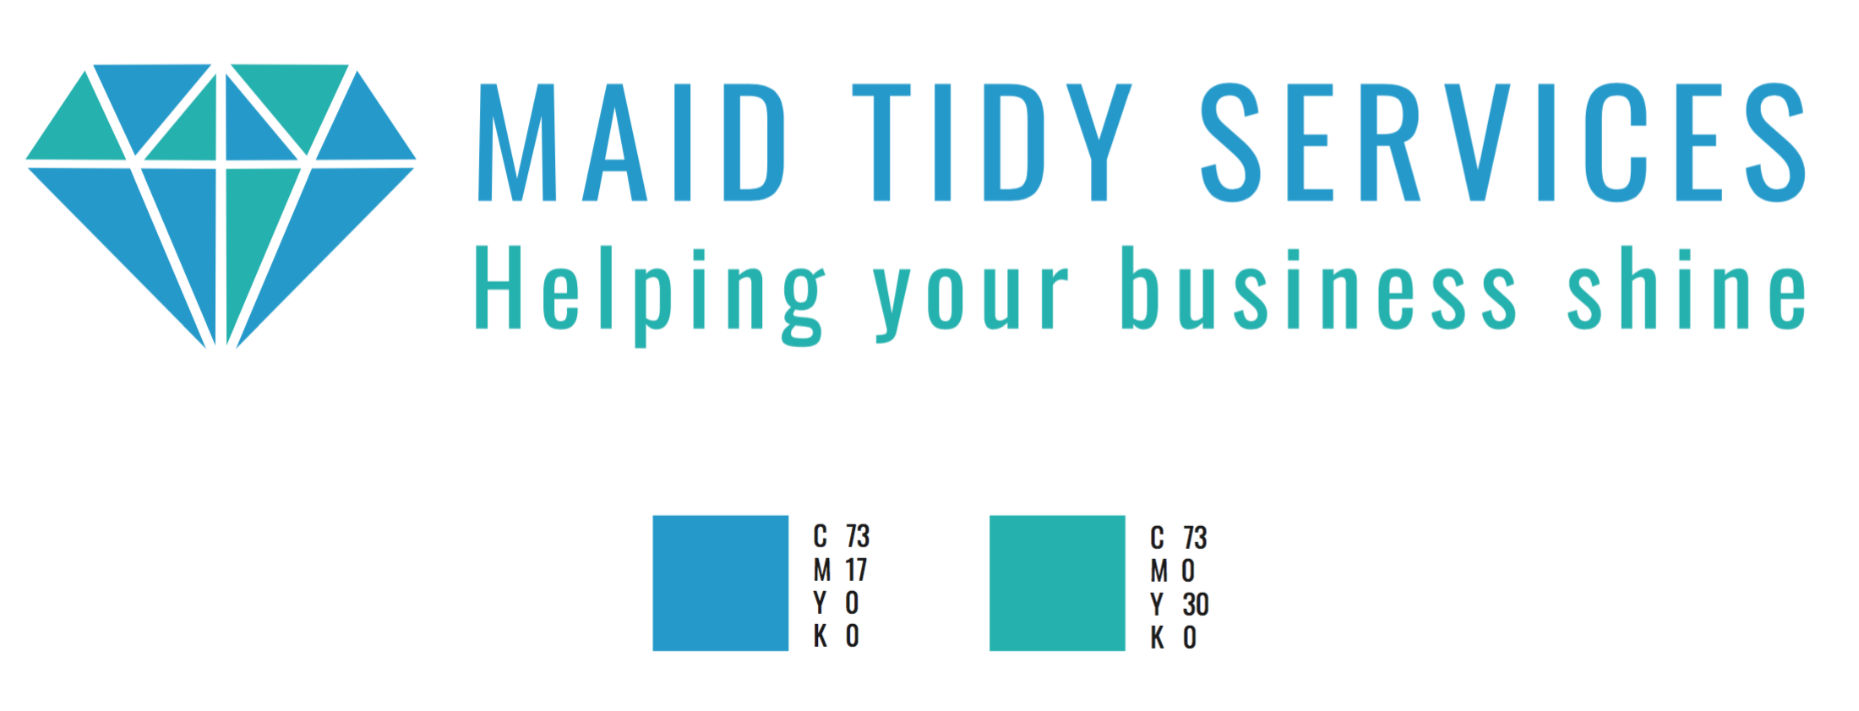
Company Logo


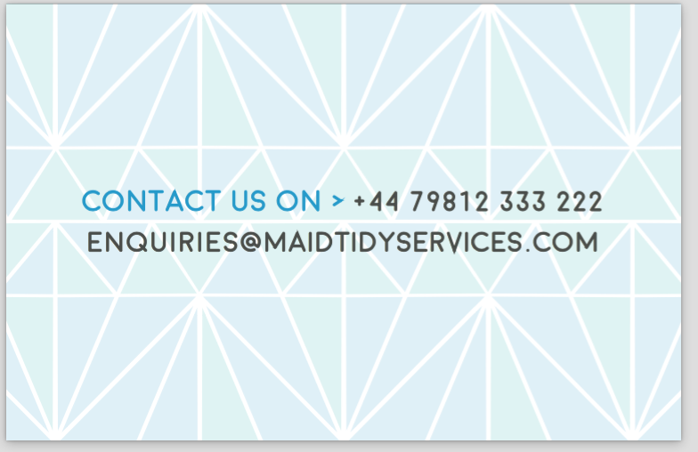
Note: Please incorporate the pattern below into the flyer. I prefer a lower opacity.

Company Contact Details

Email: enquiries@maidtidyservices.com
Web: maidtidyservices.com
Mobile: 07979193139
Office: 02089321220

About Us

Maid Tidy Services continual commitment and dedication to delivering a quality service has enabled us to build a solid foundation within the cleaning industry.

Our principle and objectives are simple, provide our customers with an affordable quality service to suit their needs and always put our clients first.

MTS rewards dependability, integrality and provide the training and development for all employees to achieve the best possible results. We believe that building relationships based on ethical conduct towards employees and clientele defines our unique working environments and is a vital key to our success.

This is why at Maid Tidy Services stand behind our performance and guarantee your satisfaction.
Quick response to costumers needs guaranteed
Unequal attention to detail
Affordable cleaning tailored to your needs
Lengthy industry experience
Insurance inclusive of Workers Compensation and Liability
Training provided to all staff and supervisors
Your satisfaction is our priority

We aim to offer the highest Commercial and Residential cleaning standards.

Commercial Cleaning
- Offices
- Education Facilities
- Medical Facilities
- Restaurants
- Showroom

Services
- General Cleaning Requirements
- Consumables supply and replacement
- Washroom services
- Building maintenance
- Window cleaning
- Carpet care
- Floor maintenance
- Scrubbing machinery
- PAT Testing
- Waste removal
- Recycling Programs

Residential Cleaning
- House Cleaning
- Apartment Cleaning
- Move In/Out Cleaning
- After Event Cleaning
- Spring Cleaning
- Post Building Works Deep Clean

Green Cleaning Available
- No harmful chemicals
- safe for children and pets
- eco-friendly
- no artificial fragrances

