Front page
- Thank you for becoming
- a School for Life child sponsor

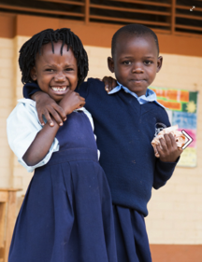

Thank you for believing in a world where every child has access to quality education.

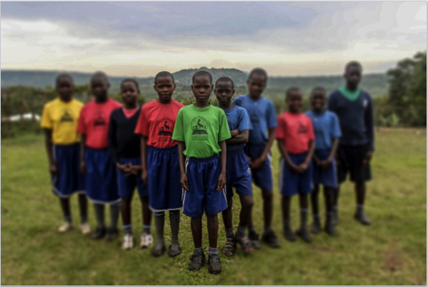

- In Uganda, 7 in 10 children won’t finish primary school.
- Can you imagine what Australia would look like if we shared these statistics? This is why we are developing a sustainable model of education. Our community-led schools provide a hand up, not a hand out, because like you, we believe education is the greatest way to make a difference to the world. Your sponsorship gives a child living in poverty the gift of education. You are giving a child the freedom to change their life.

- Welcome to the global School for Life community!

- Thank you for giving a child a hand up,
- Thank you for believing in the power of education,
- Thank you for granting a child the freedom to change their future.

- Your sponsor child goes to school here
- Map of Uganda – Annabelle has commissioned.

- Fact box: About Uganda
- Uganda is smaller than the Australian state of Victoria.
- It’s a land-locked nation bordered by South Sudan, Kenya, Tanzania, Rwanda, and the Democratic Republic of Congo.
- The average adult’s daily wage is AU$1.25 a day, although money goes a lot further in Uganda - it costs just 30c to feed a child three meals a day.
- The rate of the Ugandan shilling to the Aussie dollar is 2600:1 – and inflation sits around 7%.
- The staple meal for Ugandans is cassava and beans, although matooke, a green variety of banana cooked in its leaves, is also a favourite delicacy.
Uganda’s population is estimated at nearly 38 million, with the world’s youngest median age – around 49% of its population are under the age of 14. Life expectancy is just 44 years.
Uganda has the fifth highest fertility rate in the world, with on average 6 children born per woman before they are 25.
- Child labour is endemic, with children most often working in agriculture, helping to grow the food that gives them their one daily meal.
- 78% of the Ugandan population is illiterate. Only 7 in 10 children finish primary school.

- Ugandan has a history of civil war - in the 1970s Colonel Idi Amin became a dictator and enforced a reign of terror where it is thought 300,000 people died under his rule.
- The current president of Uganda is Yoweri Museveni, who came to power in January 1986 after a protracted six-year guerrilla war.
- English is the national language and the language in which business is conducted, although Luganda, the local language is widely spoken.
- The main industries are sugar, tobacco, cotton textiles and cement, and agriculture – coffee, tea, cotton, tobacco and beef. Main exports include coffee, fish (from Lake Victoria and farms) tea, gold and cotton.
- *data from XXXX.

You are changing the world, one child at a time.
- Polaroid magnet photo of their child that is stuck in and can be taken out and put on the fridge.

- We are thrilled to have you as part of School for Life’s child sponsorship program.
- You are not only giving a helping hand to lift one child out of poverty, but you are educating and empowering an entire community.
- Your donation will mean your child, and the wider School for Life community, will receive quality education, three nutritious meals a day, healthcare, clean running water and a safe environment to play and learn.
- Your sponsorship will also help your child’s family, allowing their parents to have access to quality vocational training, as well as community workshops to teach parents about pertinent issues such as domestic violence, family planning, health and sanitation and the importance of education.
- It is only because of your generous support, and the global School for Life community, that we are able to fight Uganda’s education crisis.
- We believe in the power of education. Because education is freedom.
- Georgie Gardner image | - Roger Montgomery image | - Girl image (Emmanuel?)
- “I sponsor four children at School for Life because it’s important to give back. School for Life is real, and I know I am making a tangible difference.” | ‘In School for Life we have discovered an organisation where the impact of our giving is tangible, where the prospects for so many are brightened, and one that is run by someone who is intelligent, energetic and honest. One suspects the true impact of Annabelle and her team’s work can never be overstated.” | - I love hearing from my sponsor child Sofia, who is the same age of me but leads a completely different life. I talk about her to my friends at school and hope to visit her soon.

- Education is freedom.
- Freedom from poverty, from disease, from violence, from war.

- What we’ve achieved so far (infographic)
- 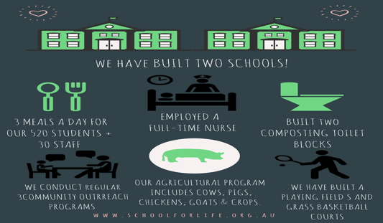

- 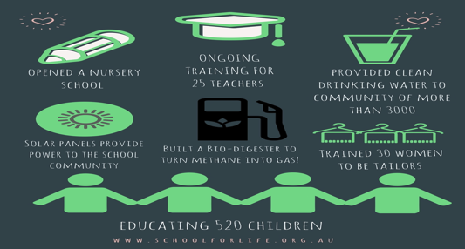

- Question and answer with School for Life Founder and CEO Annabelle Chauncy OAM

- 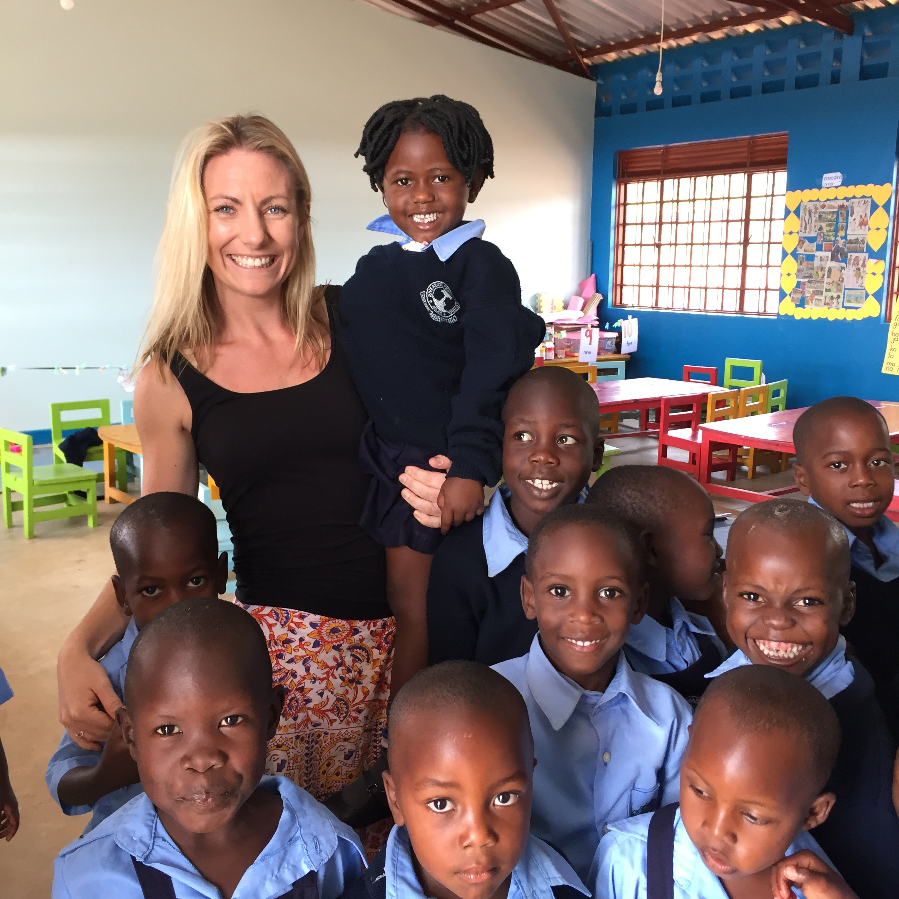

- How does child sponsorship work?
- Our child sponsorship program enables an entire community to receive an education and to develop the skills they need to help lift themselves out of poverty.
- Making a huge difference to one child’s life is easy, but it actually benefits so many more people as well. Your donation each month funds all the educational requirements for your child.
- This includes provides them with:
- three nutritious meals a day,
- clean water,
- healthcare,
- a high-quality education.
- But it also does even more than this. Your sponsorship money also provides school uniforms, books, pens and pencils, library books, learning tools, sporting fields and equipment. It also ensures all our teachers have up-to-date training and accommodation at the school. Your child sponsorship also enables your child’s family access to clean water, community learning days and vocational training such as agricultural husbandry, cropping, and tailoring.

- What will I receive from my child:
- You will have received a fridge magnet of your child in this pack, and you will also receive information from your child in a few different formats. These include video updates from your sponsor child’s class three times a year (there are three terms in the Ugandan school year), a combination of emails and letters telling you about your sponsor child’s family life, interests and school progress throughout the year. You will also receive a Christmas card and two artworks from your sponsor child every year.

- Can I visit my child?
- You can absolutely visit us in Uganda. We have a range of different programs throughout the year which you will be invited to attend. It does take resources to run visits so we try to organise a few trips each year where people can visit together in a group. School for Life’s founding principle is local empowerment and ownership so the programs compliment the local leadership and are designed to immerse you in village life and the school routine as a visitor rather than a leader. You can contact us at any time for more details – hello@schoolforlife.org.au

- Can I write to my child?
- You can write to your sponsor child, but depending on their age and level of education, they may not be able to write back. We don’t like to take time away from class work and their important learning program but your child will receive any letters sent to them and you will receive correspondence from them twice a year.

Can I send my sponsor child presents?
- Although this is a lovely idea, we ask that instead of sending gifts, you talk to our Fundraising Manager about the best way to help your child. It actually costs us money to pick up goods sent to children, and sending gifts can also cause division within the school and community.

- What happens to my child if I can no longer sponsor them?
- The vision for School for Life is to build a sustainable model of education where at least 50% of the running costs of the school is sources from community-led programs. Despite this, we depend on child sponsors to support and educate our children and to help empower the entire community. Child sponsorship should be considered a long-term commitment, but if you can no longer sponsor your child we will endeavor to find another sponsor for them.

- What if I receive artwork in a different child’s name?
- Some cross-cultural differences are hard to grapple with, but probably the hardest is that some School for Life students have their names changed frequently. Naming children is not absolute in Ugandan culture – which can be extremely confusing! Many children are born on the floor of a mud hut and do not have formal birth certificates or even a date of birth documented. From time to time names might change slightly – but we assure you, your sponsor child will remain the same person!

- How do I keep in touch with news of my sponsor child, such as their birthday?
- Where we can, we try to keep track of our students’ birthdays. Often children start at our school and look a lot younger than their actual age, as they are suffering from chronic malnutrition. However once they are fed three meals a day and start growing, it becomes apparent they are much older and may be able to skip ahead a year if they meet their educational requirements. We will keep you updated about any of these changes. Please join our Facebook and Instagram pages for daily updates from the entire School for Life community. You can also receive more information about School for Life’s child sponsorship program at any time by contacting our Fundraising Manager – hello@schoolforlife.org.au
- ,
- What happens if my child leaves school?
- From time to time children move villages. If this happens we will be in touch and can introduce you to a new sponsor child. School for Life will open its secondary school in 2018, with our first students graduating in 2024. If and when your child graduates, you will have an opportunity to join us in Uganda for their graduation and then sponsor another lucky child in pre-school.

- Can I tell my friends about my sponsor child on social media?
- You are welcome to tell your friends about your sponsor child, but please don’t share images of them on social media. We respect the right to privacy of all the children in our care, and consent from a parent or guardian is required before the distribution of any images.

- What percentage of my money goes to my sponsor child?
- School for Life is a grassroots organization where 96% of your child sponsorship money goes directly to looking after your child’s educational needs and running our school in Uganda, while 4% is spent on administrative costs. Our School for Life staff is 90% Ugandan. The money going directly to the ground in Uganda is one of the highest of all charities in Australia. More information and a complete audit is available on our website – schoolforlife.org.au

School for Life’s sustainable model of education
- School for Life believes in a world where every child has access to quality education. It is our mission to provide sustainable, community-led schools in developing countries. We employ 90% Ugandans to run our schools, empowering the entire community.

Meet our team

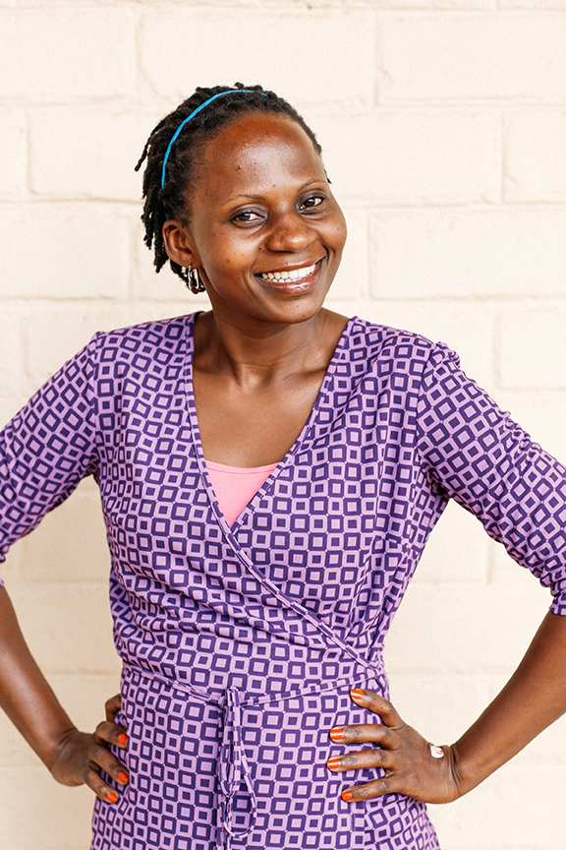

Janepher – Director of Studies
Janepher has been involved with School for Life from the day the land for our first school was purchased. She understands first hand the opportunity and freedom that comes from a quality education – and is an integral part of the School for Life community. At the age of 16, Janepher was orphaned and had to move from her village where she attended a private school, to Uganda’s capital Kampala to live with her grandmother. Here, she attended a Government-run school with untrained teachers - she wasn’t fed all day and had no money to buy food. There was no running water, doors or even windows in her classroom. Determined to change her future, Janepher began working after school and on weekends so that she could afford to put herself through a private high school. Later she trained as a teacher at a Montessori Teacher Training Centre, and also covered the expense of sending all her siblings to private schools.

Image of Robert from website is good
- Robert – Head teacher, Katuuso Primary School
Robert’s started teaching at School for Life in 2014, but his exceptional leadership skills and determination for community success saw him promoted to Head Teacher of Katuuso Primary School in 2015. Robert was in Year 2 when his mother passed away. He was forced to move out of home when his father remarried, and fortunately went to live with his older brother who was studying to become a teacher. His brother paid for Robert’s schooling and the two worked multiple jobs between classes to pay for meals. Robert understands the importance of hard work, determination and most importantly, a good education.

- KUMI (images of women working)

- 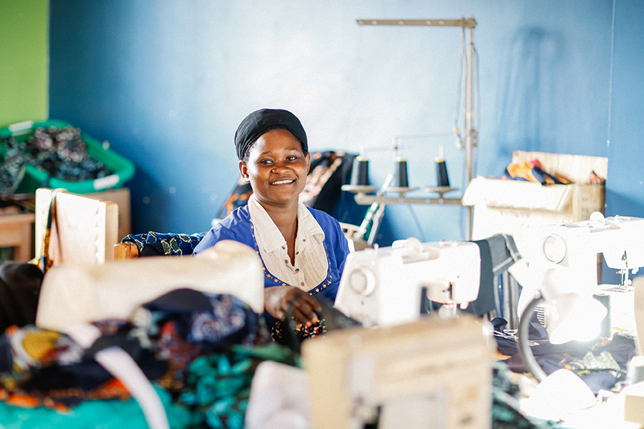

- KUMI by School for Life is our women’s empowerment program. KUMI means ten in Luganda as we first employed 10 women full time. The program has since grown and we employ 15 women from the local community to make the children’s school uniforms, as well as items such as make-up bags and shopping bags that are available for sale in Uganda and Australia. Our KUMI program also provides training to other women in the community so they are able to up-skill and gain employment. A range of KUMI products are available for purchase at www.schoolforlife.org.au

- Vocational training
- School for Life employs Ugandans in its animal husbandry program – looking after pigs, cattle, goats and chickens as well as planning crops including maize, matooke (green banana), corn, sweet potato, mangoes, beans and tomatoes. The food grown in these programs is used to feed children and staff, with livestock sold at local markets. We also train farmers from the local community in the latest farming practices from around the world so they are able to become more profitable.

Walk in the shoes of a Ugandan child…

- Goretti wakes at 5am and walks, with several other children from her village, to collect water for her family. Some days she will need to walk for more than an hour to collect water, and carrying the yellow container when it is full can be backbreaking work. After she has collected water she walks to school.
- 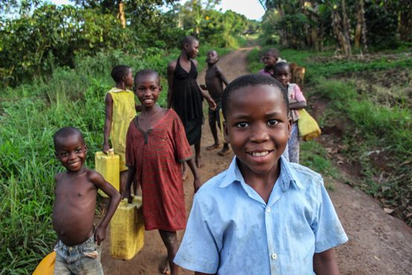
- Goretti is 13. In Australia she would most likely be in high school, but she is only in Year 5 at School for Life.. Before School for Life opened, there wasn’t a school available for Goretti to attend, so she had to start her schooling later. Sadly, for many girls in Uganda, education is not a priority. Girls usually stay at home to work, and early pregnancies around the age of 14 are common. The average Ugandan girl has six children by the time she is 25.
- Due to the generosity of sponsors like you, Goretti now has access to a quality education, three nutritious meals a day, healthcare and water. Her favourite subject is social studies and she hopes to one day become a pilot.
- 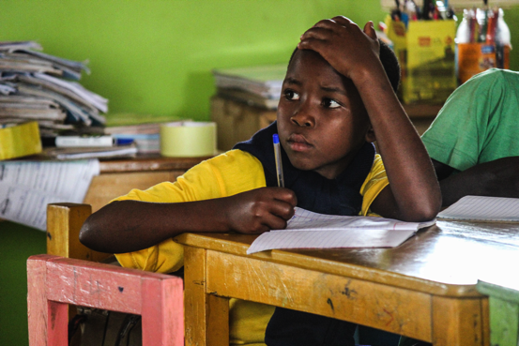

- Sadly Goretti’s parents weren’t able to provide for her, so she lives with her aunt, uncle who is a farmer, and cousins. Her brother doesn’t live with her. She shares this bed with her cousins. She helps her aunt prepare the meal for the family after school – usually beans and cassava – a staple meal for Ugandans. Goretti, like many other Ugandans, keeps her hair short to stop worms, lice and ticks.

- 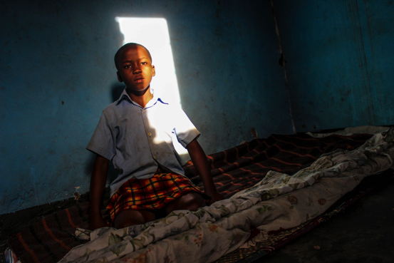

- After her chores are complete, Goretti looks after the village children and then completes her homework by candlelight. Goretti’s only possession – her only toy – is her raggedy teddy bear she has called Laeticia.

- 