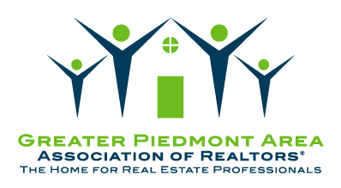

Greater Piedmont Area Association of REALTORS®
A trade association of real estate professionals and affiliate members serving the counties of Culpeper, Fauquier, Madison, Orange, and Rappahannock.
Mission Statement: We exist to provide outstanding services and leadership to help our members be successful and profitable in real estate.

