Logo Contest Brief Our organization needs a logo: We have an existing logo, but we are interested in something more original.
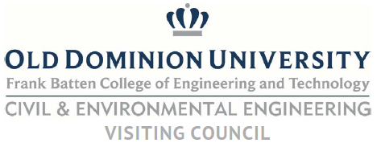
Organization Description
Our organization is the Civil and Environmental Engineering Visiting Council for Old Dominion University. The CEEVC consists of selected members of the local community of Civil Engineering professionals from across industry, consulting, government, and education. The function of the group is to:
- Review existing educational programs and research activities and assist in identifying new technology areas that should be initiated or promoted and old areas that should be reduced or eliminated.
- Serve as a sounding board for new ideas, activities, or programs.
- Assist in the formulation, structure, priority setting and fund raising for future development/endowment/scholarship type programs related to the departmental mission.
- Provide guidance for establishing an alumni/friends relations program(s).
- Assist in promoting professional relations between the Department and the business and technical community.
- Assist the Department in its communication efforts with the public and other supporting groups.
- Assist the Department with Accreditation Board for Engineering and Technology (ABET) accreditation.
- Provide support for students as requested by the Department.
There is a board of directors and the following committees; Education, Research, Fund Raising, Nomination/Membership, and Bylaws.
Guidelines
Please provide a logo that incorporates one of the images listed below and meeting the following guidelines and exclusions:

We have also provided the ODU brand book, which provides additional, detailed guidance on the allowances and limitations of incorporating the ODU logo/brand with the Civil and Environmental Engineering Visiting Council logo.
We are permitted to incorporate “ODU” or “Old Dominion University” as long as it includes the tagline “Idea Fusion” and crown. By incorporating the above images into our logo we are required to adhere to the logo guidelines in the graphic, below. The logo should match the colors, font, and type used by the University, detailed below:
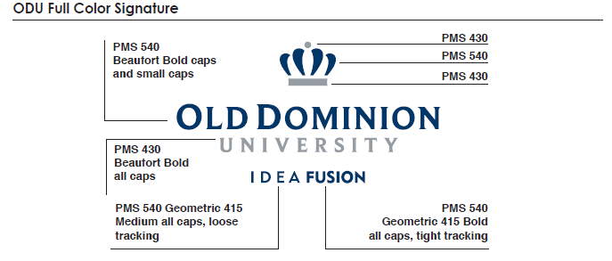
While we are associated with the university (www.odu.edu) we are not authorized to use the university seal, or Lion logos, below, which are reserved for specific uses:
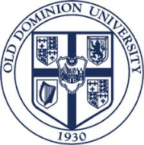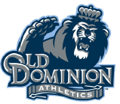
Look And Feel Professional, simple, clean, but would consider traditional and contemporary designs. Avoid using engineering clichés such as gears, T-squares, calipers, triangles, etc.

