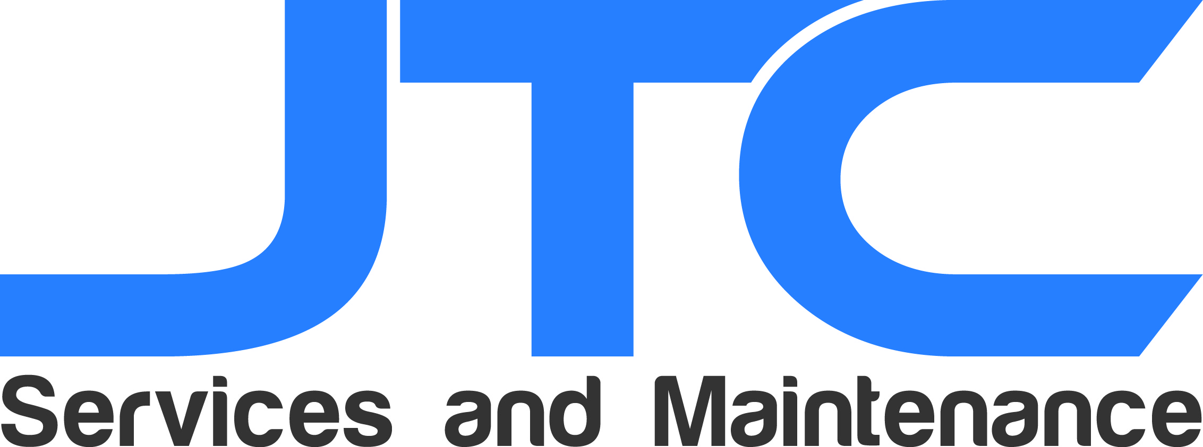

Dear Property Manager,

Hi, my name is John Smith and I am owner of JTC Services and Maintenance. I would like to introduce you to my company with the hope that you have a need for our services and perhaps, would be willing to add us as a vendor.

We are a family owned business that specializes in Painting and Landscaping Services for commercial properties. We have been in business for over five years, having completed over 300 commercial projects in that time.

What sets our company apart from the rest is our commitment to quality. We committed to delivering the best quality of work available and exceeding your expectations.

We always remain courteous, transparent, and above all else, professional with our clients.

We possess the equipment, transportation, and staff needed to complete any scope of work on time and as instructed. As a company, we are licensed to work in California and do posses the required bonds and insurances. In addition, we are Lead-Safe Certified.

We would cherish an opportunity to demonstrate what we can do. We are capable of working within a budget and are available to work on weekends.

If you have any questions or need any information, you can contact us at (111)111-1111. You can also email us at JTCServicesandMaintenance@gmail.com.

Thank you for the consideration,

John Smith
JTC Service and Maintenance
(111)111-1111
CSL# 11111
www.JTCServicesandMaintenance.com
JTCServicesandMaintenance@gmail.com

