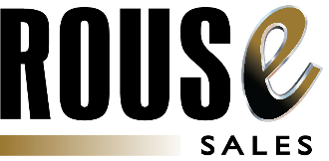
See how easy it can be
to sell your used equipment.

The biggest rental companies in the world rely on Rouse Sales to power their used equipment sales programs. Our suite of pricing and selling tools are easy to deploy and cover every step in the selling process, ensuring your team stays focused on what really matters -- engaging the customer and closing the deal.
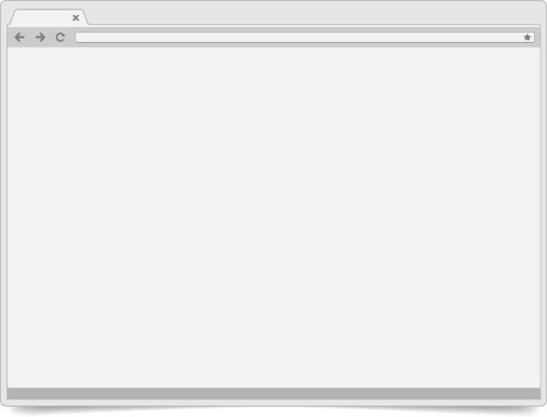
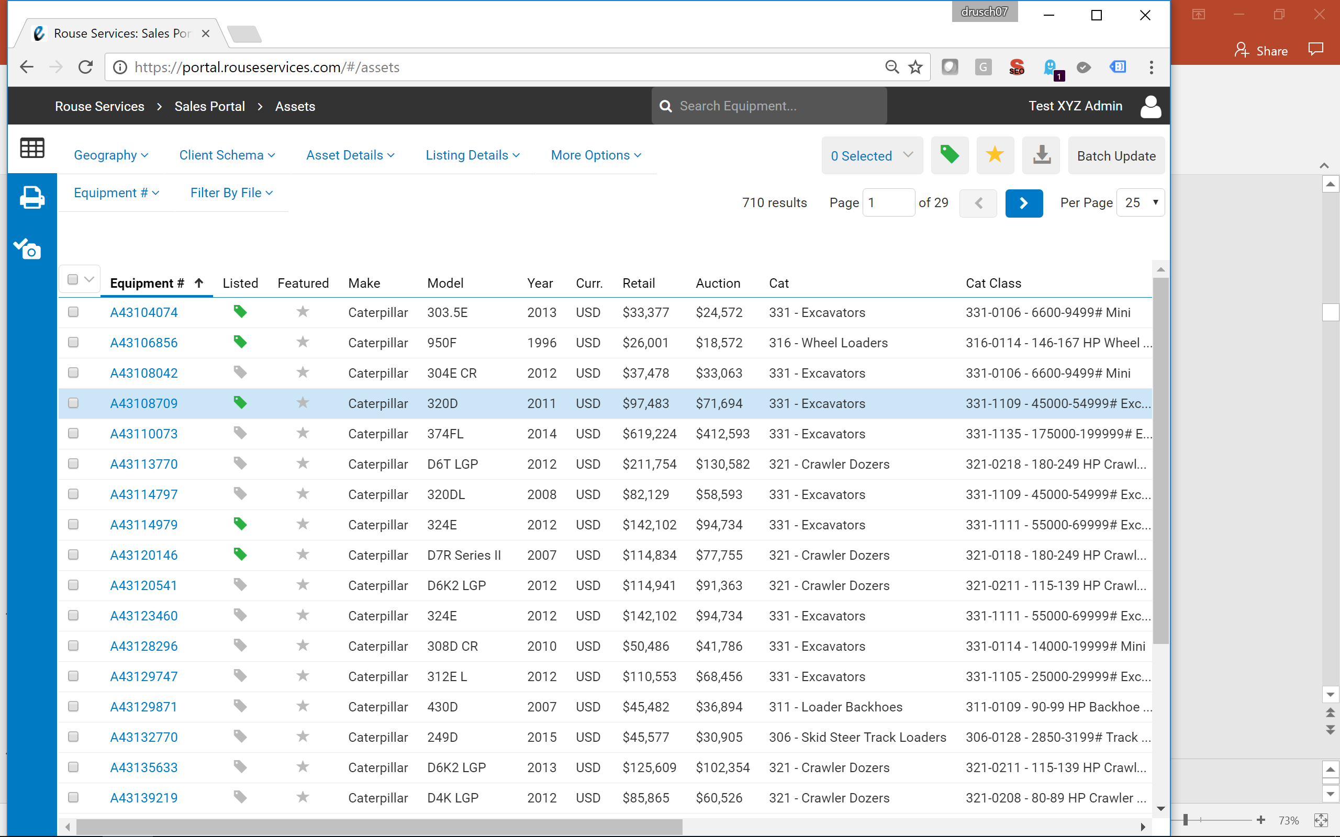
Rouse Sales – In Action
- Retail and Auction Benchmarks
Make better fleet decisions by knowing the latest market value of your machines


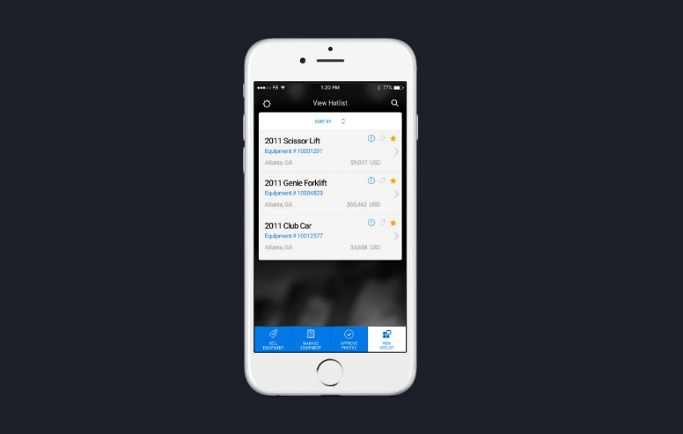
- Automated Pricing Strategy
Keep pricing aligned with the market through automatic monthly updates, subject to your own rules and validations

- Performance Analytics
Benchmark your sales results against the market, and identify opportunities for gain

- Rouse Sales Portal & Mobile App
Manage the entire selling process, all from one place – load equipment photographs, update a price, and list inventory for sale

- Lead Generation
Integrate Rouse’s used equipment catalog into your corporate website to engage prospects and generate leads

- Used Equipment Proposals
Build customized proposals for prospects with just a few simple clicks, increasing quoting activity and decreasing turnaround time

Whether you own 200 machines or 200,000, let Rouse Sales help you drive sales, realize higher recoveries, and make better fleet decisions.

