About

The core team at Kaizen Group are Innovators, Engineers, PhDs and Data Scientists who assist mid-sized companies ($25M- $500M) to capitalise on the enormous potential of the Industrial Internet of Things (“IIoT.”)

Our three business units – Strategy, Sensors and AI – mean that we can provide expert advice to both new entrants and companies already familiar with IIoT.

Founded by our Chief Strategy Officer and serial entrepreneur, Rob Goss, Kaizen is based in London and have plans to open offices in Tokyo and LA in late 2017.

Strategy:

The Strategy team work with customers to navigate the complex world of IIoT and develop world-class strategies for maximising value. We know that connecting assets is not appropriate for every business: sometimes the challenges outweigh the rewards.

However, where an IIoT strategy is appropriate we have the right team to help your company clarify its visions, goals & guiding principles and manage the IIoT roadmap in partnership with your senior team.

Ideas for IIoT strategy development include:

- Opportunities for quality and maintenance improvements
- Potential for offering new services to customers
- Investigating new data, service or product-centric business models
- Developing new revenue streams

Sensors

The Sensor team are focused on innovation using Sensors and MEMS (Micro-Electromechanical Systems.) We view ourselves as the conduit between the vast array of complex sensors and their potential applications in the ‘real world.’

Our main focus is looking at sensor deployments for Buildings, Environment, Factories, Parking, Agriculture, Water, Air and Health.

Infographic (types of sensor)
Please think of a cool way of showing this!

Data & AI

The Data & AI team focus on getting the maximum value from our customer’s sensors. We are a small team of engineers and data scientists who know that the real value from IIoT comes from the quality of sensor data. We monitor and analyse this data and then deliver it to our customers via stunning dashboards.

Infographic
Please think of a cool way of showing this!

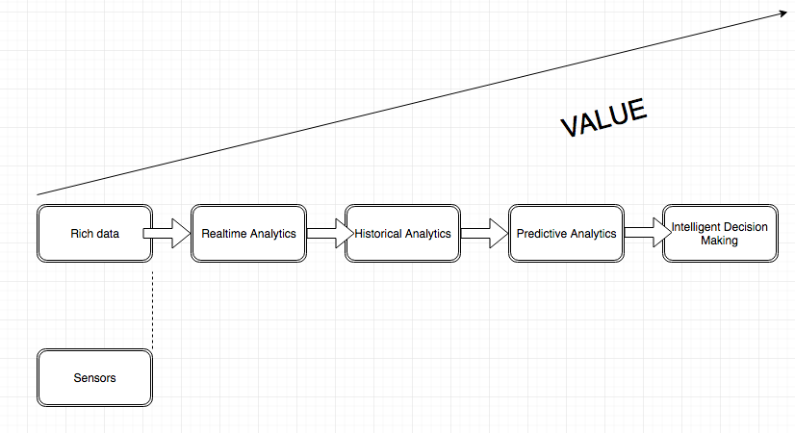

Events

We will be launching some exclusive invite-only events in 2018. If you would like to know, please enter your email address here:

Blogs

Is it possible to have a Blog page that we can independently upload new content to (poss via Hubspot?)

Contact

Kaizen Group

