Cider House Productions
494 Gilbert Street Mansfield, MA 02048 –Tel (781) 469-0005 – Fax (339) 237-5100 – web ciderhouseco.com – email info@ciderhouseco.com
Home Page:
Links: About Us – Contact Us – Check Availability – Gallery – My Event – Services – Testimonials
Front Page will have five different pictures that will fade in that will have captions that load in like
Soundchoiceevents.com web site.

Five different pictures will be: Each Picture will have a click here to learn more about each service.

One: Wedding Couple Picture
Caption: WEDDING SERVICES
We’ll help make your special day unforgettable

Two: Picture of a school prom
Caption: SCHOOL EVENTS
From, Homecoming to Prom we have the skills to make your event the best!

Three: Picture of A Photobooth
Caption: Photo Booths add life to any party!
Capture every moment in style.

Four: Picture of a large meeting with big screens and a keynote speaker
Caption: Corporate Sound, Lighting, Video and Entertainment
We specialize in delivering perfect events with attention to detail

Five: LED Up-Lighting Picture
Caption: Lighting Design
We’ll custom design a lighting package to suit your needs
Text under photos on home page will be:
New England’s finest DJ’s, Photo Booths, Lighting, Video and Sound.
“Creating unforgettable memories one perfect event at a time”

Next text down the page will be:
Cider House is a provider of New England’s finest DJ’s, Photo Booth’s Lighting, Sound
And Video Services. Located in Mansfield, MA and serving the New England area, we believe
In quality service at a reasonable price. Be our next happy customer and give us a call today
To plan your event.

Our Services
Wedding Services
The signature Cider House Productions wedding is a classic New England style wedding with excellent music, tasteful lighting accents, professional videography and classic photo booth finesse. You make up the guest list,
Well do the rest.
DJ’s, LED Up-Lighting, Videography, Photography, Photo Booths and more. Click here to learn about our custom tailored options for your perfect wedding.
Wedding Packages Button to take you to options page:

WEDDING SERVICES
Picture of a Bride and Groom here
We’re not the new kid on the block when it comes to helping you design and execute the perfect Wedding experience. Your Wedding Day is your special day
And you will not be sweating the details the day of your special event. We spend hours with you in advance pre-planning every finite detail to make sure from the perfect execution of your introductions to your final dance, you are the guests of honor and are treated as such. Members of the American Discj Jockey Association, Fully Insured, ready and able to help make your special day unforgettable. Call us to set up a free consultation today.
Our Wedding DJ Packages
CLASSIC WEDDING DJ ENTERTAINMENT PACKAGE | A LA CARTE OPTIONS | A LA CARTE OPTIONS
Up to 5 Hours of professional DJ Entertainment | Photobooths- ulimited sessions, doubleprints, props, and all the fun you can handle! | Wedding Photography ask for packages
State of the art computer based digital sound system with thousands of music tracks  To choose from. Top shelf Shure wireless microphones for MC, toasts and other  Announcements to be heard on your special day. |  | Engagement party combo discounts,
In person, phone and email consultation | Addl Ceremony systems- multiple mic setups, small discreet systems | Custom rehearsal night entertainment
Wedding specialist Disc Jockey | Your initials in lights, also known as a Gobo | Plasma Screens to run slideshow, music videos & end of night event picture show!
 | Screens for slideshows both Plasma and Projection
Individualized Online Wedding Planner which guests can also request songs | Full table Facade available
Second complete DJ sound system, as on-site backup
total price 1199.

A LA CARTE OPTIONS
Photobooths- ulimited sessions, double--prints, props, and all the fun you can handle!
Uplighting – Static or Dynamic.
State of the art lighting, professionally displayed.
Additional Ceremony systems- multiple mic setups, small discreet systems
Logo displayed on dancefloor or wall using a customized gobo projected through a special lighting instrument. Great for a Bride and Grooms initials or brand awareness for a corporate event.
Full table Facade available
Wedding Photography ask for packages
Engagement party combo discounts,
Custom rehearsal night entertainment
Front and rear projection screens, plasma and led display of many different sizes for music videos, live camera display, cocktail reception slideshow and end of reception slideshow of your special day finale! BOOK NOW BUTTON underneath will field you to the check availability portal
Next in Services is Bar/Bat Mitzvahs

New England’s finest Bar/Bat Mitzvah specialists
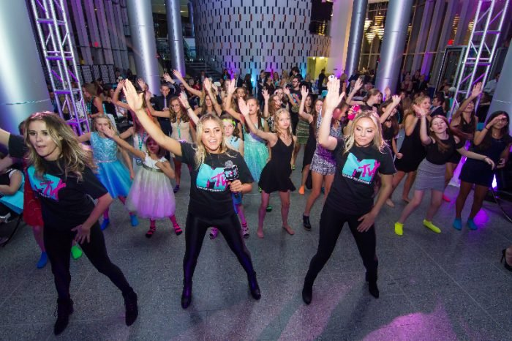

Looking to excite your guests, young & older, with a HIGH ENERGY, professionally run Bar/Bat Mitzvah celebration? Cider House Productions has the perfect combination of energetic MCs, the latest state of the art gear and exciting add-ons such as PhotoBooths, Dancers, Customized Club Style lighting, Videography and more!
.
You’re sure to find a package below to satisfy your individual taste and budget for a fantastic celebration!

Our Bar / Bat Mitzvah Packages
Classic BAR/BAT MITZVAH PACKAGE | prime BAR/BAT MITZVAH PACKAGE | Boss BAR/BAT MITZVAH PACKAGE
Interactive Lead MC who is BarBat Mitzvah Specialist and a second staffer who DJs and assists with the event. | Interactive Lead MC/DJ who is BarBat Mitzvah Specialist and a party DJ dedicated to the music | Interactive Lead MC/DJ who is Bar/Bat Mitzvah Specialist and a party DJ dedicated to the music
Professional Club style digital DJ system with state of the art laptop and controllers. | Professional Club style digital DJ system with state of the art laptop and controllers. | Professional Club style digital DJ system with state of the art laptop and controllers.
All digital music, music video and karaoke library. Thousands and thousands of choices. All music is FCC radio edited for fun family entertainment, young and old. | All digital music, music video and karaoke library. Thousands and thousands of choices. All music is FCC radio edited for fun family entertainment, young and old. | All digital music, music video and karaoke library.  Thousands and thousands of choices. All music is FCC radio edited for fun family entertainment, young and old.
In person, phone & email consultations | In person, phone & email consultations | In person, phone & email consultations
Four hours of music performance and games for kids | Four hours of music performance and games for kids | Four hours of music performance and games for kids
On line, password protected planning page, dedicated to your event | On line, password protected planning page, dedicated to your event | On line, password protected planning page, dedicated to your event
Stage 1 Lighting Package with chasing colored lights, two led disco ball effects and one strobe light hung from a light stand. | two 5 X 7 foot professional front or rear screen projection screens to display music videos, powerpoint media, live camera content and visualizations to liven up your party. | two 9 foot x 12 foot professional front or rear screen projection screens with full velour dress kits to display music videos, powerpoint media, live camera content and visualizations to liven up your party.
Complete second sound-system on site sound system for backup | Complete on site sound system for backup | Complete on site sound system for backup
 | Stage 2 Lighting Package with four moving head club style lighting fixtures, two led disco ball style effects, two laser effects hung from two light stands. | Stage 3 Lighting Package with four moving  head club style lighting fixtures, two led disco  ball style effects, two laser effects, two club style  high powered led black lights (that awesome purple light effect)  two high powered strobe lights with hyper-flash effects (used in blue man group).  All lighting is hung from a 20 foot aluminum concert style truss and suspended  By two pro style crank up lifts.
20 LED R+G+B+A+W+UV, 120 Watt, Battery Powered, completely wireless Up-Light Fixtures.
These are the Cadillac of Up-Lights in the industry and when you want the best effect and look
These are what you are looking for.
 | Awesome Club style sound system with two speakers on stands and one 18” subwoofer cabinet for big bass! | Our best sound system we offer at Cider House. Two speakers on stands, two  Extra large subwoofers with extra large double 15 high output speaker cabinets  That sit on top of the subwoofetrs. If you are looking for the best possible sound  for your event.
20 LED R+G+B+A+W+UV, 120 Watt, Battery Powered, completely wireless Up-Light Fixtures.
These are the Cadillac of Up-Lights in the industry and when you want the best effect and look
These are what you are looking for.
UPGRADE, Motivational Dancer. In addition to our DJ and MC, we
add a motivational dancer to lead and motivate the crowd!
Then a BOOK NOW button which will take you to our check availability portal

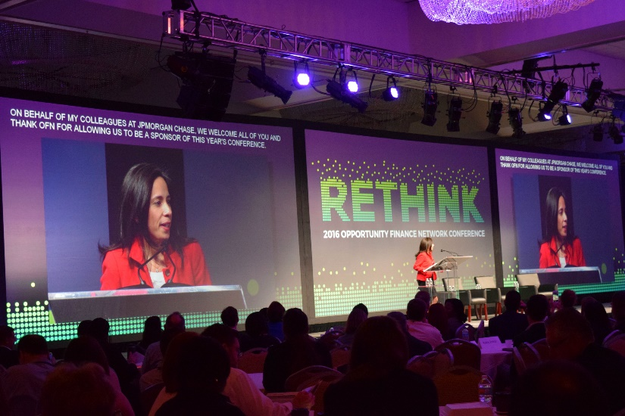

CORPORATE EVENTS

Cider House has all the necessities to bring your corporate event or meeting to the next level. From Entertainment services to A/V solutions, Photobooths, lighting, Corporate team building game shows and other fun team ideas, New England is relying on our solutions for successful events.
Click to explore the options!
Corporate Event Services
This button will bring you to the Corporate Event Options

CORPORATE EVENTS
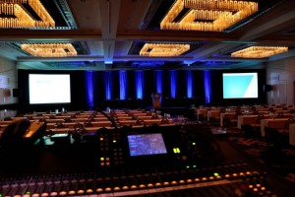
Cider House supports events big and small with DJs, MCs, lighting, (uplighting, club lighting, and theatrical) photobooths, greenscreen, social media, A/V conference support, karaoke, screens, videography, photography, and entertainers from caricature artitst to team bonding activities.
As a corporate event organizer, you are caught between a rock and a hard place. Often you are tasked with finding AV support & entertainment for a diverse group of guests. Cider House will make you look good. We are full time, insured, with fantastic references and roots in the New England area. Bring your corporate event to the next level.

SCHOOL AND FORMAL EVENTS
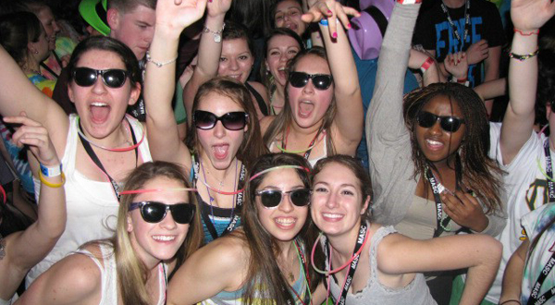
Cider House has everything you need to make your college or high school party or formal look and sound like your favorite club, including the latest in professional lighting & sound, current hot songs and remixes. Let us bring the Club to YOU!
Click to explore the packages and add-ons! Clicking button brings you to options:
School Parties and Formals

SCHOOL Events OptionS

Bring your college or school dance to the next level with New England’s finest DJ’s from Cider House Productions!
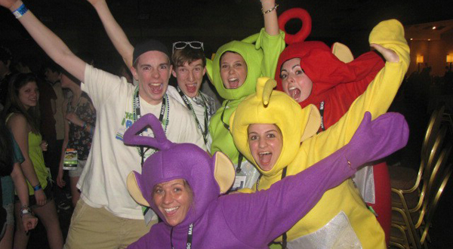
Students demand a high energy, fun party with a club feel of awesome mixes, flashing lights and all their favorite songs! School staff and administrators want a fun, professional DJ who knows how to please the students, keep the lyrics clean and everyone on the dance floor. We get our music, karaoke and music videos from Promo Only, a leader in radio edited music content. We also carry full liability insurance for peace of mind.
Start with our Foundation System and add your upgrades to customize to your liking.
We Include: • A Cider House party specialist Disc Jockey
• Complete sound system with Professional beat mixing digital sound, two pro DJ speakers on stands, professional amplifier(s) and controller, professionally presented in a flight case, with extensive and CURRENT music selection.
• FCC radio edits of your favorite hits. We receive updates of the newest and freshest music on a daily basis .
• Up to four hours continuous music-no breaks, (event prep, setup, break down, travel time included in price but does not count as part of your four hours of play time)
• Basic light show- lights add energy to the night! (includes two led effects)
Add anything or everything below to the Foundation package to put your party in FULL EFFECT & make the dance floor pop!
Photo Booths, Club Lighting, GreenScreens, Big Sound & more!

SOUND UPGRADES:
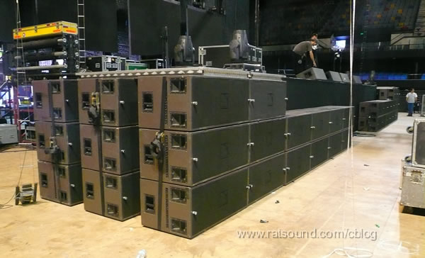
Choose from Subwoofers to ‘TURN UP THE BASS’ (needed for crowds of 100-500). More than 500 people in your crowd? We’ve got you covered!
LIGHTING UPGRADES:
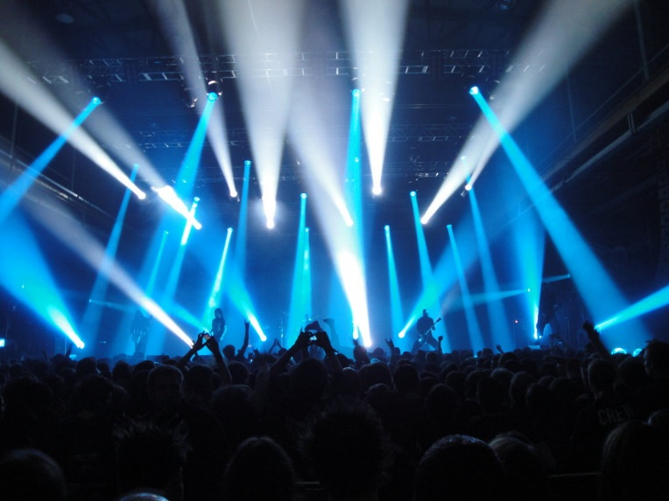
*BLACK LIGHT parties are all the rage this year- upgrade to a 1600W (or LED equivalent) black light party.
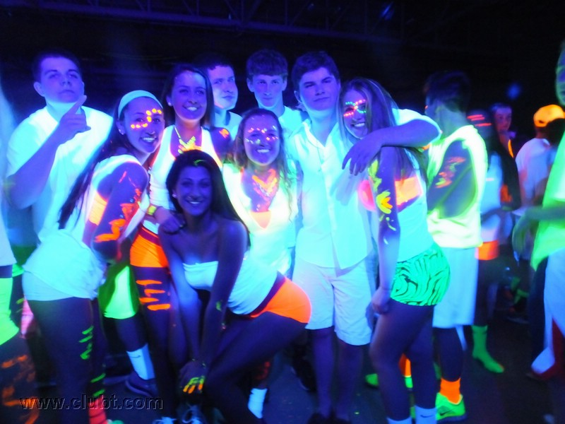
*LIGHTING UPGRADE X1: 8 multi-colored LED light-Bar that chases to the beat of the music, two led effects, one laser effect, one strobe light.
*LIGHTING UPGRADE X2– Four club style moving head fixtures, two club style strobe lights with special effects, two laser effects, two led effects all hung from two crank up, heavy duty, light stands with crossbars.
*LIGHTING UPGRADE X3– Eight club style moving head fixtures, two club style strobe lights, four high intensity led uv black lights, 4 led effects, 2 laser effects. All lighting displayed professionally from a 20 foot concert style truss and suspended high over the dance floor from (2) 16 foot crank up towers!

PHOTO-BOOTHS:
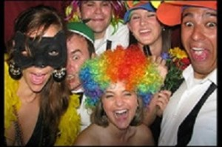*
Enclosed or Open Air Booths
*Unlimited use
*THE best costumes & props to add ALL the silly!
*Instant pics & double prints
*Digital copies of all photos AND social media options!
VIDEO OPTIONS:
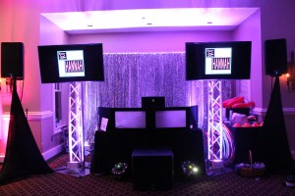
50″ Plasma Screens to show dance videos, class slideshows and an ‘End of the Night’ slideshow of all the fun during the dance!
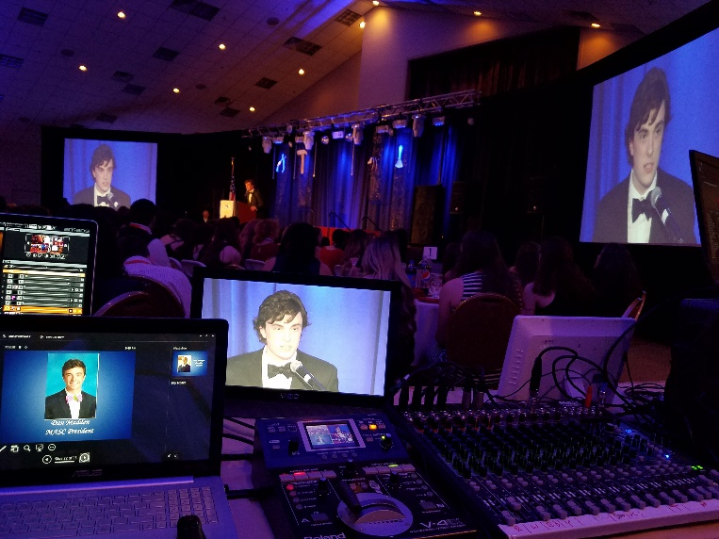
120” (5 X 7 Foot) or 180” (9 Foot X 12 Foot) Pro style front or rear projection screens to display MTV music videos from all genres, live camera shots from the dancefloor, visualizations, powerpoint content, senior slideshows or any other media you can imagine at your event!
GREENSCREENS:
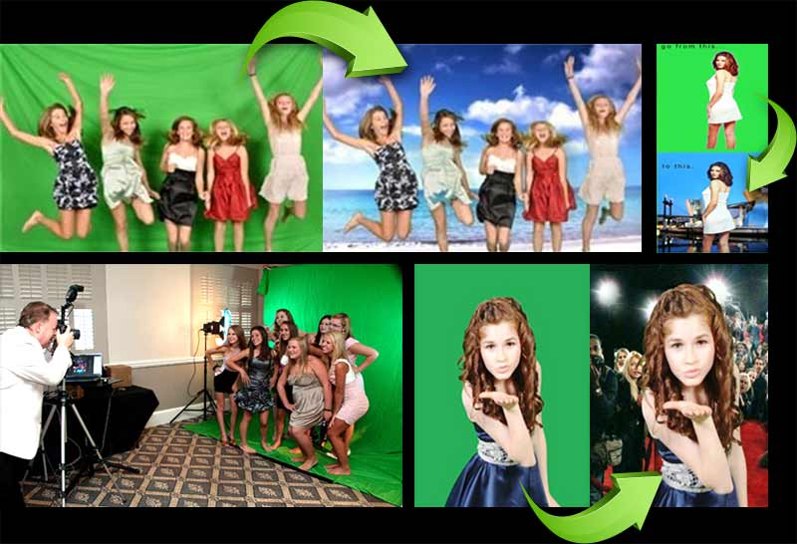
This is one of our most popular Photo options at High School & College parties to date! TURN UP the fun and join your friends on a travel adventure to the World’s hottest nightclubs, best destinations and even to steal the cover of your favorite magazine! We can even create backgrounds related to your theme; Mardi Gras, Tropical, Sports, Racing, Club Party, Hollywood, Travel Adventure, Glamour and more! Put your party IN EFFECT with this awesome memory to take home!Book Now

BIRTHDAYS, REUNIONS & GENERAL PARTY SERVICES

Whether it’s a Birthday, Reunion, Graduation, Family Get Together, Sweet 16, Quinceanera, or Retirement party, we’ve got everything to make your party into an unforgettable celebration!
Click to explore the options!
Birthdays, Reunions & General Party Services

BIRTHDAYS, REUNIONS & GENERAL PARTY SERVICES
Whether it’s a Sweet 16, Quinceanera, Reunion, Graduation, Birthday or Retirement party, we’ve got everything make your party into an unforgettable celebration! Our extensive music library has over 200,000 songs to keep your guests moving, including everything from Top 40 to ‘Oldies’, Classic rock to EDM, Reggaeton, Reggae, Swing/Electro Swing, Hip Hop, Trap, Bachata, Salsa, Cumbia and more!
Having an international/intercultural event? We’ve performed at many international events playing everything from Latin, Indian, Korean, Greek, ‘African’, Persian, Haitian, Assyrian music and more!
Whatever your party, whoever your guests may be, we make sure everybody has fun!

OUR PARTY SERVICES
Here’s what we bring to the party:
Cider House Pro DJ– This is where the fun starts! Have peace of mind knowing you have New England’s favorite DJ service, with seasoned pros experienced getting a crowd moving, young & old!
Extensive, all digital music library with hundreds of thousands of songs, including radio edited tracks, making it suitable for all ages!
Pro Set, pitch adjustable, all digital systems, expertly presented in flight cases with pro controllers and high end laptops. No beginner set-ups found here!
Top of the line sound system – 2 speaker, professional sound system on speaker stands with high quality audio file sound perfect for all ears!
Our DJ/MCs can announce any special activities and be as interactive on the microphone as you require. Or we can just bust out the tunes without all of the chatter if that is what you want. It’s your party, we cater to what you want.
‘A La Carte’ services to add the FUN to every celebration
PhotoBooths – Enclosed or ‘Open Air’, our booths do it all; OUTRAGEOUS prop packages, pics right away, color or B&W, double prints, social media options, hashtag printing and scrapbooks! Unlimited photo sessions included.
Green Screens – take your guests on an adventure to the Wonders of the World or smack dab in the middle of a magazine cover without ever leaving your party and the pics to prove it! Your friends will be amazed.
LED Uplighting – Transform any hall to a destination experience with warm colored light in any color.
Dance lighting-from the classic disco ball to full club lighting systems on custom aluminum trusses and pro lifts to get the lighting up high over the dance floor.
On site Gaming Stations & Game shows– too much fun to be believed!
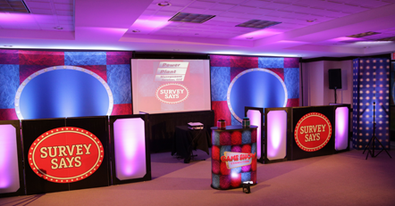
Karaoke – no explanation needed. You’re the star!
Video Dance Parties-From 80’s and 90’s theme parties with all your favorite decade MTV music videos and beyond. Your guests will be talking for weeks.
Projectors for presentations with A/V support
Photography
Videographers
Book Now

PHOTOBOOTHS & GREEN SCREENS

PhotoBooths are a great way to add the FUN to your BIG party and we have some great options for you! We have both enclosed & Open Air options. Prints right there, on the spot, customized text, props, social media stations, greenscreen, we are your Photo Booth and Green Screen resource!
Click for packages and options!
PhotoBooth Packages & Green Screens

PHOTOBOOTHS & GREEN SCREENS
PhotoBooth & Green Screen experience with Cider House: The momento your guests will actually take home!
Life is short, make sure you give your guests the opportunity to capture all of the fun moments of your event on paper. There is nothing better than taking home all of those silly photos from a party that are yours to remember forever. We even have social media kiosks that can instantly upload your pics to facebook and twitter!

*Enclosed or Open style PhotoBooths, Memory books, hashtag printing, custom text, red carpet effects, Green screen, Hashtag printing, Graffiti walls,
For more info contact us to get your party in FULL EFFECT!

Our Photobooth Packages
A- GREAT FOR HOUSE PARTIES AND BUDGET CONSCIOUS PLANNERS! | B-  EVERYTHING IN A, PLUS ENHANCEMENTS BELOW! | A LA CARTE OPTIONS:
Four Hours of Unlimited use of booth | Four Hours of Unlimited use of booth | Social Media station -guests have option to send strips  to email, phone, facebook, and more!
Photobooth Deliver, Operation & Removal | Photobooth Deliver, Operation & Removal | Red Carpet effect- Red Stanchion, Glow red carpet for  the full affect.
Booth is attended by our friendly staffer! | Booth is attended by our friendly staffer | Memory book– We provide all of the materials  (book, embellishments, glue, paper, etc) and our  staffer assembles the book and guides guests on  how to write personal notes in the memory book!
Digital Photo delivery | Digital Photos delivery | Greenscreen with pictures printed right on the spot  via our high speed dye sub printers, with props, and a  digital copy of all photos! With five choices of your image,  we can put your guests anywhere in the world!  Photographer, GS backdrop, light boxes, camera,  laptop and dye sub printer
Color or B&W Strips: You choose! | Color or B&W Strips: You choose! | Hashtag printing- Fantastic for private parties and corporate  events! Printer kiosk, Dye sublimination printer, and hashtag  printer setup.
Personalized Banner on each strip | Personalized Banner on Each Strip | LED Up-lighting – enhances any booth package,  25 per static fixture!
Fun Props included -hats, glasses, signs, an ever changing assortment to liven up the strips! | Fun Props included -hats, glasses, signs, an ever changing assortment to liven up the strips! | Prints for all in booth- the Standard package gives two  strips per session- upgrade to get up to six strips per session  for larger groups!
Photo station style with pro-lights and backdrop! | upgrade! To a booth style- both open and closed styles available! | Ultimate Prop package- Take it to the next level with more  than twice the props of the standard offering!
 | upgrade! High Speed Printer – 8 second photos, with double strips printed right on the spot! | Inflatable, curved backdrop option!
 |  | Lead capturing options for our corporate clients
Memory Book scrapbook service-scrapbook,
pens, supplies.
 |  | Multiple prints for each person in booth
Price is just 575.! | Price is just 695! | Video Messaging- your guests leave a video message  along with the traditional photo strip experience!
Book Now

About Us
Cider House Productions, is here for you. You are the star of your event. We are here to make your
Event dreams a reality. Our seasoned pro’s have the skills to take your dream and ideas and
Deliver them in an event that will be worry free for you. We take great pride in our work and it shows
In the outcome. Making satisfied customers one perfect party at a time is our philosophy. We are by no means the biggest, but we do feel we are the perfect size to provide our customers with amazing service at a very reasonable price. Give us a call today and let our professional staff show you the Cider House difference!

Staff:Tommy Walsh - Owner


