Stationary Design
We are a Western Australian Independent Public Primary School called Ocean Road Primary School.
We are looking for a new fresh and modern stationary design that reflects our innovative open minded approach.
The school colours are in the teak, turquoise range, basically ocean colours as the school is literally 3 minutes away from the beach and has ocean views.
Feel free to incorporate the school motto: Be Your Best
LIST of DELIVERABLES:

#1: Brand identity elements:
- business card

- stationary - basic package including

  - letterhead (print ready)
  - envelope design
    - DL 110 x 220
    - DLX 120 x 235
    - A4 229 x 324 and (all print ready)
  - template for invoices (delivered as PDF file and Word file)
  - cover page for annual report (digital file)
  - Notepad A4

- PowerPoint template (delivered as PP file)

- Social media banners & logo avatars (delivered as digital files. Facebook, twitter, pinterest, instagram, google plus)

- With compliment slip (DL size - 210mmx 99mm)

- Thank you card (A6)

- A2 poster background (420mm x 594mm)

#2: Brand promotion elements:

- Staff -T - shirt design - long sleeve and short sleeve polo - (Delivered as mock up and digital file / vector)

- Sport banner (roughly 1800mm x 3000) – needs to be in a darker colour please

- Featherbanner (196 x600mm) compare sketch

Attachments:
Photos of school logo and school uniform
3 x Scan of current stationary
Photo of current uniform and staff shirt
Sketch for feather banner

Student jumper: 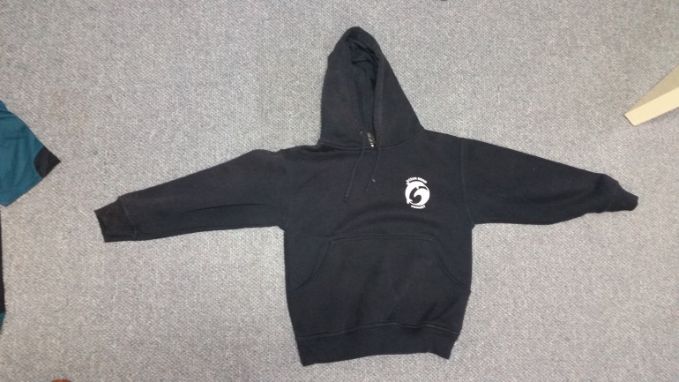

Student short sleeve polo: 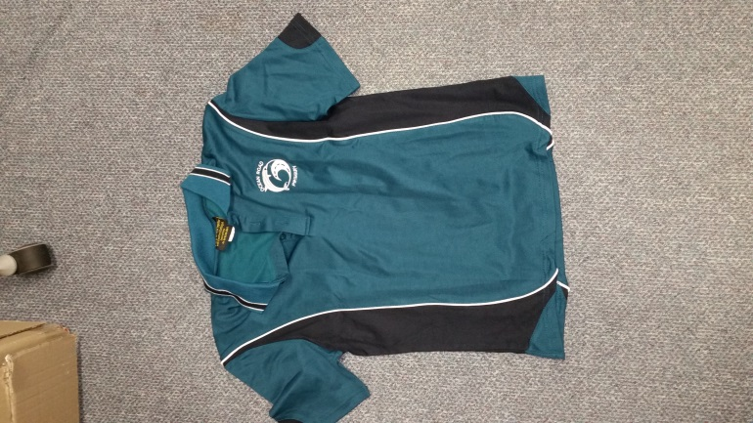

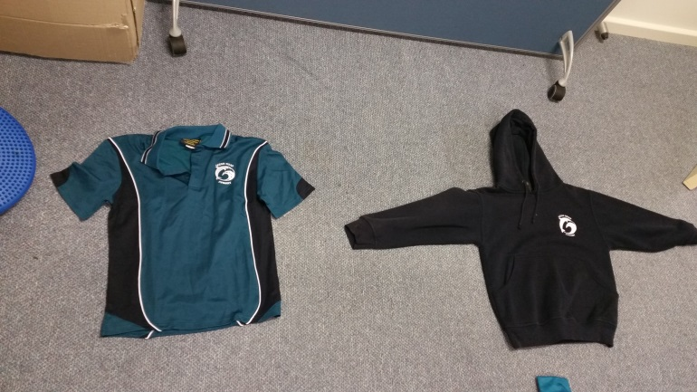

School logo and signage: 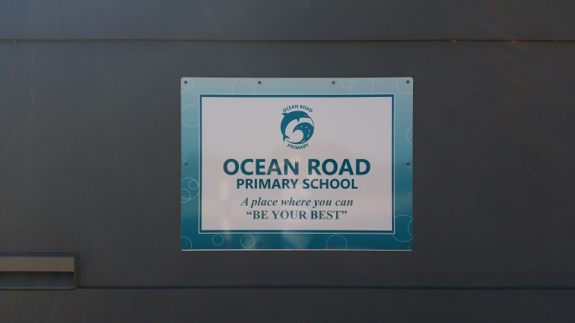

School logo and signage2: 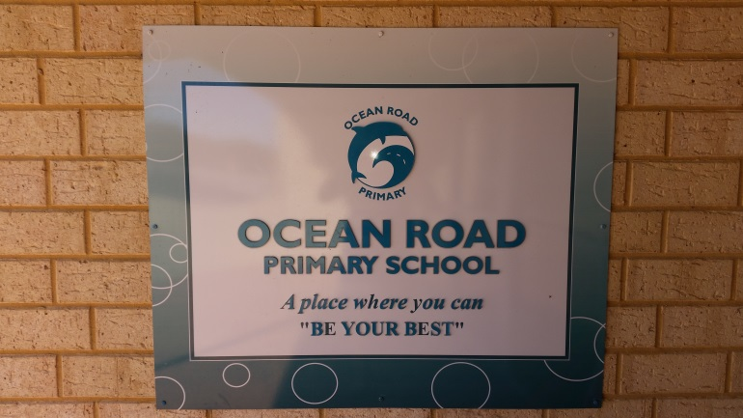

Staff polo long sleeve: 