Embellishments Creative Brief

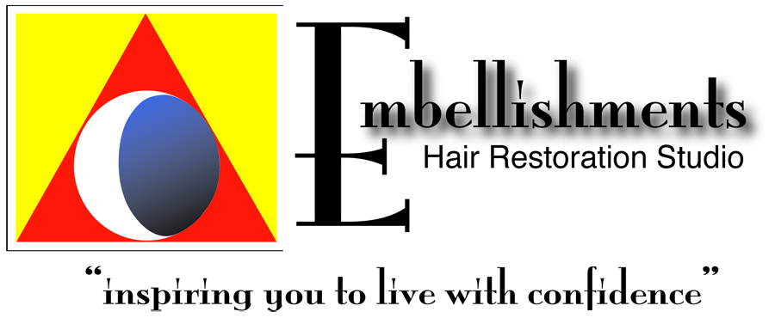

http://www.embellishmentshairrestorationstudio.com/blog/

Proposal Needs

- Advertising Creative for ½ page ads
- Advertising Creative for 5x7 cards for hand out
- Creative for 4 x6 postcard mailings
- Flyer for passing out

Target

Women and Men suffering hair loss due to heredity, damage, or medical issues.
- 55+
- Early pattern hair loss 25+

Product
- Anti-Aging Hair Restoration
- Hair Loss Prevention

Problem: As you age, your hair growth begins to slow and blood flow in the head and scalp that rejuvenate hair growth slows. Embellishments service, laser, and maintenance program is designed to stimulate blood flow for hair growth and works at the follicle, cellular level.
** Products that build up on the scalp due to silicones and clogs follicle funnels that prevents any of the moisturizing from your products topically that do not work
- Using a deep penetrating condition that is supposed to benefit the scalp, but can’t because you’ve got this build up
- From chemotherapy – post chemo services to revitalize the cells and keeps the cells healthy during that process (can do it during and after). Follicle won’t be collapsed. Didn’t lose as much hair and helped hair to grow back healthy. Clarifying scalp care and laser.
- Thinning Improvement of Fullness & Density to Aging Hair – within 3 months and noticeably different in 6 months
- Lengthen the hair as well

Your Service - Why it works

Certified Trichologist and Cosmetologist, Jeannine Wright

Step 1: Consultation & Scalp Analysis – computerized scalp analysis through Capillascope 50-200X magnification of scalp. Analysis of:
** Sebum production
** Build up of product and sebum that clogs the follicle funnels to thin and stops growth of hair (slow and inhibit)

Step 2: Prescription Trichology program - Scalp and Hair Care - Products to Use
** Scalp clarifier
** Prescribed Shampoo
** Prescribed Conditioner
** Prescribed topical to encourage hair growth

Step 3: In-studio or home laser treatment

- Stimulate blood flow
- Products that work internally and externally
- On molecular level that revitalize hair follicle
- Laser FDA Cleared – grows hair and facilitates growth in hair with live follicle
- Long run maintenance and care – topical and internal
  - Oral supplements
  - DHT inhibiting shampoo and conditions
  - Natural products to clarify the scalp & penetrate the dermis
  - Stimulate the follicle

Why Us vs Competitors

- Helps restore your confidence
- No contract – pay based on service
- Fashion & Beauty consultation and services included. We match your hair restoration services so that you will look your BEST, when you step out of our studio

Competitors

http://www.hairclub.com/
http://health.com-www4.site/article/hair-loss-products?cid=9c17759e9cc22ec0265abf8de400ff18&first_visit=1&keyword=women+hair+loss
https://www.bosley.com
http://allusionshair.com/

Results

- Reverse Damage / Proatively prevent Hair Loss
- Using a deep penetrating conditioner to clarify (unclog) the scalp and hair. Detoxify clogged scalp and reverse damaging effects of over-use of shampoos and chemicals.
- Post chemotherapy services to revitalize the cells and keep the cells healthy during the process (can do it during and after). Follicle won’t be collapsed via chemotherapy. Clients reported results: didn’t lose as much hair and helped hair to grow back healthy.
- Reverse thinning - Hair Fullness & Density– within 3 months and noticeably different in 6 months
- Lengthen the hair as well

