(header) SAFETY INVESTM​ENT AND INNOVATIONS

“Railroads’ annual investments to modernize and improve America’s freight rail network have significantly contributed to freight rail’s strong safety record. There is a direct correlation between the increase in rail network investments and enhanced safety performance.”

(Side info box):
Since 2000:
• The train accident rate fell 38 percent
• The rail employee injury rate fell 47 percent
• The grade crossing collision rate fell 42 percent

POSITIVE TRAIN CONTROL (PTC)
Since 2008, freight railroads have worked closely with the federal government and passenger railroads to implement PTC — the largest and most complex safety system in the history of the railroad industry. This cutting-edge technology is designed to automatically stop a train before certain accidents occur.

Emergency Response Training
Each year, thousands of emergency responders and railroad and shipper employees receive specialized training through individual railroad efforts and industry programs.
(photo)

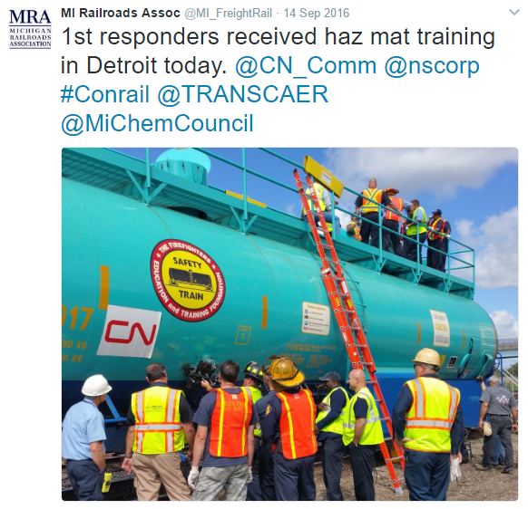

“Today, 99.999 percent of all hazmat moved by rail reaches its destination without a release caused by an incident. This strong safety record is among the many reasons the federal government requires railroads to transport hazmat.”
(Somehow show the 99.99% in a prominent way, please)

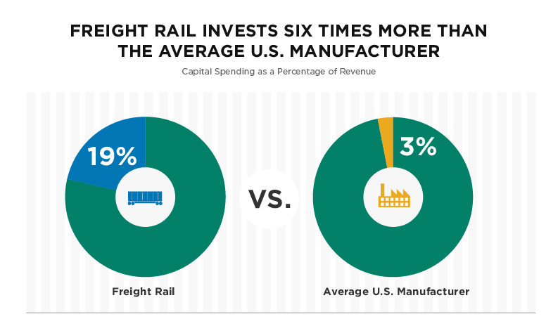
(separate info box)

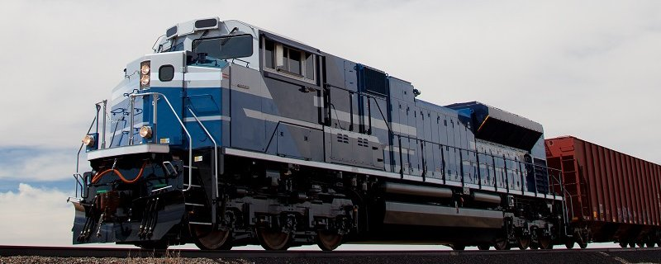
(use photo as background as needed)

