AIR SPRINGS
TQA-AB07 | BPW TYPE 30K (1V8609)
TQA-AB07 | -
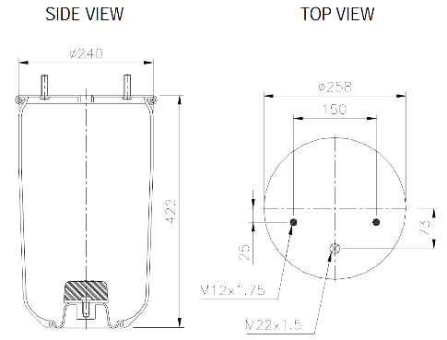 |  | REPLACES
 |  | Goodyear | ContiTech |  | BPW – Type (30K)
 |  | 1R11-703  566-22-3-501 | 940MB |  | 05.429.42.20.0  05.429.40.91.0
 |  | ITAL | Phoenix |  | Taurus
 |  | IT9070G | 1DK21K |  | UR732-01
 |  | Replacement Pistons
 |  | BP1265 (metal) |  | BP1270 (plastic)

TQA-AB09 (No Piston)  TQA-AB11 (Metal Piston)  TQA-AB14 (Plastic Piston) | BPW NO PISTON TYPE 36 (1V6013)  BPW TYPE 36 (1V6013) PLASTIC PISTON  BPW TYPE 36 (1V8966) METAL PISTON
 | -
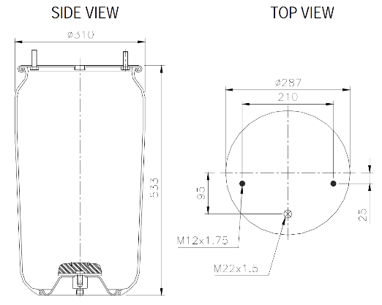 |  | REPLACES
 |  | Goodyear | ContiTech |  | BPW – Type (30K)
 |  | 1R11-703  566-22-3-501 | 940MB |  | 05.429.42.20.0  05.429.40.91.0
 |  | ITAL | Phoenix |  | Taurus
 |  | IT9070G | 1DK21K |  | UR732-01
 |  | Replacement Pistons
 |  | BP1265 (metal) |  | BP1270 (plastic)

TQA-AB40 | AIRLINER 6813200017 (1V9781) ALLY PISTON
TQA-AB40 | -
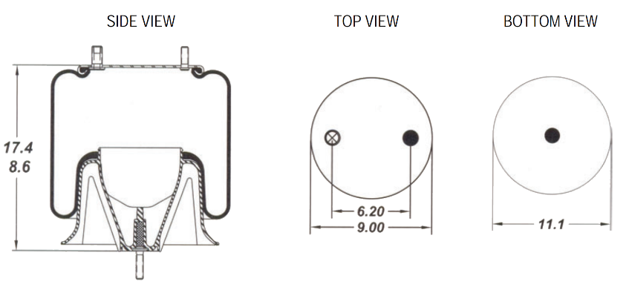 |  | REPLACES
 |  | Goodyear | ContiTech |  | BPW – Type (30K)
 |  | 1R11-700  566-22-3-500 | 941MB |  | 05.429.42.25.0  05.429.40.03.0
 |  | ITAL | Phoenix |  | Taurus
 |  | IT9060G | 1DK21 |  | UR730-1
 |  | Replacement Pistons
 |  | BP1265 (metal) |  | BP1265 (metal)
 |  |  | Alternate
 |  | BP1854 Air Spring – includes piston

AIR SPRINGS
TQA-AB23 | HENDRICKSON 57122-002 (1V9373)
TQA-AB23 | -
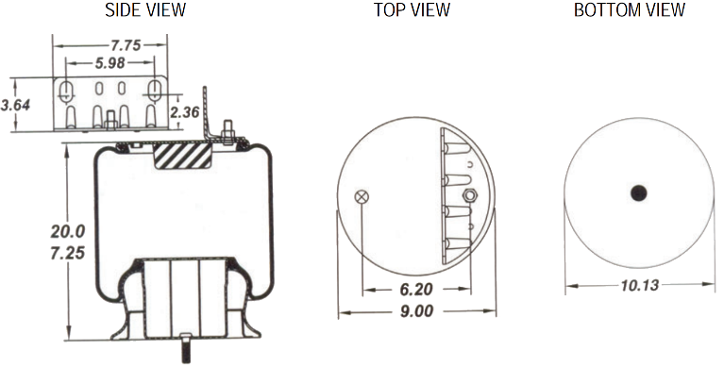 |  | REPLACES
 |  | Goodyear | Firestone | Hendrickson (HAS)
 |  | 1R12-403, 1R12-420  1S12-030, 1S12-029  566-2 4-3-097 | 9373, 9297  1T15MT8 | 57122-002  58849-002  57122-1  56624-1-019  50898-1  50898-2
 |  |  | Hino
 |  | 49710-2880

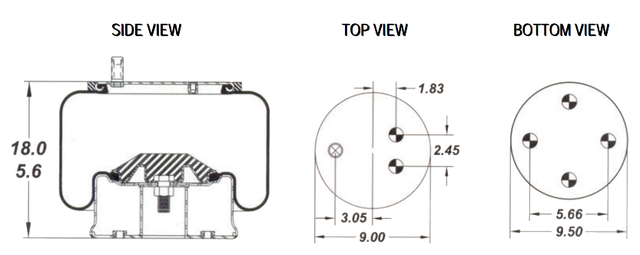
TQA-AB42 | HENDRICKSON S20010 (1V9270)
TQA-AB42 | -
 |  | REPLACES
 |  | Goodyear | Firestone | Hendrickson (HT230)
 |  | 1R13-119  566-2 6-3-053  566-2 6-3-036 | 8800, 9270  1T15VM-3.5  1T15VM-4 | S-21208  C-20010  C-21208  C-20559

TQA-AB97 | HENDRICKSON C20124 (1V9265)
TQA-AB97 | -
 |  | REPLACES
 |  | Goodyear | Firestone | Hendrickson (HT250)
 |  | 1R12-375  566-2 4-3-097 | 9265  1T15MM-9 | C-20124
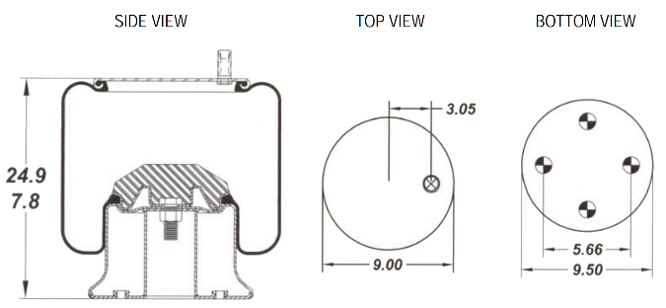

TQA-AB19 | HENDRICKSON 49048-002
TQA-AB19 | -
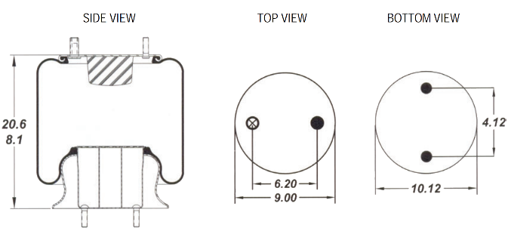 |  | REPLACES
 |  | Goodyear |  | Firestone |  |  | Hendrickson (HA Series)
 |  | 1R12-365  1R12-197  566-24-3-038 |  | 9466  1T15MT-6 |  |  | 50405-002L  49048  49674
 |  | Mack |  |  | Taurus
 |  | 57QL411M |  |  | KR504-04
AIR SPRINGS
TQA-AB25 | HENDRICKSON HT300 B4771
TQA-AB25 | -
 |  | REPLACES
 |  | Goodyear | Firestone |  |  | Hendrickson (T15, T17, HT300)
 |  | 1R14-039  1R14-083  566-28-3-015 | W01-358-8050  1T19ZK-5.7  1T19J-6 |  |  | S-4771  36514-13
 |  | ITAL
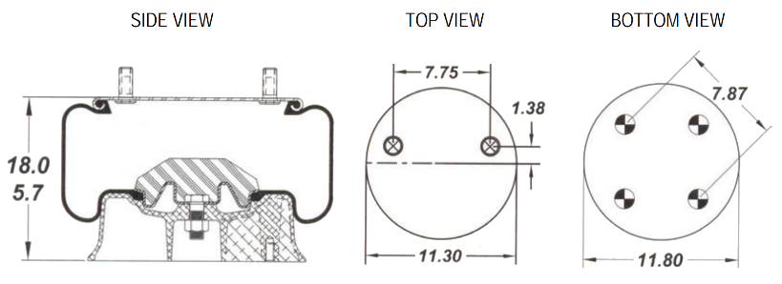 |  | 1685174C1, IT9051

TQA-AB69 | AIRGLIDE 100 (1K9422) (1V9422)
TQA-AB69 | -
 |  | REPLACES
 |  | Goodyear | Firestone | ITAL
 |  | 1R11-028  566-22-3-021 | 9422  1T15L-1.5, 1T15KW-1.5 | 554762C1  IT9050
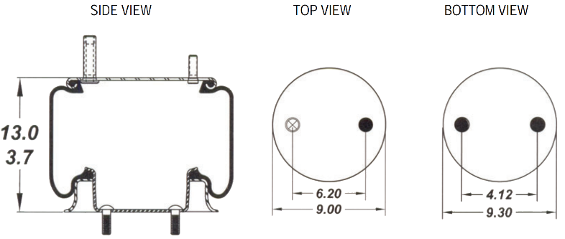 |  | Kenworth (Airglide 100)
 |  | K303-6, -14, -15

TQA-AB46 | YORK 61610121 (1V9082)
TQA-AB46 | -
 |  | REPLACES
 |  | Goodyear | Firestone | Hendrickson (T15, T17, HT300)
 |  | 1R14-039  1R14-083  566-28-3-015 | W01-358-8050  1T19ZK-5.7  1T19J-6 | S-4771  36514-13
 |  | ITAL
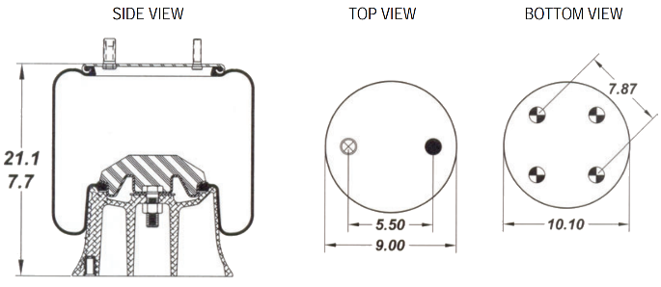 |  | 1685174C1, IT9051

TQA-AB16 | ROR 21221307 (1V6297)
TQA-AB16 | -
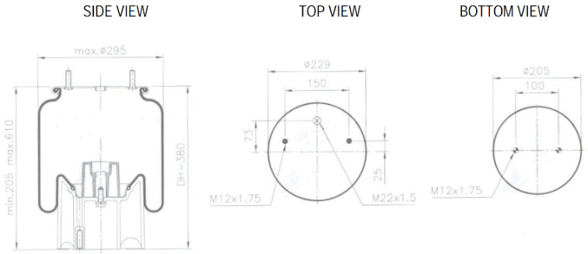 |  | REPLACES
 |  | Goodyear | Firestone |  | ContiTech
 |  | 1R11-111, 566-22-3-521 | 6297, 1T15MP-7 |  | 4157N P04
 |  | ITAL | Meritor (ROR Flexair) |  | Phoenix
 |  | IT9071 | 2501202, 295034-A, 21221307 |  | 1DK21 A-8
 |  | Krueger (RFS2000) |  | Holland (9T E & U Series) Taurus
 |  | 95034-A, 51295031 |  | KR915-54
AIR SPRINGS
TQA-AB37 | MERITOR 21215632 (1V6345)
TQA-AB37 | -
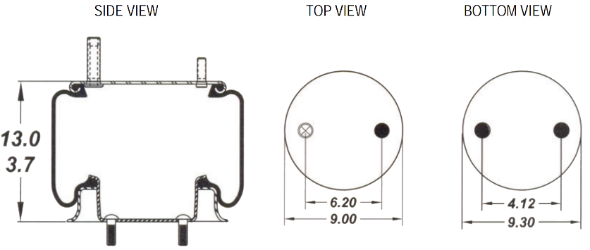 |  | REPLACES
 |  | Goodyear | Firestone |  | ContiTech
 |  | 1R14-716  566-28-3-5 48  56628-3-021 | 7337, 8775  1T19F-7 |  | 810MB
 |  | Phoenix | SAF |  | Taurus
 |  | 1D28A-2 E1 | 2228000200, 2229000200 |  | KR621-26
 |  | York (Tecair 1 & 2) | ITAL |  | Meritor (ROR)
 |  | 61506243 | IT9056 |  | 12108082, 21215632  21208082

TQA-AB16 | ROR 21221307 (1V6297)
TQA-AB16 | -
 |  | REPLACES
 |  | Goodyear | Firestone |  | ContiTech
 |  | 1R11-111  566-22-3-521 | 6297  1T15MP-7 |  | 4157N P04
 |  | ITAL | Meritor (ROR) |  | Phoenix
 |  | IT9071 | 2501202, 295034-A,  21221307 |  | 1DK21 A-8
 |  | Krueger (RFS2000) |  | Holland (9T E & U Series) Taurus
 |  | 295034-A  51295034 |  | KR915-54

TQA-AB37 | MERITOR 21215632 (1V6345)
TQA-AB37 | -
 |  | REPLACES
 |  | Goodyear |  | Firestone |  | ContiTech
 |  | 1R14-716  566-28-3-548  566-28-3-021 |  | 7337, 8775  1T19F-7 |  | 810MB
 |  | Phoenix |  | SAF |  | Taurus
 |  | 1D28A-2 E1 |  | 2228000200, 2229000200 |  | KR621-26
 |  | York (Tecair 1 & 2) | ITAL |  | Meritor (ROR)
 |  | 295034-A  51295034 | KR915-54 |  | 12108082, 21215632  21208082

AIR SPRINGS
TQA-AB87 | YORK TECAIR 505859-01
TQA-AB87 | -
 |  | REPLACES
 |  | Goodyear | Firestone |  | ContiTech
 |  | 1R14-705  566-28-3-547 | 6364, 6339  IT19L-11 |  | 813MB
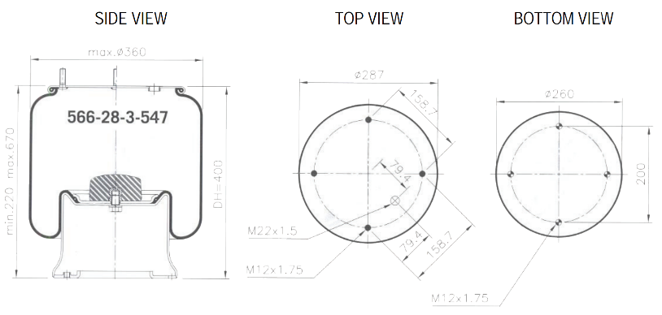 |  | Phoenix | ITAL |  | Kassbohrer
 |  | 1D28B-2 E2 | IT9057 |  | 4731030000  4731033000
 |  | Meritor (ROR) | SAF |  | Taurus
 |  | 21215633 | 2229000300,  3228000300 |  | KR622-26
 |  | Volvo |  | York (Tecair 2)
 |  | 1622116 |  | 61505859

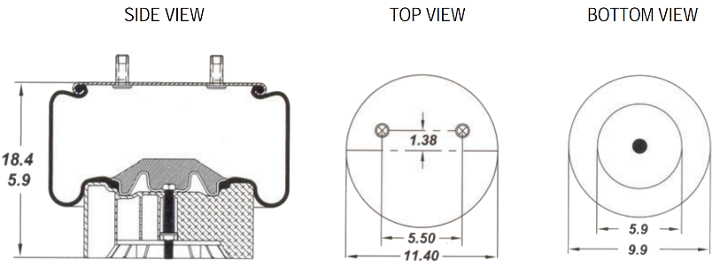
TQA-AB15 | HENDRICKSON C21784 (1K8091)
TQA-AB15 | -
 |  | REPLACES
 |  | Goodyear | Firestone | Hendrickson  (INTRAAX AA250)
 |  | 1R14-171  1R14-093  566-28-3-015 | 8083, 8091  1T19FC-5  1T19FC-6 | C-21784  S-20901

TQA-AB17 | HENDRICKSON C21800 (1K8709)
TQA-AB17 | -
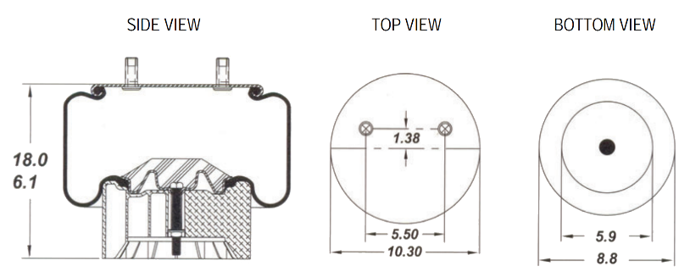 |  | REPLACES
 |  | Goodyear | Firestone | Hendrickson  (INTRAAX AA230)
 |  | 1R13-159  566-26-3-073 | 8709, 8751  1T17CA-5 | C-20900  S-21800

AIR SPRINGS
TQA-AB45 | MERITOR 21222442 (1V7074)
TQA-AB45 | -
 |  | REPLACES
 |  | Goodyear | ContiTech | Firestone
 |  | 1R11-106  566-22-3-521 | 4157 N P05 | 7074  1T15MP-7
 |  | Meritor (ROR FL9000 9T Standard) | Phoenix | Taurus
 |  | 21222442 | 1DK21 A-3 | KR913-57
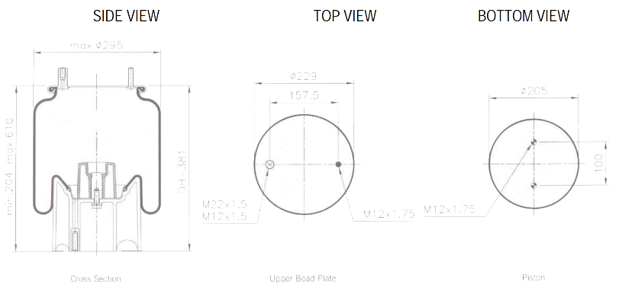

TQA-AB60 | NEWAY 90557212
TQA-AB60 | -
 |  | REPLACES
 |  | Goodyear | Firestone |  | Neway
 |  | 1R12-552  1R12-372  566-24-3-038 | 9471  1T15V-8 |  | 90557212
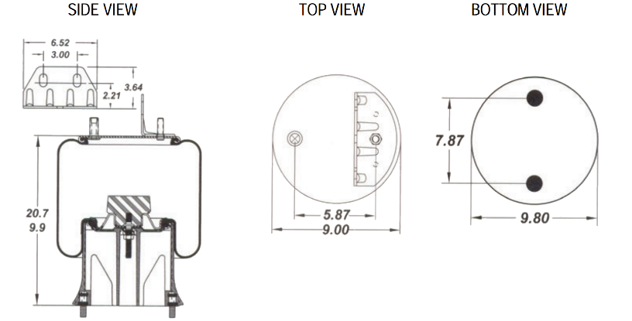 |  | Neway |  | Mack Titan

TQA-AB59 | AIRGLIDE 200 (1V9622)
TQA-AB59 | -
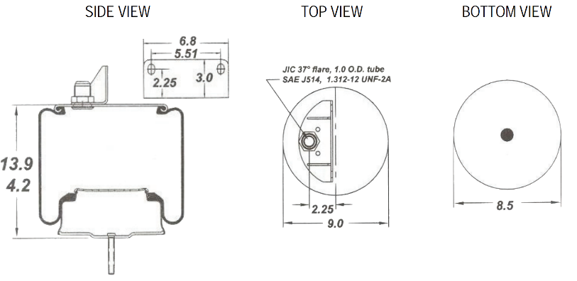 |  | REPLACES
 |  | Goodyear | Firestone | Kenworth  (Airglide 200)
 |  | 1R11-221  566-22-3-021 | 9622  1T15LA-(-1)  1T15KW-0 | K-303-22

AIR SPRINGS
TQA-AB32 | HENDRICKSON S7128 (1V9156)
TQA-AB32 | -
 |  | REPLACES
 |  | Goodyear | ContiTech | Firestone
 |  | 1R14-727  566-28-3-020 | 4813NP07 | W01-M58-7358  1T19F-11
 |  | Phoenix | Scania | Taurus
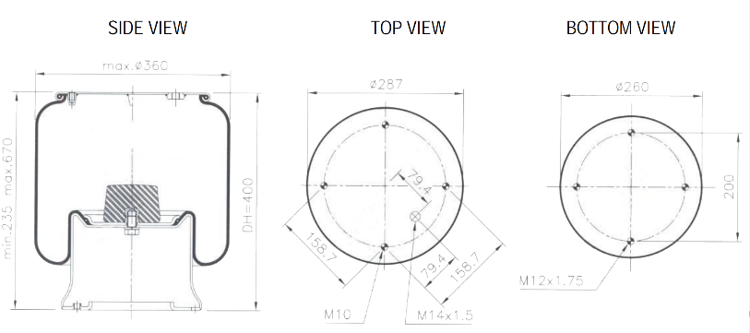 |  | 1D28B-9 | 255295, 298568, 1107674, 1314906,  255293, 325748 | KR622-01

TQA-AB?? | -
TQA-AB?? | -
 |  | REPLACES
 |  | Goodyear | Neway | Firestone
 |  | 1R12-484* | 90557215 | W01-358-9504
 |  | * Same as Goodyear 1R12-486 except with a bracket. Neway 90557216

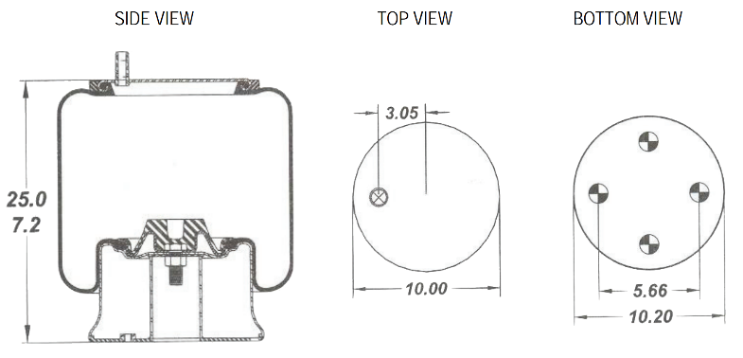
TQA-AB84 | HENDRICKSON C20127
TQA-AB84 | -
 |  | REPLACES
 |  | Goodyear | Firestone | Hendrickson
 |  | 1R13-118  1R13-081  (Replaced by  1R13-118)  566-26-3-068 | 9262  9580  1T15VLT-10.5  1T15V-11 | C20127  C20414 (Rotate 45 Degress)

AIR SPRINGS
TQA-AB60 | NEWAY 90557212
TQA-AB60 | -
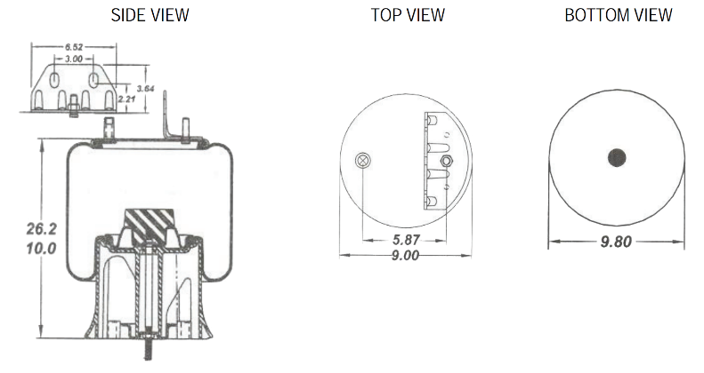 |  | REPLACES
 |  | Goodyear | Firestone | Neway  (AD-123/246-10)
 |  | 1R12-504  566-24-3-066 | 9471  1T15V-8 | 90557146  90557182  (Remove Bracket)

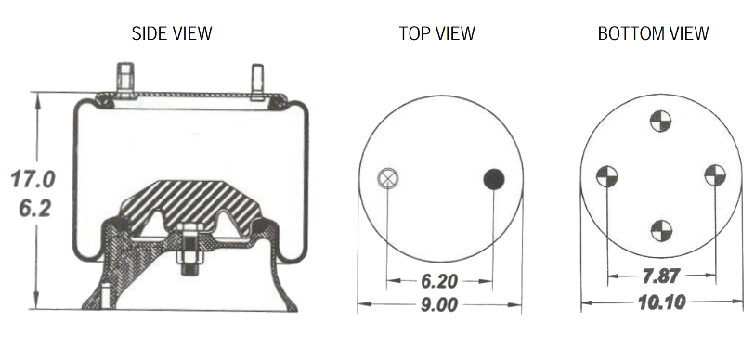
TQA-AB89 | YORK TECAIR FB 61610122
TQA-AB89 | -
 |  | REPLACES
 |  | Goodyear | Firestone | York (FB Tecair)
 |  | 1R11-039  566-22-3-143 | 9439  1T15L-4 | 61610122

TQA-AB10 | BPW TYPE 30 (1V8619)
TQA-AB10 | -
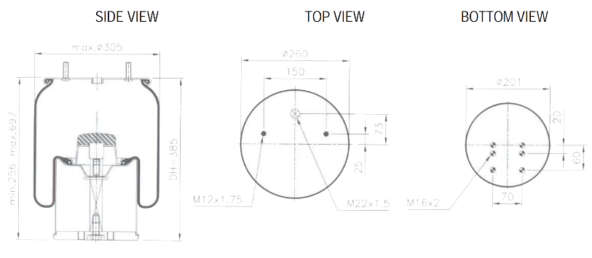 |  | REPLACES
 |  | Goodyear | Firestone | Springride
 |  | 1R11-762  566-28-3-522 | W01 M58 8619  1T17D-8.3 | D11B38
 |  |  | BPW (Type 30)
05.429.43.20.0, 05.429.40.10.1, 05.429.40.28.1
05.429.40.36.1, 05.429.41.24.1

AIR SPRINGS
TQA-AB86 | VOLVO 8061151 / 8169818
TQA-AB86 | -
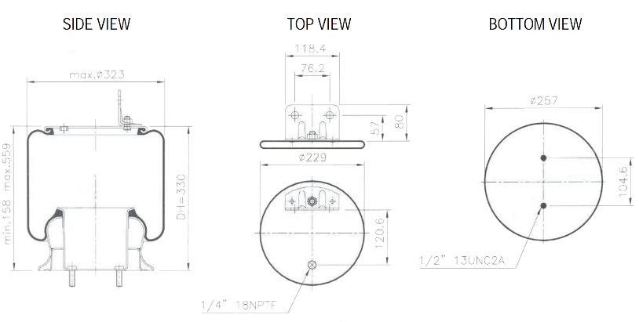 |  | REPLACES
 |  | Goodyear | Firestone | Volvo
 |  | 1R12-400  566-24-3-038 | W01 358 9296  1T15M-6 | 8061151  8169868

TQA-AB46 | YORK 61610121 (1V9082)
TQA-AB46 | -
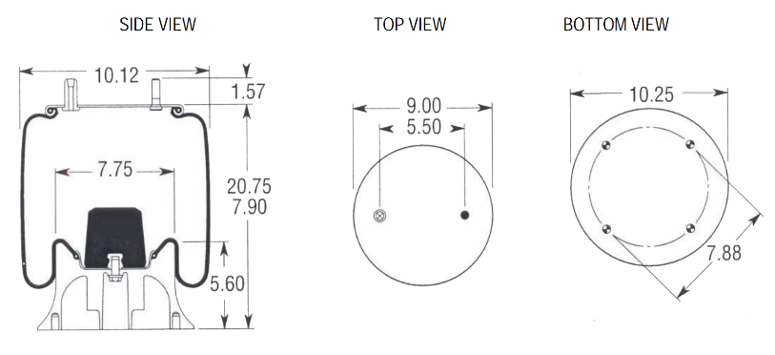 |  | REPLACES
 |  | Goodyear | Firestone | York
 |  | 1R12-547  566-24-3-097 | W01 358 9082  1T15M-6  Metal Piston | FB VRH Air Suspension  61610121

TQA-AB85 | MTC 626104 / 642
TQA-AB85 | -
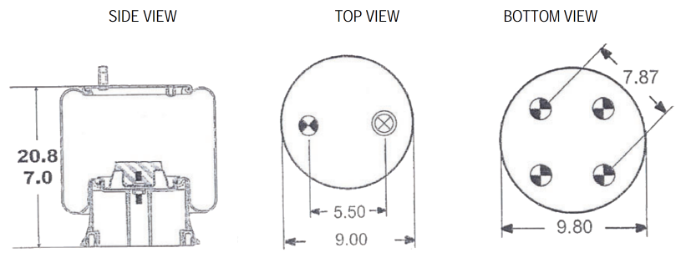 |  | REPLACES
 |  | Goodyear | TMC
 |  | 1R12-642  566-24-3-038 | 626104  Composite Piston

AIR SPRINGS
TQA-ABV2B07R | HENDRICKSON LIFT S23114 (2B5263)
TQA-ABV2B07R | -
 |  | REPLACES
 |  | Goodyear | Firestone | Hendrickson
 |  | 2B10-226  578-92-3-250 | W01-358-7795  20F | B14486  S14486
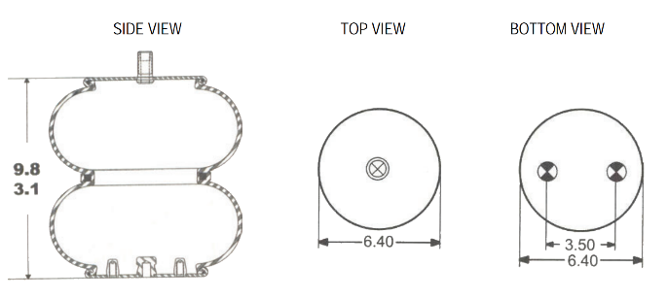

TQA-AB94 | NEWAY 90557155 (1V9144)
TQA-AB94 | -
 |  | REPLACES
 |  | Goodyear | Firestone | York
 |  | 1R13-047, 566-26-3-051 | W01-358-9141 | 61610443
 |  | Neway
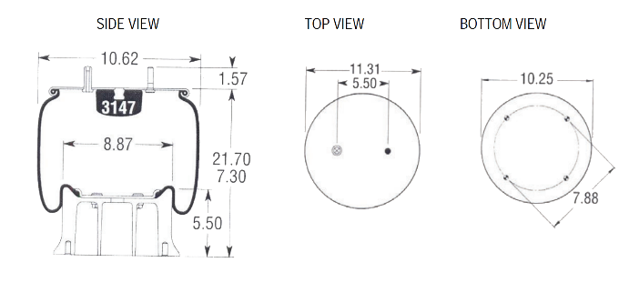 |  | 90557110

TQA-AB72 | AIRGLIDE 460 C81-1005 (1V9541)
TQA-AB72 | -
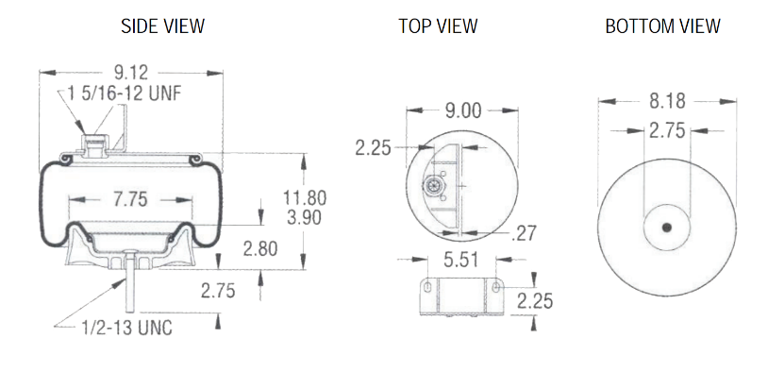 |  | REPLACES
 |  | Firestone | Kenworth (Airglide 200, 460, 690)
 |  | W01-358-9541  1T15LA-0, 1T15KW-0 | C81-1005

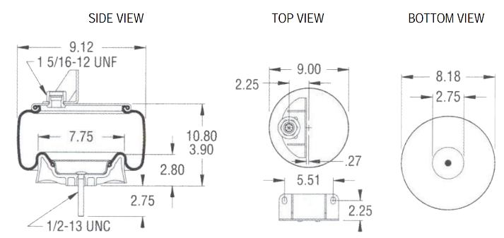
TQA-AB90 | AIRGLIDE 460 C81-1004
TQA-AB90 | -
 |  | REPLACES
 |  | Firestone | Kenworth (Airglide 200, 400)
 |  | W01-358-9547  1T15LA-(-1), 1T15KW-(-1) | C81-1004

AIR SPRINGS
TQA-AB98 | K-HITCH S-0107G
TQA-AB98 | -
 |  | REPLACES
 |  | Firestone | Fuwa KHitch
 |  | W01-358-8637 | S-0107G
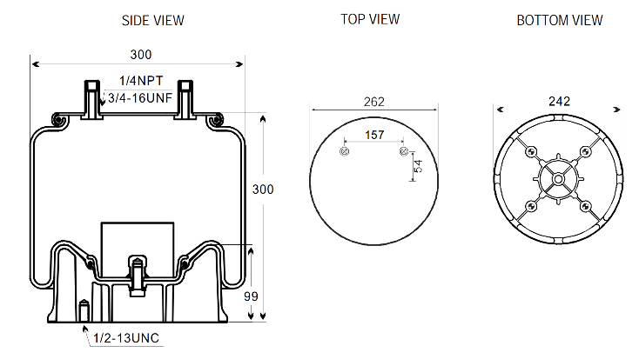

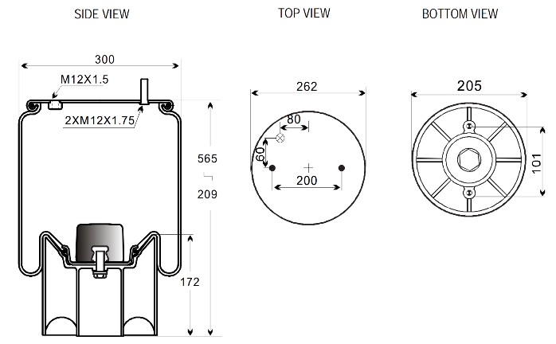
TQA-AB83 | MERITOR CS-9 21229214
TQA-AB83 | -
 |  | REPLACES
 |  | ArvinMeritor | Firestone
 |  | 21229214 | W01-M58-8608  1T17DJ7

TQA-AB66 | VOLVO 20427803 (1K7803) (1V6035)
TQA-AB66 | -
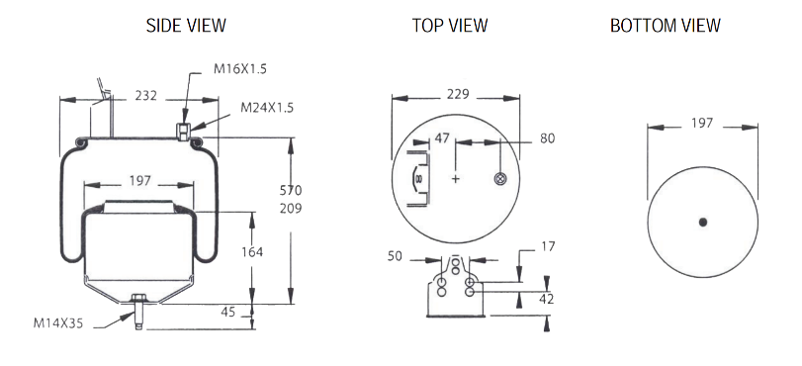 |  | REPLACES
 |  | ContiTech | Firestone | Volvo
 |  | 6605NP01 | 1T15LNR-6 8472 | 20582206  20427803

AIR SPRINGS
TQA-AB55 | VOLVO 1076416 (1K6416) (1V6030)
TQA-AB55 | -
 |  | REPLACES
 |  | Goodyear | ContiTech | Phoenix
 |  | 1R10-704  566-20-3-504 | 6608NP01 | 1DF17B-1
 |  | Volvo
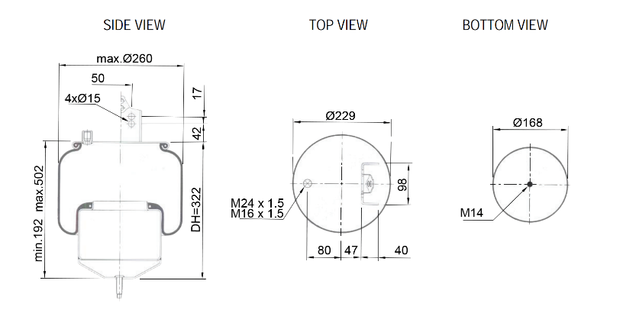 |  | 20531985, 20582215

TQA-AB58 | HENDRICKSON C23721 (1V9644)
TQA-AB58 | -
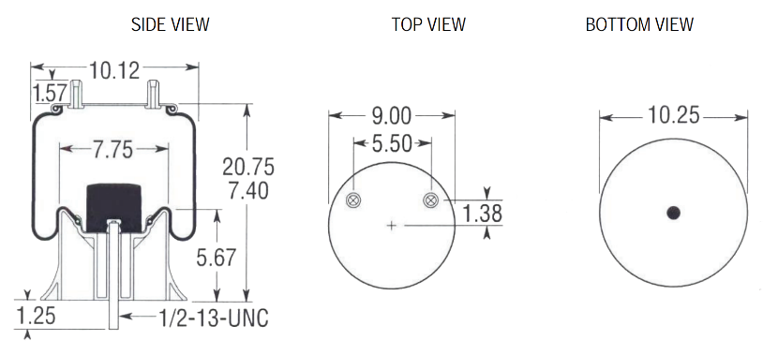 |  | REPLACES
 |  | Hendrickson | Firestone
 |  | C23721  S23721 | 1T15MBTW-6 9644

