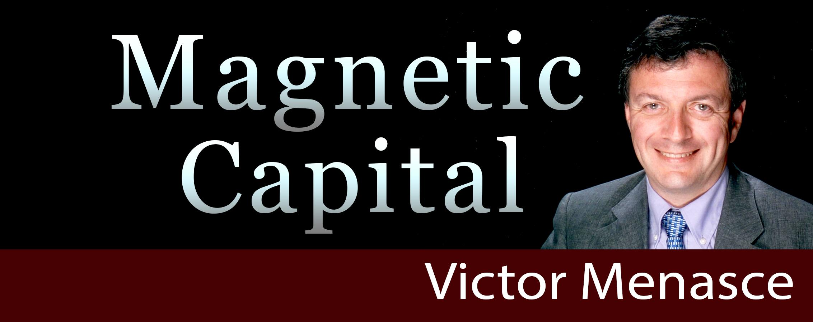

My personal introduction is:

Developer and Consultant who turns ordinary people into millionaires through real estate.

My latest book is Magnetic Capital. www.magneticcapitalbook.com

The logo tagline should be:
Inspire, Design, Excel

