Spring Diagnostics
Is a premier diagnostics lab with a focus on women’s health (may branch other into other disciplines beyond women’s health/fertility).

We want the new logo design to differentiate us visually, from a color-choice as well, from what exists in the marketplace. Many labs use color schemes with blue, grey and greens.

We would like a new logo created based around the various meanings of the word “spring”:
- Spring – as in spring water, a well, water of life
  (water spring, really like this abstract component)
(wrong colors for a spring but like the design)
 logo could be letter “S” for spring, while also looking like a water drop

- Spring – a mechanical spring, representative of springing forward, progress
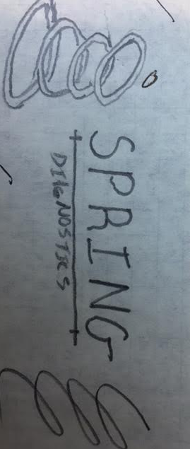
- Spring – as the season spring, representative of growth, nurture, new life, hope, vitality (least favored option, unless you are such a creative genius that this design blows all the other ones out of the water!)
 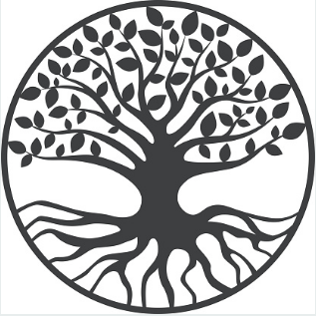Note: ovum, family circle, life

Note: the images you see are just some ideas that we liked, but not a mandatory direction for you to follow

Please integrate the brand traits, as applicable, into the visual look of the logo:
- Trusted
- Unique
- Reliable
- Efficient
- Simple/easy
- Innovative
- High-quality
- Adaptable
- Service oriented
- Upscale

Design files should be vector based/line drawing (adobe illustrator):
- One in black/white/greyscale
- In addition, a handful of color variations suggestions presented

Logo should not have the company name fully integrated/become the logo. In other words the example #1 below where the logo has the name of the company is in close proximity is preferred, but not entirely integrated as in #2.
- Yes: you can get creative about where the name is located ()
- No: 

Here is a logo of a lab we really like:  (clean, simple - even the font ties to the logo)

