-------------------------------------------------------
RtDUET
1 Minute Promo: https://www.youtube.com/watch?v=kFoJ3y6EhIM
5 Minute Demo: https://www.youtube.com/watch?v=XwUVcapftcg

RtEMIS
1 Minute Promo: https://www.youtube.com/watch?v=P1-42UbzZRY

Cipher (More detailed video on Cipher functionality being worked on)
1 Minute Promo: https://youtu.be/vaW6Z1D7t6Q

Link to a video highlighting our Cipher connect and its configuration. https://www.dropbox.com/s/x7aa7nlpihejbk3/Cipher%20Connect%20Setup%20Tool.mp4?dl=0
Link to a video preview of our Cipher live cloud broker. https://www.dropbox.com/s/31305y401qimyq6/Cipher%20Live.wmv?dl=0
-------------------------------------------------------
RtTech (and under its previous ownership) has been building industrial applications since 2002 and in the last 24 months we have moved our applications into a SaaS model using cloud services. In this new model we also built a data connector that runs embedded on edge devices and provides flexible and robust connectivity to OSISoft PI. Careful selection of edge devices technology combined with significant attention paid to developing a flexible and certified data collector was key to having quality and reliable data for our industrial apps in the cloud.

RtTech’s New Cipher suite can be fully deployed on an edge device OR it can use an edge device to connect assets that would normally not be connected for monitoring. The Edge Gateways and Industrial PCs are a great fit for RtTech’s Cipher deployment strategy and provide edge connectivity.

Our latest version of our industrial apps are rolled up into a new suite of Industrial IoT apps called Cipher. Cipher is RtTech’s NEW fully integrated, flexible IIoT solution that:

- Is not based on any 3rd party platform
- Is a full Infrastructure and is 100% owned by RtTech
- Delivers Industrial Apps without the historian prerequisite
- Takes advantage of today’s cloud based technology
- Allows traditional on site deployments if required

The Cipher suite offers:
- High Connectivity
  - Windows and Linux platforms
    - Single connector supports simultaneous multi-server connections
    - Embedded hardware solutions
      - Edge Based Analytics
      - Distributed load balancing on edge devices.
  - OPC Certification
- Optimize networking and storage to support scalability
  - Secure data transport using AMQPs or HTTPs
    - AMQPs (Advanced Message Queuing Protocol Secure)
  - Advanced compression algorithms
  - Token based connection security
  - Redundancy on collectors and disconnected data collection
  - Continuous integrity monitoring with notifications
- Advanced triggers with dynamic and complex logic
- Centralized management console
- Integration layer (RESTful API)
- Interactive + adaptable dashboard
- Native iOS + Android mobile apps with push notifications
- Multilingual functionality including complex language definitions
- Login-based security with role definitions
- Embedded diagnostics
  - Audit logs
  - Application exceptions
  - Health checks
-------------------------------------------------------
Company Info: Founded in 2011
Web: www.rttechsoftware.com
Key contact: Keith Flynn, President and Co-Founder
Vertical: Industrial IoT
One liner description:
RtTech Software provides industrial analytics applications that help manufacturing companies improve their asset availability, asset utilization, and utilities consumption.
Executive Summary:
RtTech products connect to multiple sources around your plant, including any PLC, DCS, meter or data historian aggregating environmental, production, and operational data. Data is automatically monitored to increase data accuracy and eliminate manual recording from the manufacturing process. Customized dashboards and user-level permissions ensure every level of operations can see and measure areas that directly impact their business metrics. The company currently offers two products; RtDUET manufacturing analytics which include 16 out-of-the-box KPI calculations and RtEMIS which offers valuable energy reports.

-------------------------------------------------------
An abstract for upcoming 2017 conference presentation:

RtTech is working in the Industrial IoT space connecting wireless sensors using industrial edge devices to OSIsoft’s PI. RtTech has developed an embedded data connector that allows for easy edge deployment and high connectivity for PI. The embedded data connector allows for collection of data using the IIoT MQTT protocol and OSISoft’s WebAPI or OMF connectivity.

This new IIoT connector has several features that makes it attractive to connect devices that traditionally would not be connected.
1. It is both Linux and Windows based and embeddable on most industrial edge devices,
2. It is OPC UA certified, Very Important point.
3. It provides n-way failover,
4. It provides local buffering,
5. It allows for auto PI tag creation and population of data,
6. It provides a live cloud based broker,
7. It allows for Cellular data connectivity.

RtTech is currently executing a project using this new technology with a large company in Moncton NB to add assets to PI that would not normally be connected in PI due to the high cost of cabling, API computers, and general maintenance cost of the supporting hardware.

-------------------------------------------------------
Some sample images I was aiming for but not looking quite professional enough.

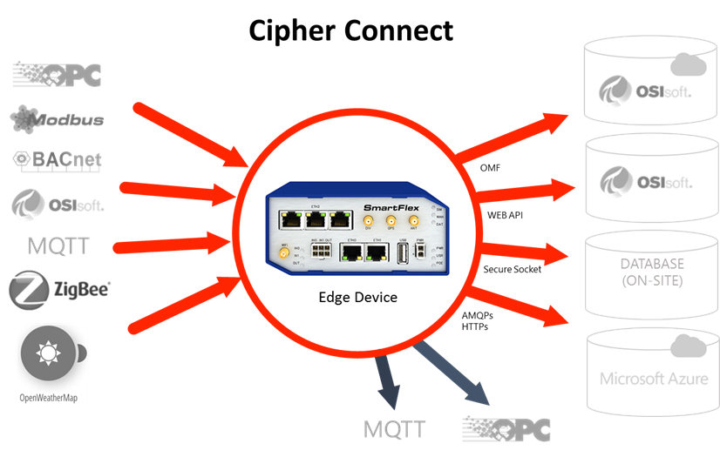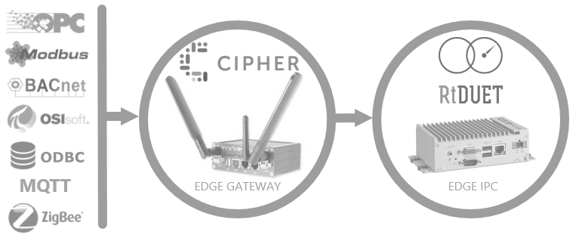

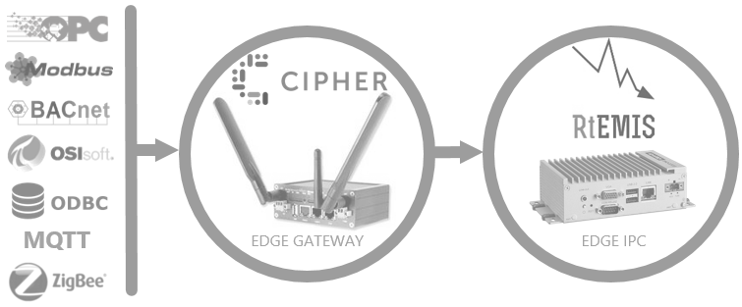

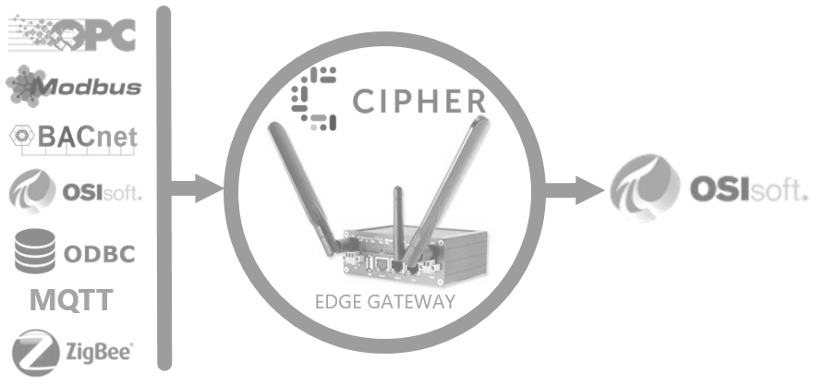

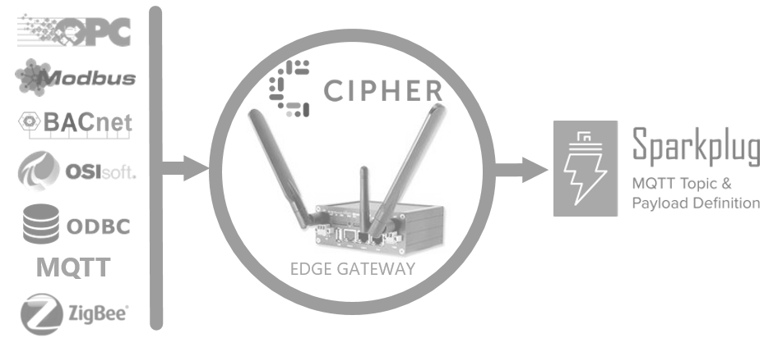
This one is the closest to what I need.

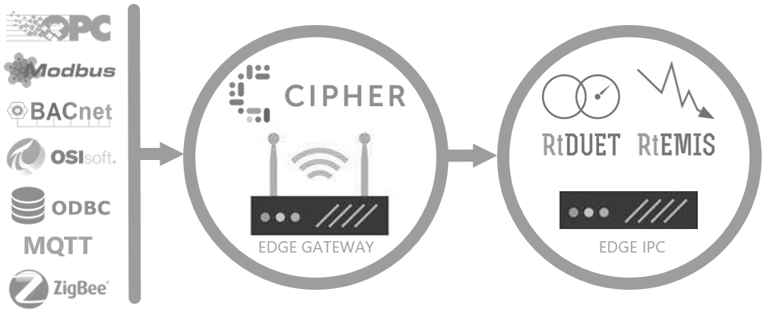

There is also a PowerPoint included to use for images and ideas.

