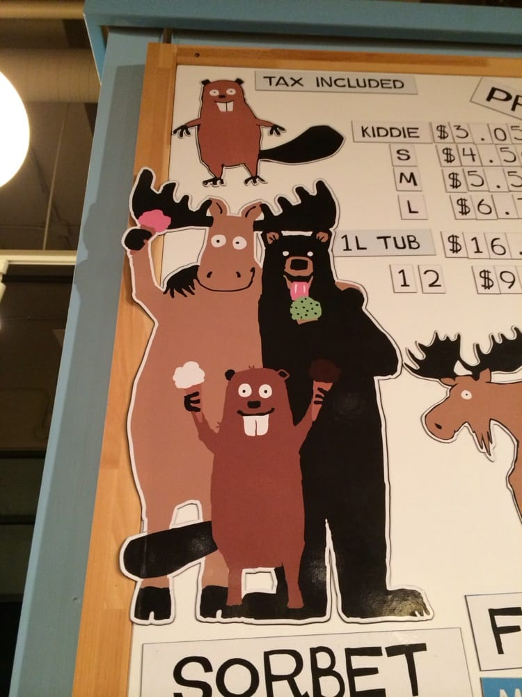
This beaver is a 1 dimensional “sign” with 2 other animals – but the cute, a little bit wacky factor is what I am looking for.

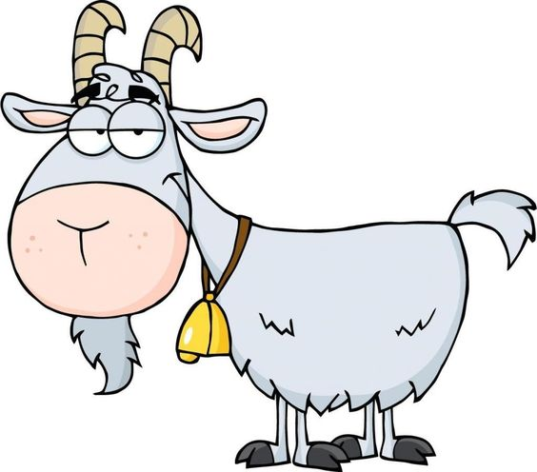
Sample I found online
This is a male goat – would want to see an udder and adjust the eyes to be more alert/fun etc.

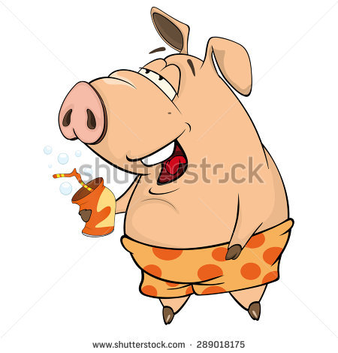
This pig is kind of fun, eyes are too sleepy looking but it has character

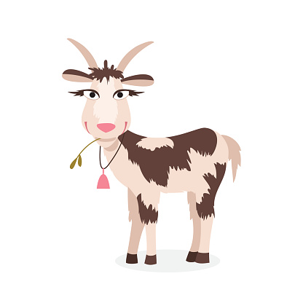
Again looking for udder, and a little more fun/wacky looking and probably not pink

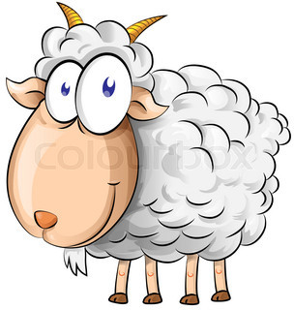This sheep has a fun wacky kind of look in its eyes.

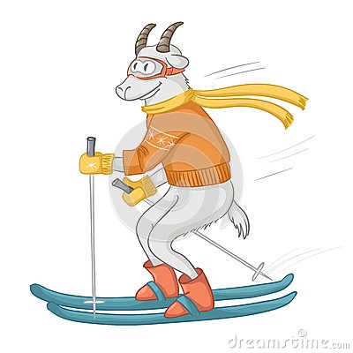
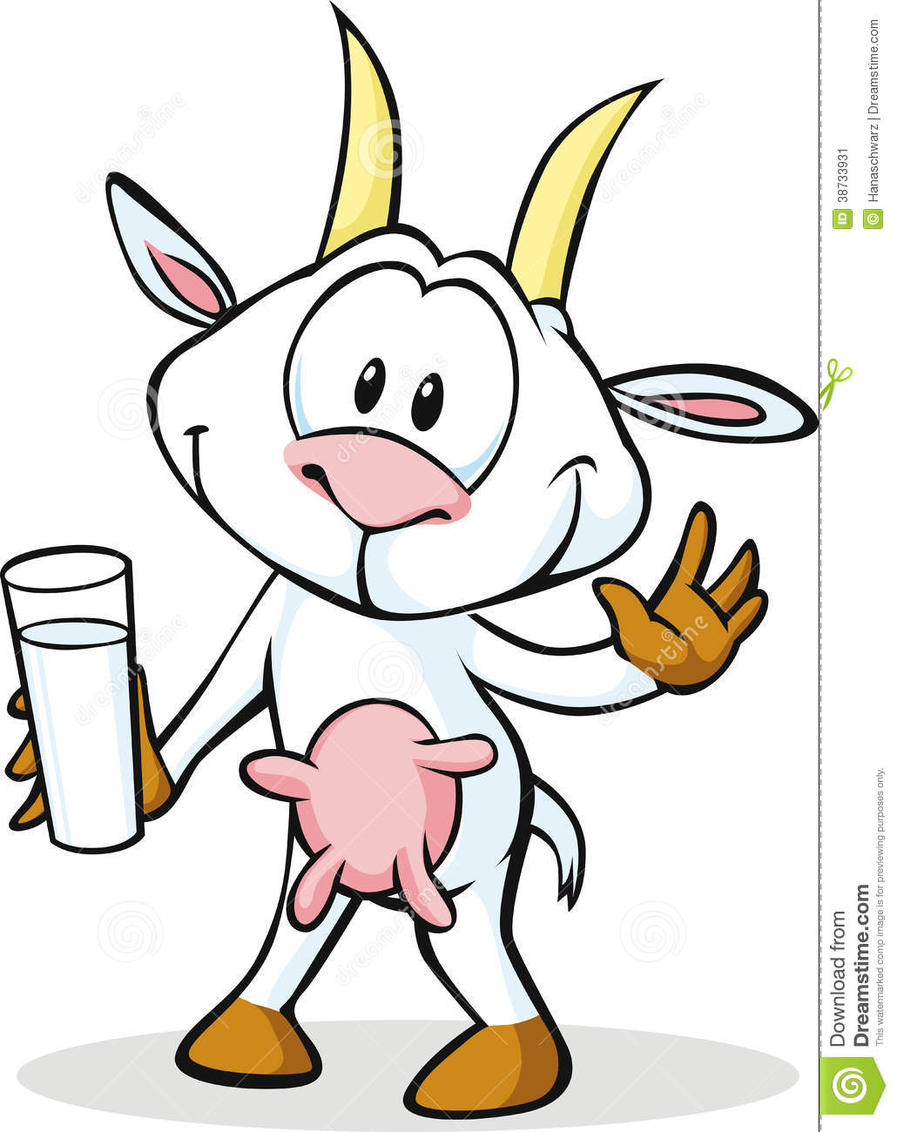

This is a bit like a cow – a goat has 1 udder – this could have a tongue and an ice cream cone and adjust the eyes etc.

