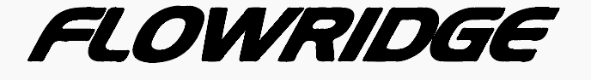
Font: Hanzel Extended Normal
Source: Adobe Illustrator
Edited by: Transformar : 30° : Trazo: 5pt Más cambios: palstificado? Calcado?
Copyright: ???
YES

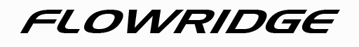
Font: Hanzel Extended Normal
Source: Adobe Illustrator
Edited by: Transformar : 30°
Copyright: ???
YES
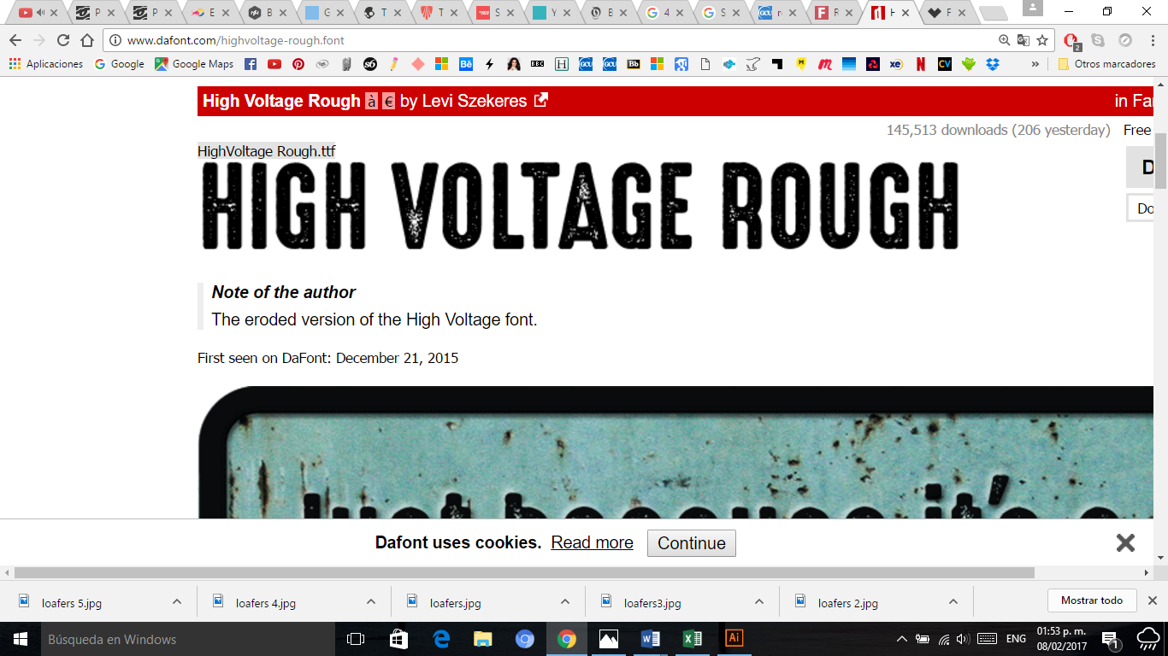
Copyright: 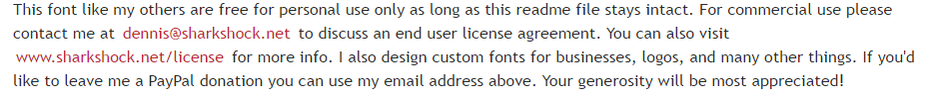
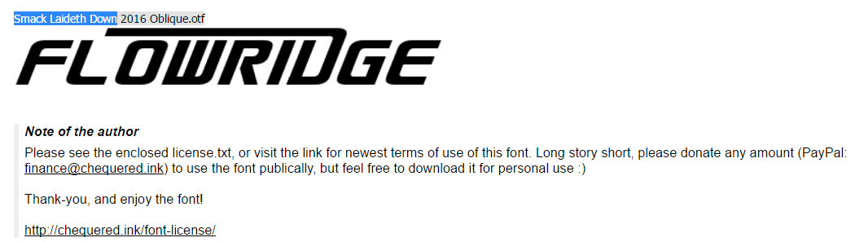
Font: Smack Laideth Down
Source: http://www.dafont.com/smack-laideth-down-2016.font?text=FLOWRIDGE&back=author
YES

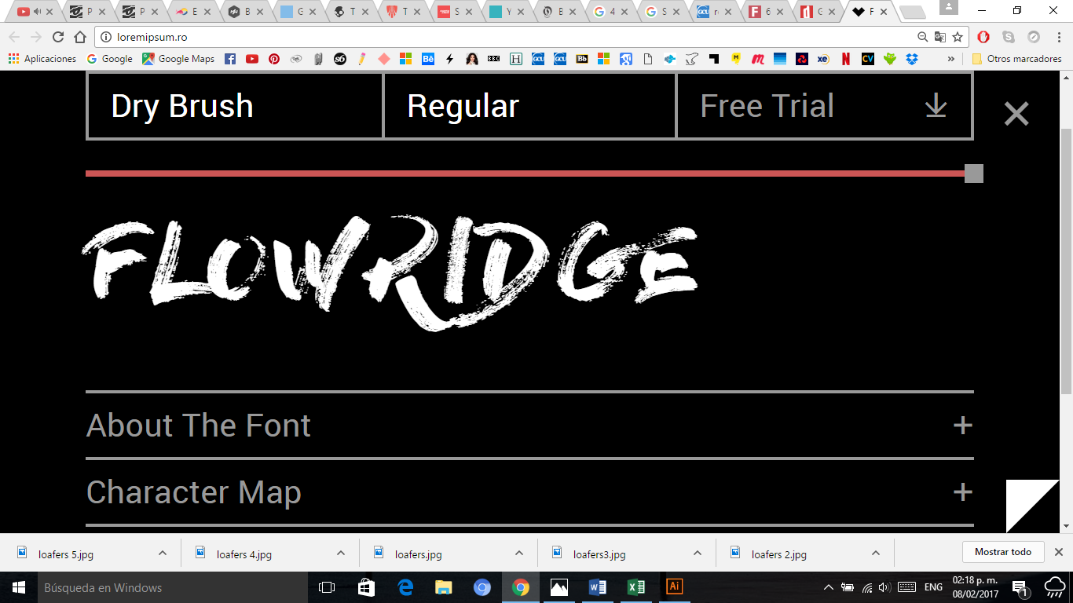
YES

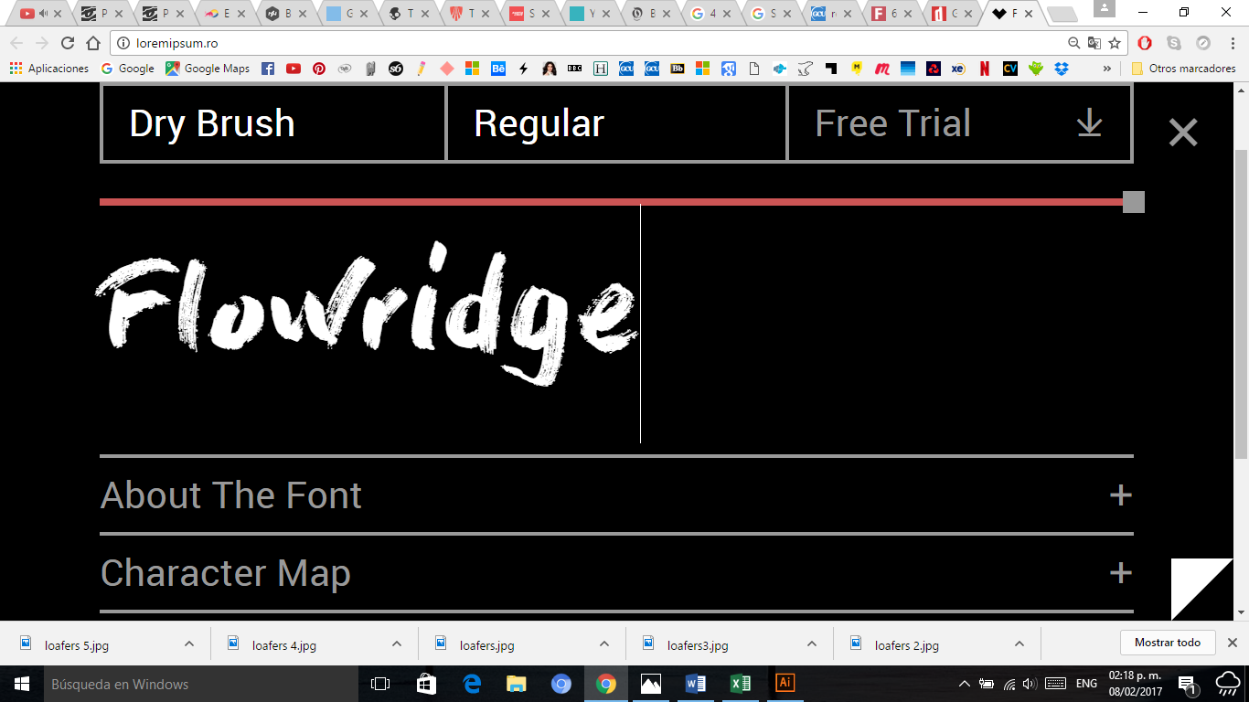

Font: Dry Brush
Source: http://loremipsum.ro/
YES

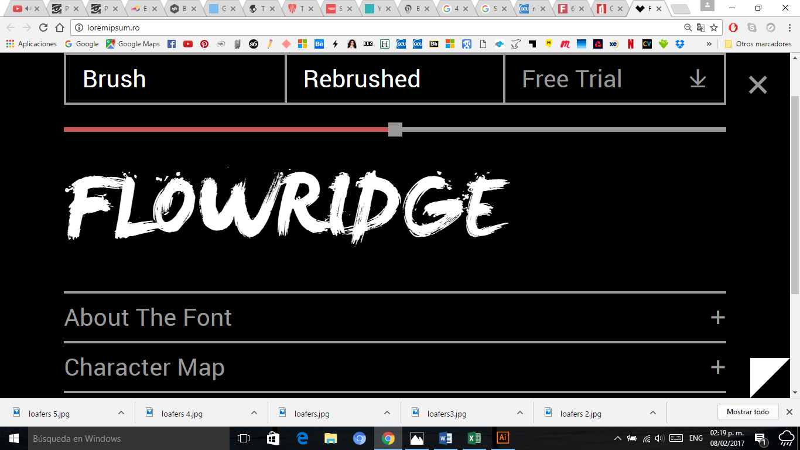

YES

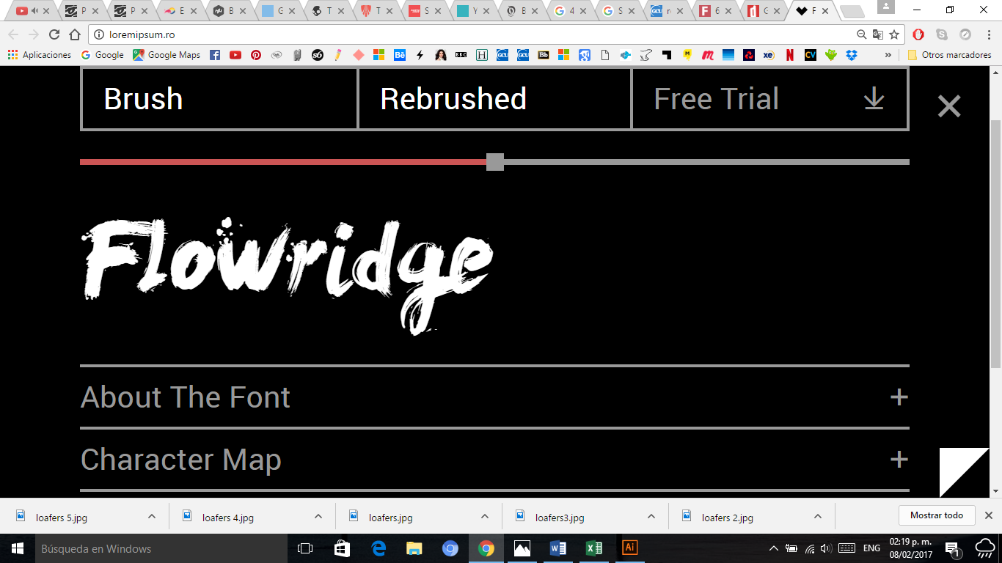
Font: Brush
Source: http://loremipsum.ro/

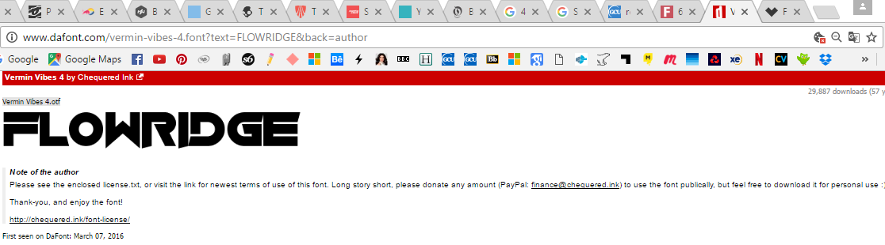

Font: Vermin Vibes 4
Source: http://www.dafont.com/vermin-vibes-4.font?text=FLOWRIDGE&back=author

YES

